**Acknowledgment**

First and foremost thanks to ***Allah***who gave me the ability to complete this work.

I would like to express my unlimited appreciation to ***Prof.Dr.Mohamed El Metwally Mansour,*** Professor of Clinical Pharmacology, Faculty of Medicine, Benha University for his kind help, precious supervision and useful advice. It is a great honor to work under his guidance and supervision.

I would like to express my deep gratitude to ***Prof.Dr.Mohie EL Din Sayed Sherif,*** Professor of Clinical Pharmacology, Faculty of Medicine, Benha University for his continuous supervision and great help during all stages of this work.

Also, I am very grateful to ***Dr.Yasmeen Mohammed Ismail,*** Lecturer of Clinical Pharmacology, Faculty of Medicine, Benha University for her kind supervision and accomplishment of this work.

I would like to thank ***Dr.Abeer Attia Abd ELhameed*,** Lecturer of Clinical Pharmacology, Faculty of Medicine, Benha University for her kind supervision and valuable constructive assistance during all stages of this work.

Iwould like to thank ***Dr.Eman Adel,*** Lecturer of pathology, Faculty of Medicine, Benha University for her great help and valuable cooperation in the histopathological part.

Lastly thanks to all members of The Clinical Pharmacology department, Faculty of Medicine, Benha University.

**CONTENTS**

|  |  |
| --- | --- |
| Page | List of contents |
| III | List of abbreviations |
| VI | List of figures |
| VII | List of tables |
| 1 | 1-Introduction |
| 2-review of literature | |
| 3 | * Rheumatoid arthritis |
| 16 | * Methotrexate |
| 23 | * fluoxetine |
| 29 | * moringa oleifera |
| 45 | 3-Aim of the work |
| 46 | 4-Materials and Methods |
| 58 | 5-Results |
| 82 | 6-Discussion |
| 95 | 7-Summary and Conclusion |
| 99 | 8-Refrances |
|  | 9-Arabic summary |

**List of abberviations:**

|  |  |
| --- | --- |
| Serotonin | 5HT |
| Angiotensin-converting enzyme | ACE |
| Anti-citrullinated protein antibodies | ACPA |
| American College of Rheumatology | ACR |
| Attention deficit hyperactivity disorder | ADHD |
| Adjuvant induced arthritis | AIA |
| Aminoimidazole Carboxamide Ribonucleotide | AICAR |
| Acquired immunodeficiency syndrome | AIDS |
| alkaline phosphatase | ALP |
| Alanine Aminotransferase | ALT |
| Adenosine monophosphate | AMP |
| Anti-carbamylated protein antibody | Anti-Carp |
|  | Anti-CCP |
| Autism spectrum disorder | ASD |
| Aspartate aminotransferase | AST |
| Calcium | Ca |
| Complete Fruends Adjuvant | CFA |
| Cyclooxygenase | COX |
| C-Reactive Protein | CRP |
| Cytochrome P450 | CYP450 |
| Dendritic cells | DCs |
| Dihydrofolate reductase | DHFR |
| Disease modifying anti-rheumatic drugs | DMARDS |
| 5,5'-dithio-bis-[2-nitrobenzoic acid] | DTNB |
| Extra articular manfistation | EAM |
| Epstein-Barr virus | EBV |
| Enzyme Immunoassay | EIA |
| enzyme-linked immunosorbent assay | ELISA |
| Erythrocyte sedimentation rate | ESR |
| European League Against Rheumatism | EULAR |
| Folate transporter | FOLT |
| Follicle-stimulating hormone | FSH |
| gamma-Aminobutyric acid | GABA |
| Granulocyte-macrophage colony-stimulating factor. | GM-CSF |
| Reduced glutathione | GSH |
| oxidized glutathione | GSSG |
| hematoxylin and eosin | H&E |
| Helicobacter pylori | H.pylori |
| hepatitis B virus | HBV |
| Hydroxychloroquine | HCQ |
| Human Dermal Fibroblast | HDF |
| high-density lipoprotein | HDL |
| human immunodeficiency virus | HIV |
| Human leukocytic antigen | HLA |
| 3-hydroxy-3-methyl-glutaryl-coenzyme A reductase | HMG-CoA reductase |
| Herpes simplex viruses | HSV |
| Interferon gamma | IFNγ |
| Immunoglobulin G | IgG |
| Interleukin | IL |
| Interstitial lung disease | ILD |
| Low-density lipoprotein | LDL |
| Luteinizing hormone | LH |
| Lipopolysaccharides | LPS |
| Moringa Oleifera | M.Oleifera |
| Major histocompatibility complex | MHC |
| Matrix metalloproteinase | MMPs |
| Moringa Oleifera | MO |
| Moringa Oleifera Extract | MOE |
| Magnetic Resonance Image | MRI |
| messenger RNA | mRNA |
| Methotrexate | MTX |
| Methotrexate polyglymate | MTX Glu |
| Nuclear factor kappa B | NF-KB |
| Nitric Oxide | NO |
| nitrogen species | NOS |
| Non-Steroidal Anti-inflammatory Drugs | NSAID |
| peroxisome proliferator-activated receptor | PPAR |
| Rheumatoid arthritis | RA |
| Rheumatoid factor | RF |
| Folate transporter | RFC1 |
| Reactive oxygen species | ROS |
| Subcutaneous | S.C |
| standard deviation | SD |
| Serotonin transporter | SERT |
| Statistical Package for the Social Sciences | SPSS |
| Serotonin Syndrome | SS |
| Selective Serotonin Reuptake Inhibitor | SSRI |
| Sulfasalazine | SSZ |
| T-cell receptor | TCR |
| Transforming growth factor β | TGF-β |
| T-helper cell | Th |
| Toll like receptor | TLR |
| Tumor necrosis factor α | TNFα |
| Upper Limit of Normal | ULN |
| Ultrasonography | US |
| Ultraviolet rays | UVR |
| Vitamin | Vit |
| very-low-density lipoprotein | VLDL |
| Water/mineral oil emulsion | W/O |
|  |  |

**List of figures**

|  |  |  |
| --- | --- | --- |
| Page | Title | Fig.No. |
| 9 | Schematic view of a normal joint and a joint affected by RA . | 1 |
| 16 | Chemical structure of methotrexate | 2 |
| 20 | Mechanism of action of methotrexate | 3 |
| 23 | Chemical structure of fluoxetine | 4 |
| 30 | Moringa oleifera tree, flower and leaves | 5 |
| 60 | Histogram showing serum rheumatoid factor (RF) in different study groups | 6 |
| 62 | Histogram showing serum tumor necrosis factor-α (TNF-α) in different study groups | 7 |
| 64 | Histogram showing serum C-reactive protein (CRP) in different study groups | 8 |
| 66 | Histogram showing serum reduced glutathione (GSH) in different study groups | 9 |
| 68 | Histogram showing serum anti-CCP antibodies in different study groups | 10 |
| 70 | Histogram showing the effect of methotrexate, Fluoxetine and Moringa Oleifera, on serum RF, TNF-α, CRP , GSH and anti-CCP antibodies in different groups | 11 |
| 73 | Histogram showing Arthritis score in different study groups, at different times | 12 |
| 74 | Line graph showing arthritis score in different study groups, at different times | 13 |
| 77 | Photomicrograph of a cut section in normal rat joint. | 14 |
| 78 | Photomicrograph of a cut section in rat joint of diseased group. | 15 |
| 79 | Photomicrograph of a cut section in rat joint of MTX. | 16 |
| 80 | Photomicrograph of a cut section in rat joint of fluoxetine treated group. | 17 |
| 81 | Photomicrograph of a cut section in rat joint of Moringa oleifera treated group | 18 |

**List of tables**

|  |  |  |
| --- | --- | --- |
| Page | Title | Tables No. |
| 59 | Effect of methotrexate, fluoxetine and moringa oleifera on the serum concentration of rheumatoid factor (RF) | 1 |
| 61 | Effect of methotrexate, fluoxetine and moringa oleifera on the serum concentration of Tumour necrosis factor-α (TNF-α). | 2 |
| 63 | Effect of methotrexate, fluoxetine and moringa oleifera on the serum concentration of C-reactive protein (CRP). | 3 |
| 65 | Effect of methotrexate, fluoxetine and moringa oleifera on the serum concentration of reduced glutathione (GSH). | 4 |
| 67 | Effect of methotrexate, fluoxetine and moringa oleifera on the serum concentration of anti-CCP. | 5 |
| 69 | The effect of methotrexate, Fluoxetine and Moringa Oleifera on serum RF, TNF-α, CRP , GSH and Anti CCP antibodies in experimentally induced rheumatoid arthritis in rats | 6 |
| 72 | Arthritis score in the study groups at different times. | 7 |

**Introduction**

Rheumatoid arthritis (RA) is an inflammatory rheumatic disease with a progressive course affecting articular and extra-articular structures that result in pain, disability and mortality **(Birch et al., 2010).**

It is characterized by the presence of long-standing inflammation of the joints resulting in symmetric polyarthritis and synovial membrane hypertrophy with progressive joint damage, bone and cartilage destruction and also deformity. The disease is systemic, leading to extra-articular manifestations (EAM) **(Amaya et al., 2012)**

RA is not limited to the affected joints and its physical impact. It is associated with a number of systemic complications related to the underlying immunological disease process. As osteoporosis, myocardial infraction, glomuronephritis, stroke and decrease cognitive function. Patients with extra-articular manifestations of RA appear to have higher mortality (**Myasoedova et al., 2011)**.

RA primarily starts as a state of persistent cellular activation leading to [autoimmunity](https://en.wikipedia.org/wiki/Autoimmunity) and [immune complexes](https://en.wikipedia.org/wiki/Immune_complex) in joints and other organs where the manifestations start. The initial site of disease is the synovial membrane, where swelling and congestion lead to infiltration by immune cells. **(shah &ankur , 2012).**

Main classes of drugs are currently used in RA: analgesics, non-steroidal anti-inflammatories (NSAIDs), glucocorticoids, nonbiologic and biologic disease-modifying antirheumatic drugs. recent clinical practice guidelines recommend that start biologic agents if patients have suboptimal response or intolerant to one or two traditional disease modifying agents (DMARDs). **(Kumar and Bain , 2013).**

Methotrexate is considered the most important and useful disease-modifying anti-rheumatic Drug and is often part of the initial line of treatment. But Methotrexate has shown to have toxic gastrointestinal, hematologic, pulmonary and hepatic adverse effects **(Wasserman, 2011).**

The current trend of medical treatment of RA seeks for new drugs with more efficacies and less side effects since methotrexate, a standard diseased modified anti-rheumatoid drug, causes many adverse effects and toxicities. (**Hendawy et al., 2015**)**.**

Fluoxetine is a selective serotonin uptake inhibitor that has been widely used to enhance the neurotransmission of serotonin in the central nervous system & has emerged as the drug of choice for the treatment of depression due to its safer profile and fewer side effects. **(Ravera et al., 2012).**

Studies have found the following important functions of fluoxetine related to the central nervous system: neuroprotection; anti-inflammatory properties , antioxidant properties and anti-apoptotic properties, with greater neuron survival and a reduction in apoptosis mediators and also oxidative substances, such as superoxide dismutase and hydrogen peroxide. **(Caiaffo et al., 2016)**.

Moringa oleifera is known for its nutritional and numerous medicinal uses. In addition to its high nutritional value, these plants are very important for its medicinal value. Various parts of these plant act as cardiac and circulatory stimulants, possess antitumor, antipyretic, , antiulcer, antispasmodic, diuretic, antihypertensive ,analgesic, antioxidant, antimicrobial, anti-inflammatory effect**. (Ravindra et al., 2019).**

**Rheumatoid Arthritis**

Rheumatologic diseases are the most prevalent diseases worldwide. about one-third of physical disabilities in elderly are due to rheumatologic disease as a primary cause. They are one of the main causes of disability and morbidity all over the world with greatly bad impact on the quality of life**. (Goma et al., 2016).**

Rheumatoid arthritis (RA) is a symmetric, inflammatory, peripheral polyarthritis of unknown etiology. It typically leads to deformity through the stretching of the tendons and ligaments and destruction of joints through the erosion of cartilage and bone. If it is untreated or unresponsive to treatment, inflammation and joint destruction lead to loss of physical function, inability to perform daily tasks. **(Venables & Maini, 2014).**

Involvement of the organs such as skin, eye, lung, heart, kidney, blood vessels, salivary glands, central and peripheral nervous systems, and bone marrow occurs in about 40% of patients with RA. **(Engin et al., 2019).**

Rheumatoid arthritis is a common autoimmune disease that affects up to 1% of the general adult population worldwide. **(Stahl et al., 2010).**

The oncet of RA occurs between 35-50 years of age in 80% of patients. It tends to run in families and occurs more commonly in women than men (∼3:1 ratio). The course is variable, ranging from mild brief illness affecting a few joints with minimal damage to a progressive polyarthritis that leads to sever functional impairment and [deformity](https://www.sciencedirect.com/topics/pharmacology-toxicology-and-pharmaceutical-science/deformity). **(Cooper & Stroehla, 2003)**

It is well established that genetic factors, such as human leukocyte antigen (HLA), and environmental factors, such as infection, UVR, radiation and smoking, can affect the development of various autoimmune diseases.**( Scott et al.,2010)**.

Among these factors, cigarette smoking significantly increases the risk of not only various types of cancer and cardiopulmonary diseases, but also autoimmune diseases, such as systemic lupus erythematosus and RA. **(Hoovestol** **and Mikuls,** **2011)**.

**Pathogenesis**:

The disease pathophysiologybased on the presence of several autoantibodies as rheumatoid factor (RF), anti-citrullinated protein antibodies (ACPA), anti-carbamylated protein antibodies (anti-CarP) and anti-acetylated protein antibodies, RA can be subdivided into seropositive and seronegative disease. Formation of autoantibodies is associated with both genetic and environmental risk factors for RA, like specific human leukocyte antigen (HLA) and smoking.**( Derksen et al.,2017)**

In RA anti–citrullinated peptide autoantibodies (ACPA or anti-CCP) are found in the serum of about 70% of RA patients **(Benham et al., 2015).**

The production of ACPAs requires the participation of both innate immunity and adaptive immunity. activated innate immunity is able to produce citrullinated auto-antigens that iniate autoimmunity and provide an inflammation, proliferation of self-reactive T/B cells and the production of ACPAs, after their production by plasma B cells, ACPAs are also able to interact with innate immunity to exacerbate the manifestation and chronicity of RA. **(Dong et al., 2018).**

Immune responses developed to endogenous epitopes resulting from the release of self-antigens. In this stage, increased titer of ACPA gradually increased and this can last several years before the onset of joint symptoms. **(Van der woude et al.,2010).**

Citrullination neoantigens would activate MHC class II-dependent T cells that in turn would help B cells produce more ACPA. ACPA can induce pain, bone loss, inflammation and induce osteoclast activation which might explain important features of the gradual development of RA. **(Krishnamurthy et al., 2016).**

Innate immunity is recognized as a key mechanism not only in preventing invasion of the body by microorganisms, but also in participates in the pathogenesis of autoimmune and [inflammatory diseases](https://www.sciencedirect.com/topics/medicine-and-dentistry/inflammatory-disease). The cellular and protein effectors of innate immunity are found in the rheumatoid [synovium](https://www.sciencedirect.com/topics/medicine-and-dentistry/synovial-membrane), indicates that they are directly involved in joint inflammation and in destruction of the joint cartilage and bone. **(Falgarone et al .,2005).**

Three phases of progression of RA are an initiation phase (due to non-specific inflammation), an amplification phase (due to [T cell](https://en.wikipedia.org/wiki/T_cell) activation), and chronic inflammatory phase, with tissue injury that result from the [cytokines](https://en.wikipedia.org/wiki/Cytokines), [IL–1](https://en.wikipedia.org/wiki/Interleukin_1), [TNF-alpha](https://en.wikipedia.org/wiki/TNF-alpha) and [IL–6](https://en.wikipedia.org/wiki/Interleukin_6).**( Shah and Ankur,2012).**

Synovial compartment is infiltrated by the influx or local activation, or both, of mononuclear cells such as (T cells, B cells, plasma cells, dendritic cells, macrophages and mast cells) and by angiogenesis **(Choy, 2012).**

ACPA can enhance NF-kB activity and TNF-α production in monocyte/macrophages via binding to surface-expressed citrullinated antigen. (**Lu et al., 2010).**

Synovial hyperplasia results from a marked increase in macrophage and fibroblast-like synoviocytes. Locally expressed degradative enzymes, including metalloproteinase and proteases, digest the extracellular matrix and destroy the articular structures. **(Firestein , 2003).**

Cytokines, particularly IL-1 and 17, and reactive oxygen intermediates affect chondrocytes that undergo apoptosis. This results in cartilage degradation and joint-space narrowing on radiography. **(McInnes & Schett, 2011).**

Articular damage in turn probably generates a rich source of neo-antigens to promote further autoimmune reaction. In addition, the articular environment is profoundly hypoxic and angiogenesis is a characteristic feature of RA. **(McInnes & Liew, 2005).**

Systemic involvement may be explained by the systemic activities of cytokines released from the inflamed synovium**.( Nishimoto & Kishimoto, 2006)**

Tumor necrosis factor alpha (TNF-α) promotes cachexia, depressed mood and altered cognitive function. **(Sattar et al., 2003).**

T cells are implicated in the pathogenesis of rheumatoid arthritis due to genetic association with MHC class II so there is detection of high numbers of T cells in the inflamed synovium. **( Panayi, 2006)**.

The differentiation of human Th subsets into Th1, Th2&Th17 cells is largely regulated by the three cytokines, IL-12, IL-23, and transforming growth factor β( TGF-β).**(Schmitt & Ueno, 2015).**

Th1 cells were originally thought to play a role in the genesis of autoimmune disease because IL-12 and IFN-γ are highly expressed at sites of inflammation. **(Zhu& Qian, 2012).**

In RA elevated levels of IL-12 have been identified in both serum and synovial fluid of a large number of patients and correlated with increased disease activity. **(Furst & Emery, 2014).**

Th17 cells is a key effector in the immune response and play critical roles in the development of autoimmunity by producing IL-17, TNF-α and IL-6 .**( Niu et al., 2012).**

Synovial T cells are activated by T-cell receptor (TCR) and co-stimulation pathways and by cytokine- or Toll-like receptor (TLR)-driven stimuli. In particular, the surrounding synovium contains IL-12, IL-23, IL-6 and TGFβ, and as such promotes the differentiation of TH1and TH17 cells. **( Ridgley, 2018)**.

Activated T cells mediate effector function in rheumatoid arthritis through the release of cytokines that promote activation of macrophages, fibroblasts and endothelial cells through direct cell contact. **(McInnes & Schett, 2007).**

The activation and functional differentiation of B cells are regulated by CD4+ T cells through secretion of IL-21. **( Bentebibel et al.,2011).**

IL-21 can directly act on B cells. IL-21 co-stimulation is capable of promoting plasma cells differentiation and stimulating blood B cells into IgG-secreting plasma cells in humans. **(Spolski & Leonard, 2014).**

The inflamed synovium in RA develops lymphoid aggregates, which can range from small clusters to organized follicles with germinal centers. **(Rao, 2018).**

Macrophages are a potent source of proinflammatory cytokines, in particular TNFα, IL-6 and IL-1, and matrix metalloproteinases (MMPs), leading to activation of the endothelial cell, acute phase reactions, and cartilage damage. These cells can also produce a wide range of chemokines, which help attraction of additional leukocytes to the inflamed joint. **(Roberts et al., 2015).**

Monocytes have the ability differentiate into osteoclasts, which may further contribute to their role in RA pathogenesis.**( Davignon et al.,2013).**

Monocytes and macrophages are major sources of IL-1β, IL-6, IL-12, and IL-23, cytokines known to be present in the RA.**( Stamp et al.,2009).**

Dendritic cells (DCs) are professional antigen-presenting cells that have significance and potency that can act as intermediators between innate and adaptive immune responses. **(Germic et al., 2019).**

In addition to their role as antigen-presenting and cytokine-producing cells, macrophages can efficiently generate ROS. **(Roberts et al.,2015).**

Toll-like receptors (TLRs) have been implicated in the pathogenesis of RA with many studies showing an increasing in TLR2 and TLR4 expression in the perivascular regions of the joints at the sites of attachment and invasion into cartilage/bone, and on synovial macrophages.**( McGarry et al.,2015).**

Continuous TLR activation is associated with progression in the inflammation. **(Joosten et al., 2016).**

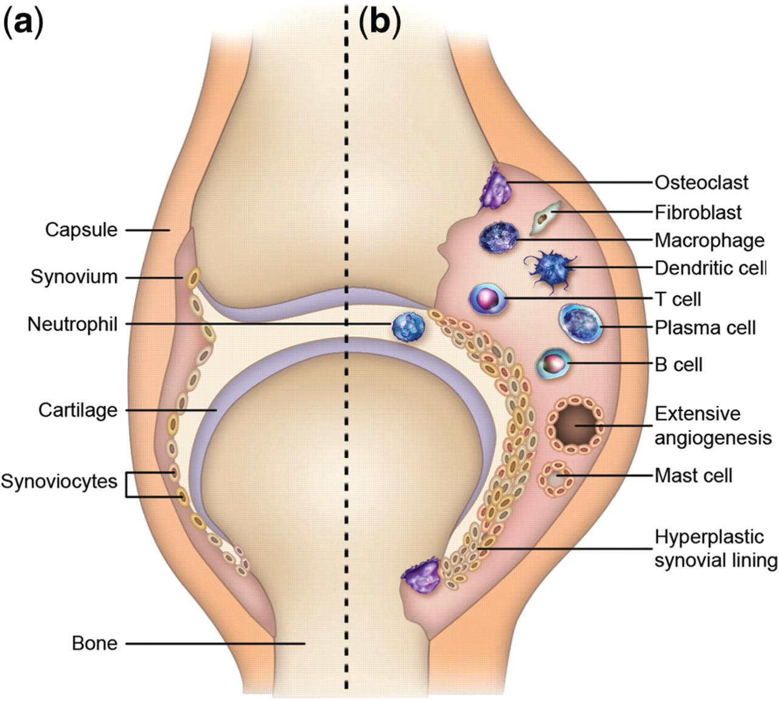

**Figure (1)**: Schematic view of a normal joint (**a**) and a joint affected by RA (**b). (Smolen & Steiner, 2003).**

Another major pathological phenomenon of RA is the formation of a destructive type of tissue that invades the interface between cartilage and bone, and is known as pannus. Pannus formation is one of the important

characteristic features of RA, which makes it distinct from other inflammatory arthropathies. Also, chronic synovitis can progress to the destruction of adjacent bone and cartilage leading to joint deformity and disability. **(Aletaha et al., 2010).**

**Signs and Symptoms:**

RA primarily affects joints, but it also affects other organs in more than 15–25% of individuals. Symptoms include Pain, swelling, limited motion, warmth and tightness around affected joints, which most commonly include the hands and wrists, feet and ankles, elbows, shoulders, neck, knees and hips, usually in a symmetrical pattern. Fatigue, stiffness and aching, particularly in the morning and afternoon (described as morning stiffness and afternoon fatigue). **(Gohil et al.,2017).**

Lumps or rheumatoid nodules below the skin, weight loss, trouble sleeping, depression, local osteoporosis occurs in RA around inflamed joints, constitutional symptoms including fatigue, low grade fever, malaise, morning stiffness, loss of appetite and loss of weight are common systemic manifestations seen in people with active RA.**(Rowaida et al., 2013).**

RA commonly involves the small joints of the hands (metacarpophalangeal and proximal interphalangeal joints), wrists, and feet (metatarsophalangeal joints). Large joints may also be affected and include the shoulder, elbow, hip, knee, and ankle. **(Aletaha et al.,2010).**

Rheumatoid arthritis is a systemic inflammatory disease. all patients have joint manifestations& up to 50% will develop one or more extra-articular manifestations (EAM) with 15% having a severe manifestation.**( West, 2018).**

**The EAM include:**

Rheumatoid nodules are the principal cutaneous manifestation occurring in up to 30% of RA patients with EAM. They are mainly found on the extensor surface of the forearm and also over pressure areas throughout the skin. **(Cojocaru et al., 2010).**

Pleuritis is a common EAM in RA, affecting almost 5%–10% of RA patients. There are variety of clinical pictures may represent the pulmonary system involvement in RA that encompass pleural effusion, interstitial lung disease (ILD). **(Prete et al., 2011).**

Pleural effusion if occur is mostly bilateral. Rheumatoid pulmonary nodules are another important finding which are asymptomatic and found almost exclusively in seropositive RA patients. Radiographically, they are coin-shaped lesions. **(Lioté, 2008).**

Patients with RA suffer from the increased cardiovascular disease. The more prevalent manifestations include atherosclerosis, myocardial infarction, pericarditis, arrhythmias, and valvular heart disease.The most common EAM in cardiovascular system is pericarditis, usually associated with seropositive RA patients. **(Ortega-Hernandez et al.,2009).**

In active RA patients the Common hematologic manifestations include anemia and thrombocytosis, RA patients who develop leukopenia must have Felty’s syndrome, Felty’s syndrome is defined as the triad of RA, splenomegaly, and leukopenia. It is found in less than 1% of RA patients who typically have severe, long-standing, and seropositive disease. **(West, 2018).**

Neuropsychiatric manifestations are quite common in RA, including depression, [cognitive dysfunction](https://www.sciencedirect.com/topics/medicine-and-dentistry/cognitive-defect), behavior changes, [spinal cord compression](https://www.sciencedirect.com/topics/medicine-and-dentistry/spinal-cord-compression) and [peripheral nerve](https://www.sciencedirect.com/topics/medicine-and-dentistry/peripheral-nerve) involvement.**(Joaquim& Appenzeller, 2015).**

Entrapment neuropathies are relatively common in RA patients. The peripheral nerves are compressed by synovitis . The median nerve (carpal tunnel), posterior tibial nerve (tarsal tunnel), ulnar nerve (cubital tunnel), and posterior interosseous branch of the radial nerve are most commonly involved. **(West, 2018).**

There are other ophthalmologic manifestations that can occur in RA patients including keratoconjunctivitis sicca, episcleritis, nodular scleritis, and rarely ulcerative keratitis. **(Majumder et al., 2018).**

The renal toxicity of ant rheumatic drugs (for example, NSAID or cyclosporine toxicity), secondary renal disease induced by the chronic inflammatory process especially renal amyloidosis**.( Anders & Vielhauer,2011).**

**The diagnosis of rheumatoid arthritis (RA) can be made when the following clinical features are all present:**

**2010 ACR/EULAR criteria**: American College of Rheumatology(ACR) European League Against Rheumatism (EULAR)  definite RA is based upon the achievement of a total score of at least 6 (of a possible 10) from the individual scores in four domains. The highest score achieved in a given domain is used for this calculation. These domains and their values are:

* **Number and site of involved joints**
* 2 to 10 large joints (from among shoulders, elbows, hips, knees, and ankles) = 1 point
* 1 to 3 small joints (from among the metacarpophalangeal joints, proximal interphalangeal joints, second through fifth metatarsophalangeal joints, thumb interphalangeal joints, and wrists) = 2 points
* 4 to 10 small joints = 3 points
* Greater than 10 joints (including at least 1 small joint) = 5 points
* **Serological abnormality (rheumatoid factor or anti-citrullinated peptide/protein antibody)**
* Low positive (above the upper limit of normal [ULN]) = 2 points
* High positive (greater than three times the ULN) = 3 points
* **Elevated acute phase response (erythrocyte sedimentation rate [ESR] or C-reactive protein [CRP]) above the ULN = 1 point**
* **Symptom duration at least six weeks = 1 point. (Venables & Maini , 2014).**

Ultrasonography (US) offers a non-invasive and relatively inexpensive method for detecting joint effusion and bursal fluid collection and may show hyperplastic synovium and the underlying erosive disease, Color Doppler US/Power Doppler US is important in distinguishing complex effusion and pannus and in the assessment of vascular abnormalities at the synovial tissue.**(** **Carotti et al 2018).**

Magnetic resonance imaging (MRI) are more sensitive than clinical examination in detecting synovitis and in particular for large joints such as the shoulder and knee **(Zappia et al., 2017).**

**Treatment**:

The goals of treatment are to reduce symptoms such as pain and swelling, control disease activity, prevent the deformity of the joints, improve the quality of life, and allow patients to maintain his physical activity. **(Kianifard& Chopra, 2018).**

Analgesics and NSAIDs are used temporary until the DMARDs take effect, and also during disease flares. Nonsteroidal anti-inflammatory drugs (NSAIDs) inhibit cyclooxygenase activity and inhibit prostaglandins (PG) production. **(Page et al., 2010).**

Glucocorticoids are frequently include in the RA treatment regimen for a short period aiming to minimize disease activity in patients with active RA until occurance of a clinical response to the given DMARD. **(Kavanaugh& Wells, 2014**).

Methotrexate (MTX), sulfasalazine (SSZ), leflunomide, hydroxychloroquine (HCQ) and gold salts are the commonly used DMARDs used in the treatment of RA. They are Non-biologic DMARDs that require regular monitoring. **(Aaltonen, 2015).**

Methotrexate (MTX) is the recommended first-line disease-modifying anti-rheumatic drug (DMARD) used in the treatment of RA. This is due to its low cost and many patients achieve disease control with monotherapy.  However, about 30% of patients devolpe inadequate treatment response and many patirnts stop MTX due to toxicity .**( Ling& Bluett , 2020).**

Biological DMARDs are a group of drugs that target specific molecules or molecular pathways involved in the inflammatory processes of RA. TNFα inhibitors as Infliximab, anti-B cell therapy as rituximab, T-cell co-stimulation blocker as abatacept, anti- IL-6 as tocilizumab,and anti- IL-1as anakinra. **(Guo et al.,2018).**

It is difficult to predict the response to various biological DMARDs especially since they have different modes of action. **(Nakayamada et al.,2018).**

Anti-TNF therapies trigger auto-immune responses such as a lupus-like syndrome. Although the fact that all biological agents have the potential for immunogenic reactions.**( Matucci et al.,2016).**

Physical exercise can play an important role in the treatment of rheumatic diseases in improving both physical and mental health, increase energy, decreasing fatigue and improving sleep. In this way, the muscles around the affected joints become strong, the loss of bone decreases and controlling of joint swelling, stiffness and pain improves also, anxiety decreases and the mood improves. This achieved through exercise program for patients with rheumatic diseases. **(Musumeci , 2015).**

There is a global trend toward a decreasing of surgical intervention for rheumatoid arthritis, as medical management has improved. However, surgery continues to play a role in the management of the disease as structural damage tends to be both cumulative and irreversible. Prosthetic joint arthroplasty is the most common surgical procedure for large joint involvement. **(Lee et al., 2018).**

**Methotrexate**

Methotrexate is a folic acid antagonist that reversibly inhibits dihydrofolate reductase (DHFR), which is an enzyme that catalyzes the conversion of dihydrofolate to tetrahydrofolate, an essential cofactor in the synthesis of purine and thymidine. Inhibition of this pathway by methotrexate results in impair synthesis of DNA and cellular replication. **(Verberne et al., 2019).**

**Chemistry:**

Methotrexate (2,4-diamino-N10-methyl propyl glutamic acid, MTX) There are three parts in its structure : (1) pteridine ring, (2) p-amino benzoic acid, and (3) glutamic acid. It has molecular weight of 454.5 g/mol (C20H22N8O5). **(Abolmaali et al., 2013).**

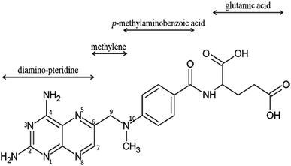

**Figure (2)**: Chemical structure of methotrexate **(Alinejad et al.,2019).**

**Pharmacokinetics:**

MTX is actively absorbed from the proximal part of jejunum. The extent of absorption of MTX is highly variable between individuals and has mean absolute bioavailability ranging from 30–90%. On average, 70% of MTX is absorbed. MTX shows high rate of absorption and reaches maximum plasma concentration within 0.75 to 2 h after oral administration. **(Maksimovic et al.,2020).**

Oral MTX is absorbed from the small intestine by the proton-coupled folate transporter, which is active at pH 5.5 and transports reduced folates and methotrexate. **(Desmoulin et al.,2012).**

About 30–70% of MTX is bound to proteins mostly to albumin. And significantly increased drug plasma concentration for 8 hours following methotrexate administration reflecting the possible enterohepatic cycling of the drug. The concentrations of MTX in the synovial fluid are mostly equal to plasma concentrations at 4 and 24 hours after oral or intramuscular administration. **(Grim et al.,2003).**

After absorption, 10% of MTX is converted to hydroxymethotrexate in the liver. Both methotrexate and its metabolite hydroxy methotrexate are primarily excreted by the kidneys and a small portion is also excreted in the bile.**( Saka& Aouacheri, 2017).**

The half-life of MTX in serum range from 6 to 8 hours after administration of the drug, and MTX is undetectable in the serum by 24 hours. Once taken-up by cells, a portion of MTX and hydroxymethotrexate is metabolized to polyglutamate derivatives. MTX polyglutamates (MTXGlu) are stored in the tissues, including liver and erythrocytes, for long periods. **(Tian & Cronstein, 2007).**

After MTX reaches circulation, it is transferred intracellular,mostly to erythrocytes, white blood cell, hepatocytes and synoviocytes. In erythrocytes, MTX is polyglutamated by adding glutamate groups in gamma linkage. This reaction uses ATP as energy source and is catalyzed by enzyme folylpolyglutamyl synthetase. MTX polyglutamates in erythrocytes act as a depot, thus allowing weekly administration of MTX. **(Stamp& Roberts, 2011).**

More than 90% of MTX is cleared by the kidneys .MTX and its metabolites are poorly soluble at acidic pH. An increase in the urine pH from 6.0 to 7.0 results in a five- to eight fold greater solubility of MTX and its metabolites. So with high dose MTX, routine administration of fluid and/or bicarbonate is recommended to prevent intratubular precipitation of the drug.**( Widemann & Adamson, 2006).**

In addition to urinary excretion about 1-30% of MTX is excreted in bile .but only about 1-2 % is execrated in stool and this is due to extensive enterohepatic circulation. **(Van Roon** **et al.,2010).**

**Mechanism of action:**

Part of its anti-inflammatory action is due to it is a folate antagonist MTX up taken into the cells by folate transporter 1 (FOLT, also known as RFC1). Within the cell MTX is polyglutamated in a reversible reaction by folylpolyglutamate synthetase. Polyglutamation of methotrexate increasing inhibition of dihydrofolate reductase (DHFR), thymidylate synthetase and 5-aminoimidazole- 4-carboxamide ribonucleotide transformylase. **( Brown et al.,2016).**

Cells lacking adequate thymidine are unable to synthesize DNA, which results in the arrest of cellular proliferation; the net result is reduced DNA synthesis. **(Friedman& Cronstein, 2019).**

MTX polyglutamates show potent inhibition of aminoimidazole carboxamide ribonucleotide (AICAR) transformylase, the net effect of this inhibition is the accumulation of AICAR and its metabolites, which are inhibitors of adenosine deaminase and AMP deaminase.so, reduce the catabolism of adenosine and adenine nucleotides so adenosine levels increase. Adenosine might be one of the main mediators of down regulation of the activation and proliferation of T lymphocytes**.( Chan & Cronstein ,2013).**

Adenosine inhibits leukocyte chemotaxis, oxidative inflammation neutrophils/monocytes and cytokine synthesis from monocyte/macrophages (TNF-α, IL-6,-8,-10 and −12). **( Sramek et al.,2017).**

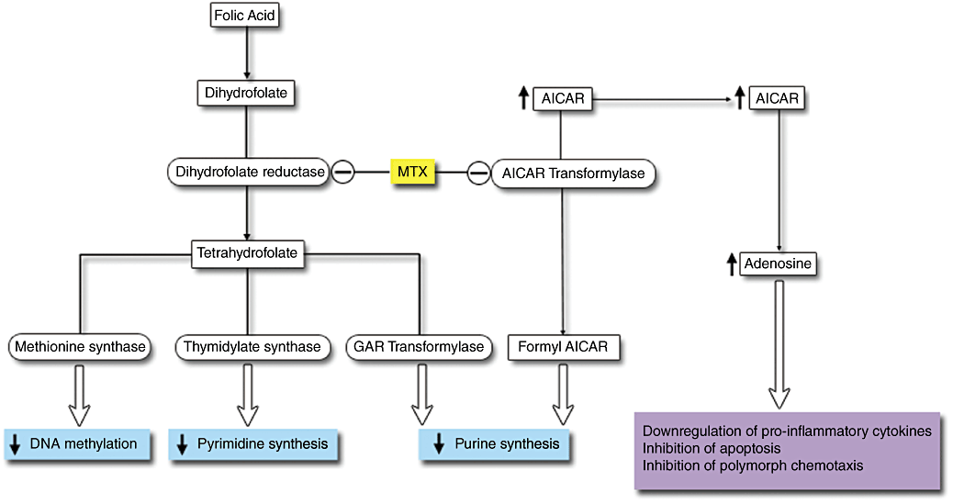**Figure** (**3**): Mechanism of action of methotrexate. **(Shen et al.,2012).**

Other mechanisms of methotrexate Polyamine reduction which is one of its anti-inflammatory mechanisms as polyamines can converted into lymphotoxins. also inhibit chemotaxis in monocytes.**( Spurlock, 2014).**

Other studies have also shown that MTX inhibits T cell activation induces apoptosis, and alters expression of T cell cytokines and adhesion molecules. **( Wessels et al.,2008).**

**Uses:**

MTX has been approved for the treatment of a range of different tumors including osteosarcoma, lung cancer, breast cancer, leukemia and lymphoma. **(Link, 2019).**

MTX could have an additional anti-inflammatory effect. MTX is also used in diseases such as psoriasis, bullous diseases, vasculitis, atopic dermatitis, lupus erythematosus, RA and sclerodermia.**( Nedelcu et al.,2019).**

Also it is used in Multiple-doses in treatment of ectopic pregnancies as alternative to surgery. **( Tug et al.,2019).**

**Adverse effects:**

The most common adverse effects include: gastrointestinal side effects (nausea, vomiting, abdominal pain) followed by stomatitis (oral ulcers), liver function abnormalities, bone marrow suppression and alopecia. **( Singh, 2013).**

Due to drug excretion from the kidneys by glomerular filtration and active transport, nephrotoxicity occurs more than other side effects. **(Asci et al., 2017).**

MTX has been associated with fetal malformations in central nervous system abnormalities, mental retardation, skeletal abnormalities, partial or absent ossification of bones, micrognathia, cleft lip or palate, broad depressed nasal bone, short limbs, syndactyly absent digits,clubfoot ,dextrocardia,hepatic affection and intrauterine growth retardation.**( Salman et al.,2016).**

**Drug interaction**:

**Folate supplementation during MTX therapy**

A folate deficiency causes side effects such as mouth sores, stomach problems such as nausea or abdominal pain, liver and blood cells problems. These side effects are sometimes bad enough that they cause people to stop taking MTX discontinue treatment. Supplementation with folic or folinic acid in MTX treated RA patients provides a reduction in the incidence of abnormal liver function tests and a reduction in the withdrawal of treatment. also it reduce the incidence of gastrointestinal side effects and stomatitis.**( Shea etal.,2013).**

Concomitant intake of Folic acid (1–5 mg/day) reduces side‐effects without decreasing the efficacy of MTX. **( Dogra& Mahajan , 2013)**

NSAIDs may reduce the clearance of methotrexate, thereby increasing plasma methotrexate concentrations and the risk of toxicity. **(Davies& Skjodt, 2000).**

Salicylates, phenylbutazone, phenytoin, and sulfonamides, may increase MTX toxicity by displacing albumin-bound methotrexate. Probenecid inhibits renal tubular transport, which can result in higher serum concentrations of MTX. **(Bezabeh et al., 2012).**

**fluoxetine**

Fluoxetine is an antidepressant and one member of a class of drugs that act as selective serotonin reuptake inhibitors (SSRI). It has been used for over 25 years to treat major depression and many psychiatric disorders. **(Sumpter et al., 2014).**

**Chemistry:**

it is weak base drug, it has molecular weight of 309.3 g/mol. **(Karlsson et al.,2016).**

‏Its chemical name is (7)-Nmethyl-3-phenyl-3-propylamine hydrochloride, and its molecular formula C17H18F3 NO.HCl. It consists of white crystals or a yellowish white powder and is soluble in water at a concentration of 14 mg/ml. **(Düsman et al., 2014).**

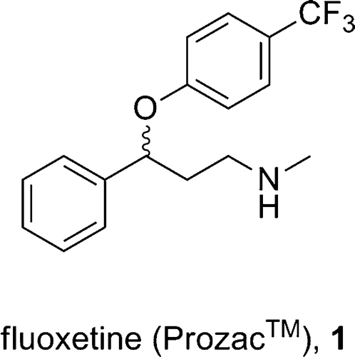

**Figure (4)**: Chemical structure of fluoxetine. **(Wenthur et al., 2014).**

**Pharmacokinetics:**

Fluoxetine is water soluble having about 72% oral bioavailability. Fluoxetine undergoes extensive hepatic metabolism. **( Deshmukh& Mohite,2018).**

It has longest half-life in all the selective serotonin reuptake inhibitors (SSRIs).It is highly bound to plasma proteins, mostly albumin. Fluoxetine is well absorbed from the gastrointestinal tract. After oral administration peak plasma concentration occurs between 4-8 or 6-12 h and maximal cerebral effect reported between 8-10 h. **(Siddiqui et al., 2011).**

Fluoxetine undergoes hepatic metabolism and CYP2D6 isoenzyme convert fluoxetine to norfluoxetine which is pharmacologically active metabolite by demethylation, while the enzymes CYP2C9, CYP2C19 and CYP3A4 also play a role. norfluoxetine is also serotonin reuptake inhibitor.**( Kandasamy et al.,2010).**

Plasma half-life of fluoxetine is 2 days. Its active metabolite has a half-life of 7-10 days. **( Aggarwal et al., 2012).**

The elimination of Fluoxetine as the following 80% excreted in the urine (as 11.6% Fluoxetine, 7.4% Fluoxetine glucuronide, 6.8% nor fluoxetine, 8.2% nor fluoxetine glucuronide, >20% hippuric acid, 46% others) and approximately 15% excreted in the stool.**( Andrés-Costa et al.,2017).**

**Mechanism of action:**

Fluoxetine acts by blocking of the presynaptic membrane serotonin transporter (SERT), that increasing serotonin (5-HT) levels in the synaptic cleft and the firing activity of post-synaptic neurons. **(Bidel et al., 2016).**

Fluoxetine also has anti-inflammatory effects. There is evidence that there is a link between the immune system and the symptoms of depression. This was referred to as the macrophage theory of depression, suggesting an association with inflammatory cytokines. It has since been showed that patients with depression have elevated blood levels of cytokines, as compared with healthy controls, and that these levels are reduced upon treatment with fluoxetine. This suggests a connection between fluoxetine, depression, and the immune system. **(Sacre et al.,2010).**

Fluoxetine has role in the reduction of oxidants and apoptosis. **( Hu et al.,2018).**

Patients with autoimmune diseases, when depression coexists, the quality of life become worse. Depression-like symptoms, such as fatigue and disinterest are also common in rheumatic diseases. Also, there is strong evidence suggesting roles of inflammatory cytokines in the pathogenesis of depression .These findings suggest an associations between depression and rheumatoid arthritis . This raises the possibility that treatment of one of them might influence the outcome of the other. **(Varan et al., 2018).**

Fluoxetine is able to modulate immune functions, It was shown that fluoxetine suppresses T- and B-lymphocyte proliferation in a dose-dependent manner and it also significantly reduces the production of the pro-inflammatory cytokines TNF alpha, IFN-y and the( IFN-y/IL10( ratio, so fluoxetine is able to decrease the inflammatory reaction .**( Di Rosso et al.,2016).**

***Uses***:

Fluoxetine is one of the most important drugs used as antidepressants. It also has other therapeutic applications as anxiety disorders, bulimia nervosa, and premature ejaculation. **(Barakat et al ., 2018).** Also fluoxetine control menopausal vasomotor symptoms. **(Pinto et al., 2017).**

However, fluoxetine has contribution to nociceptive pain management through, solitary anti-nociceptive effect, enhancement of morphine acute analgesia, blocking morphine analgesia tolerance development, and blocking dependence development and associated abstinence syndrome.**( Hamdy et al.,2018).**

Fluoxetine modulates brain activation during working memory in both Attention deficit hyperactivity disorder (ADHD) and autism spectrum disorder (ASD). **( Chantiluke** **et al., 2015).**

An important functions of fluoxetine related to the central nervous system its neuroprotective function against microglial activation due to neurotoxicity in neurons.**(Chung et al., 2011).**

Due to a positive effect of fluoxetine against stress induced oxidative cell damage, Fluoxetine and its metabolite norfluoxetine decreased protein levels in microglial cells and increase the expression of the apoptotic marker in microglia. **(Dhami et al.,2019).**

**Adverse effects:**

Fluoxetine show activating side effects (e.g. insomnia, agitation, tremor and anxiety) and gastrointestinal adverse events (e.g. nausea, vomiting, diarrhea, weight loss and anorexia). **(Sghendo& Mifsud , 2012).**

Sexual dysfunction is one of the most common causes of discontinuation of fluoxetine. All phases of sexual function (desire, arousal, and orgasm) can be affected and it can cause sexual impairment. Reported frequencies of SSRI-induced sexual dysfunction have been between 7% and 70 %.**( Modabbernia et al., 2012).**

Beside the ability of fluoxetine to inhibit serotonin reuptake it also inhibit L-type and T-type voltage-dependent Ca2+ channels, as well as other ion channels. It was shown to exert significant vascular effects, These vascular effects appear to be mediated by inhibition of L-type voltage-dependent Ca2+ channels in the vascular smooth muscle cells leads to impaired pressure-induced myogenic constriction of peripheral resistance arteries so may leads to orthostatic hypotension.**( Ungvari et al.,2019).**

**Drug interactions:**

Metoprolol is primarily metabolized by the cytochrome P450 2D6 enzyme (CYP2D6), fluoxetine is a potent inhibitors of CYP2D6. Thus, there is potential for a clinically significant interaction between metoprolol and fluoxetine, with a resulting increase in metoprolol concentration and adverse drug effects, including hypotension, bradycardia, and heart block. **(Lam, 2019).**

Drugs with serotonergic activity, including selective reuptake inhibitors (SSRIs) have a high potential to trigger Serotonin syndrome (SS). Clinical manifestations of SS are often mild as confusion, myoclonus, hyperreflexia, and trembling, certain forms can be life-threatening that include hyperthermia, muscle rigidity, autonomic dysfunction, shock, status epilepticus, and coma. **( Mazhar et al.,2016).**

There is positive association for maternal fluoxetine use during the first trimester with cardiovascular malformations in infants. Healthcare providers and pregnant women should decide the risks of an increased risk of minor cardiac anomalies with the benefits of fluoxetine use during pregnancy. **( Gao et al .,2017).**

**Moringa oleifera**

Moringa oleifera (MO), native to India, grows in the tropical and subtropical regions of the world .it has high nutritive values, every part of the tree is suitable for either nutritional or commercial purposes. It is rich in minerals, vitamins and other essential phytochemicals. **(Gopalakrishnan et al., 2016).**

It has many other names including Horseradish tree (because of horseradish mild taste of the leaf) and Drumstick tree (because of drumsticks fruit similarity). **(Sulaiman et al., 2017).**

Moringa Oleifera is universally called the miracle plant or the tree of life. The name of Moringa plant based on its uses especially in medicine and nutrition. Almost all the parts of this miracle tree have been found to be very useful. **(Oyeyinka& Oyeyinka, 2018).**

**Morphology of moringa oleifera tree:**

Moringa oleifera is a small, fast-growing evergreen tree that usually grows with height about 9 meters, with a soft and white wood and corky and gummy bark. Roots have the taste of horseradish. Leaves are about 30-75 cm long main axis, with not toothed margins, and is rounded or blunt-pointed at the apex and short-pointed at the base, the twigs are finely hairy and green, flowers are white, and pods (fruits) are pendulous, ribbed. **(Agboke, 2015).**

Each pod usually contains up to 26 seeds which are dark green during their development and take up to 3 months to mature after flowering. **(Omotesho et al., 2013).**

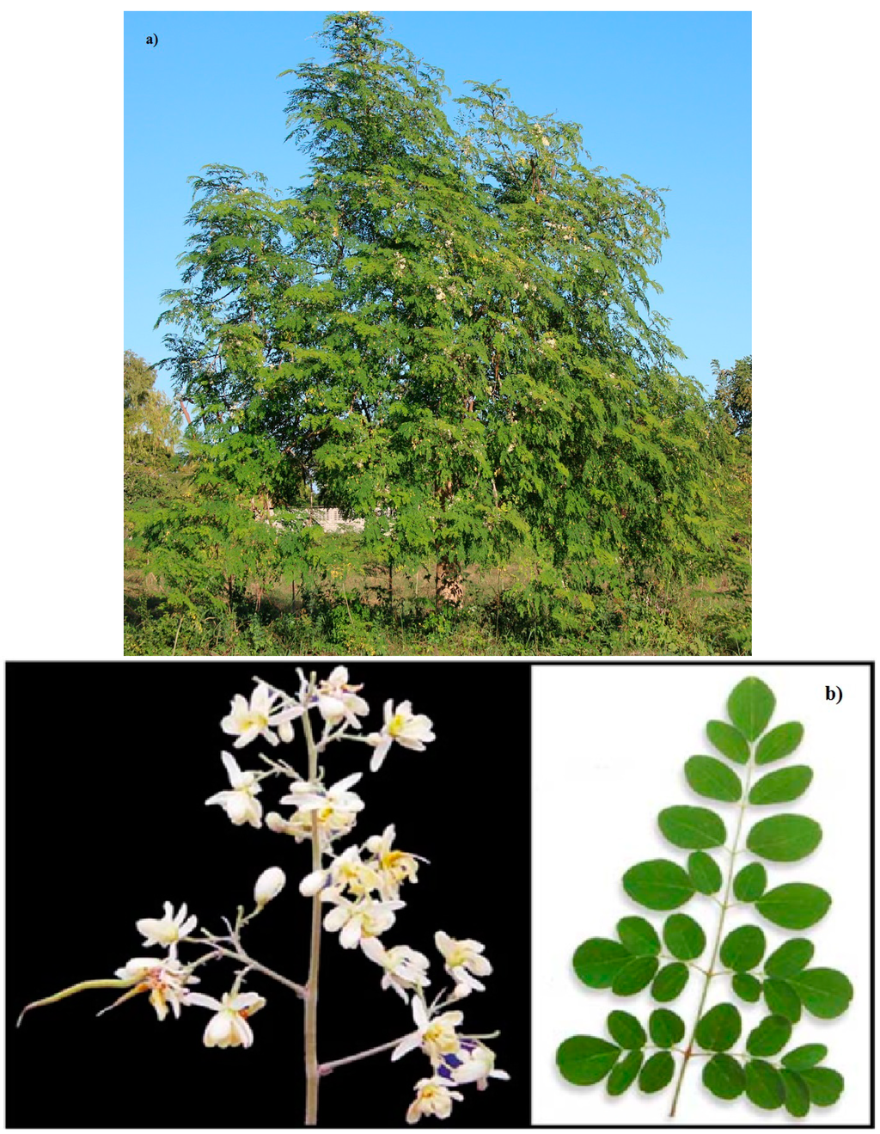

**Figure (5)** Moringa oleifera tree, flower and leaves.**( Leone et al.,2015).**

The evaluation of different plant products according to their traditional uses and medicinal value depending on their therapeutic efficacy leads to the discovery of newer and recent drugs for treating many diseases. This fact makes various plant sources may be used as templates for the development of new drugs by the pharmaceutical industry. **(Lahlou , 2013).**

**Neutrional value of Moringa oleifera:**

Vital minerals are present in the Moringa oleifera including iron, potassium, calcium, copper, zinc, magnesium, manganese , vitamins A and D, essential amino acids, as well as such known antioxidants such as β-carotene, vitamin C, and flavonoids.**( Paikra, 2017).**

MO is rich in nutrition due to the presence of a many essential phytochemicals present in its leaves, pods and seeds. In fact, Moringa is said to provide 7 times more vitamin C than oranges, 10 times more vitamin A than carrots, 17 times more calcium than milk, 9 times more protein than yoghurt, 15 times more potassium than bananas and 25 times more iron than spinach. **( Dixit et al.,2018).**

The seeds of MO have a very high amount of fat with a high energy value. So can be used to combat malnutrition and to assure nutritional security. The seed oil of Moringa is a rich source of oleic acid, tocopherols and sterols. Incorporation of the seed oil would enhance the nutritional value and thus enhance the food. **(Chhikara et al.,2020).**

**Phytochemistry:**

Moringa olifera contain various phytoconstituents such as flavonoids, glucosinolates, phenolic acids, terpenes, alkaloids, steroids, tannins, saponins, and these phytochemicals contributes to its numerous pharmacological uses.**( Abd Rani et al.,2018).**

The Moringa genus has high antioxidant activity mainly due to its high content of flavonoids. **(Wang et al., 2017).**

Moringa contain abundant glucosinolates. Disruption of plant tissues usually from cutting or chewing caused the release of myrosinase which is group of enzymes catalyze hydrolysis of glucosinolate Producing isothiocyanates. Recently, isothiocyanates are known with various biological activities such as their anticancer, antidiabetic, antimicrobial, and anti-inflammatory effect. **( Maldini et al .,2014).**

Phenolic compounds are extracted from Moringa olifera especially seeds which is agood source of antioxidants and antibacterial effects. **(Singh et al., 2013).**

High amount of carotenoids, tocopherol, ascorbic acid and antioxidant potential were recorded in fresh leaves of M. oleifera whcich has good nutrients and antioxidant activity.**( Saini et al., 2014).**

Alkaloids are a group of chemical compounds, which contain mostly basic nitrogen atoms, It has cardio-protective potential and possibly the beneficial action is mediated through its free radical scavenging property.**( Panda et al.,2013).**

A sterol glycoside, namely β-sitosterol-3-O-β-D-galactopyranoside, was isolated from a chloroform extract of M. oleifera stem bark and seeds it has anti-asthmatic actions that may be mediated by inhibiting the cellular responses and subsequent release/synthesis of Th2 cytokines.**(Rajanandh & Kavitha,2010).**

Tannins are water-soluble phenolic compounds Tannins have been reported to have anti-cancer, antiatherosclerotic, anti-inflammatory and anti-hepatoxic properties.**( Adedapo et al.,2015).**

MO leaves are also a good source of saponins **(Sharma& Paliwal , 2013).** Saponins have anti-cancer properties. **(Tian et al.,2013).**

**Others:**

The seeds and seed oil contain a high amount of oleic (70–80%), palmitoleic (6‐10%), stearic (4–10%), arachidic (2–4%), and low amount of linoleic and linolenic acids. **( Amaglo et al.,2010).**

**Moringa oleifera seeds extract value:**

Moringa oleifera seeds contain high amount of antioxidant compounds such as phenolics and flavonoids are important indicators of antioxidant capacity of M. oleifera seeds. **(Singh et al., 2013).**

polyphenol content in MO seeds are well known to have antioxidative power and effective scavenging of free radicals .Those phyto-constituents serve in plant defense mechanisms to counteract reactive Reactive Oxygen Species in order to survive, prevent molecular damage in humans and other organisms.**( Mohammed& Manan , 2015).**

MO seed extract exerts bactericidal activity against Gram-positive and Gram-negative bacteria. **( Lürling& Beekman., 2010).**

Antimicrobial activity is also related to the presence of a short cationic protein. This protein, known as the MO cationic protein, that cause bacterial cell damage through rapid flocculation and the fusion of inner and outer membranes of the cell.**( Dasgupta et al.,2016).**

The seeds are roasted and mixed with coconut oil and used for their antibiotic and anti-inflammatory properties to treat arthritis, rheumatism, gout, cramp, sexually transmitted diseases and boils. Roasted seeds and oil can encourage urination and can be used as a relaxant for epilepsy. **( Abbas& El-Badawi, 2014).**

Seed extract of Moringa has a suppressive effect on macrophages and neutrophils and inhibits phagocytosis, so it can be considered as an immune-modulator and/or immune-suppressive. **(Mahajan & Mehta, 2010).**

Seed extract suppresses prostaglandin biosynthesis through an inhibitory effect on COX-I and COX-II enzymes, and suppresses leukotriene biosynthesis; also it was effective in blocking production of several cytokines including TNF-α, IL-4, and IL-6. It is probable that additional mechanisms such as mast cells stabilization. **( Minaiyan et al.,2014).**

Recent studies observe a cytotoxic effect of MO oil in several cancer cell lines due to Many bioactive compounds isolated from MO seeds have been found to be potential antitumor action.**( Elsayed et al.,2015).**

MO seeds also has hepatoprotective, anti-inflammatory and anti-fibrotic properties against liver damage and fibrosis. Lowering serum levels of Aspartate aminotransferase (AST) and Alanine Aminotransferase (ALT) and higher serum albumin levels, indicating better liver synthesis function, lower hepatic infiltration of inflammatory cells, Anti-fibrotic activity also appears to be associated with the antioxidant properties of MO seed extract. **(Hamza, 2010)**

Other studies report that the ability of Moringa seed extract to improve the chronic immune-mediated inflammatory responses of bronchial asthma. Treatment with Moringa seeds extract has been found to decrease broncho-alveolar inflammation by decreasing the infiltration of inflammatory cells into the bronchi and reducing the secretion of inflammatory mediators into the airways.**( Mahajan** **et al.,2007).**

Also, treatment with the extract of MO seeds was found to reduce the paw edema volume, the serum levels of inflammatory mediators and to protect against lymphocytic infiltration, bone destruction and cartilage erosion in the synovial joint, subsequent to the development of arthritis in rats. **(Leone** **et al., 2016).**

MO seed also reduce nocturnal heart rate and improve cardiac diastolic function, also, a significant reduction in fibrosis in the left ventricle was also observed. This is associated with an increased expression of the nuclear receptors, PPARα and PPARδ. **(Randriamboavonjy et al., 2016).**

MO seeds extract has also been found to have antidiabetic properties. **( Al-Malki & El-Rabey, 2015).**

**Moringa oleifera leaves value:**

MO leaves contain phytosterols as β-sitosterol which can reduce intestinal uptake of dietary cholesterol that may decrease plasma cholesterol and the increase of fecal cholesterol.**( Lin et al .,2010).**

The leaf extracts from MO has strong anti-proliferation and potent induction of apoptosis. So, it indicates that MO leaf extracts has potential for cancer chemoprevention and can be used as a therapeutic target for cancer. **( Sreelatha et al.,2011).**

Flavonoids act as insulin secretagogues or insulin mimetics, other studies revealed MO may be responsible for the stimulation of glucose uptake in peripheral tissues and regulation of the activity and expression of the enzymes involved in carbohydrate metabolism. **(Gupta et al., 2012).**

MO leaves is useful as a natural product against hypertension. The antihypertensive effect of MO leaves may be mediated by inhibiting vascular dysfunction and oxidative stress and promoting endothelium-dependent vasorelaxation. **(Aekthammarat et al.,2019).**

MO leaves also used in diarrhea, the action might be via anti-secretory action. Alcoholic extract of MO contains pharmacologically active phyto molecules with potential anti-diarrheal properties and can be used as non-specific anti-diarrheal agent.**( Misra et al.,2014).**

The leaves of MO are rich in minerals (such as iron and calcium), vitamins (such as Vit. A, B and C), and proteins (as methionine, cysteine, and essential sulfur amino acid). **(Ahmed et al., 2020).**

The leaf extract has anti-inflammatory, antihypertensive, hypolipidemic, hepatoprotective and antimicrobial activities. **(Sikder et al.,2013).**

**Moringa flowers value:**  flower juice improves the quality and flow of milk in lactating mothers**. )Agbogidi& Ilondu., 2012).**

Moringa Flower contains pterogospermin, an antibiotic that is highly effective in the treatment of cholera.**( Aliyu et al.,2016).**

The flowers have the ability to cure muscle diseases, inflammations and also decrease cholesterol phospholipid and triglyceride.**( Sachan et al.,2011).**

**Moringa fruits value:**

The fruits are rich in minerals, protein, thiamine, riboflavin, vitamin A and C.**( Aliyu** **et al.,2016).**

MO fruits have antihypertensive property which is due to the presence of thiocarbamate and isothiocyanate glycoside present in it. **(Kumar et al.,2010).**

MO fruits have the ability to reduce the serum cholesterol, phospholipid, triglycerides, low density lipoprotein (LDL), very low density lipoprotein (VLDL),and cholesterol- phospholipid ratio. The fruits also has the ability to increase the fecal cholesterol .**( Dubey et al.,2013).**

**Medical uses of Moringa Olifera:**

1. **Antiviral action:**

It showed significant activities against viruses like human immunodeficiency virus (HIV), Herpes simplex viruses (HSV), hepatitis B virus (HBV) and Epstein-Barr virus (EBV). **(Biswas et al.,2019).**

It is suggested that enhanced nutrition that which can be achieved via Moringa due to its high nutritional value could benefit a person with Acquired immunodeficiency syndrome (AIDS), as its high content of vitamins and minerals enhance immunity. **( Monera & Maponga, 2012).**

1. **Anti-bacterial action:**

It has anti-bacterial action on the pathogenic Gram-negative and Gram-positive bacteria, affecting membrane permeability and integrity. **(Coriolano et al., 2020).**

Ethyl acetate and acetone extracts showed maximum antibacterial activity against Escherichia coli, Staphylococcus aureus, Salmonella gallinarum and Pseudomonas aeruginosa.**( Dewangan et al.,2010).**

These antimicrobial actions are due to activities of bioactive compounds depending on interactions between their lipid components with the net surface charge of microbial membranes. **(Priadarshini et al., 2013).**

1. **Anti-fungal action:**

Essential oil of M. oleifera showed different degrees of antifungal activity. **(Marrufo et al., 2013).**

1. **Anticancer Activity:**

All parts of the M. oleifera tree have been tested for anticancer activity were highly cytotoxic to cancerous cells but not to normal cells. **(Khor et al., 2018).**

MO leaves inhibit cancer cell growth as It targeted the cell cycle resulting in cell sustained at sub-G1 phase. Also, MO leaves down-regulated the nuclear factor kappa B (NFκB pathway), Glucosinolates present in MO is effective against cancer and induce apoptosis. **(Tiloke et al., 2018).**

1. **Cardioprotective Activity:**

Moringa also has cardio protective effect. The leaves extract have cardio protective effect which may be due to its antioxidant antiperoxidative and myocardial preservative effect. **(Kumar, 2017**).

1. **Central Nervous System(CNS) Activity:**

MO is known to act on the CNS and cause an anti-convulsant action. Such activity is due to its action on a central mechanism, which is releasing of γ-amino butyric acid (GABA). Therefore, it has been used traditionally for the treatment of epilepsy. **(Bakre et al.,2013).**

MO has protective effects against degenerative and chronic neuronal diseases like Alzheimer’s disease. It has enhanced effects on memory as it works on the neurons in the hippocampus . It also has an induction effect on differentiation of myeloid cells and photoreceptors and promotes the development of neurons in the hippocampus.**( Al-Abri et al., 2018).**

MO extract potentiate morphine and pethidine-induced analgesia, The methanolic extract of the root prolong sleeping time. Also the seeds of MO have also been reported to have antipyretic effect **(Njan et al., 2014).**

MO has antidepressant activity alone and also when combined administration with low doses of fluoxetine or other SSRI drugs seems to have good synergic effect. **(Kaur et al., 2015).**

1. **Antiinflammatory, Antiasthmatic, Antiarthritic Activities:**

The protective effect of MO extracts against protein denaturation is similar to the effect of NSAIDs which exert significant anti-inflammatory effect in arthritis. Anti-arthritic activity of MO may be due to the scavenging of free radicals, inhibition of protein denaturation, membrane stabilization and anti-trypsin activity. **( Saleem et al.,2020).**

Methanolic extract of MO leaf has beneficial effects against bronchoconstriction, airway inflammation and asthma. **(Suresh et al., 2020).**

1. **Anti-hyperlipidemia, Anti hypercholesterolemic Activities:**

MO extract shows significant anticholesteremic and antilipidemic action. **(Lakhne et al., 2015).**

MO extract inhibited lipid synthesis by down regulating HMG-CoAR, PPARα1, and PPARγ gene expression, which reduced lipid metabolism. **(Sangkitikomol et al., 2014).**

1. **moringa and obesity:**

Moringa tea helps to get loss of the body weight in a healthy way. **( Khanna et al.,2015).**

The anti-obesity, anti-atherogenic and anti-diabetic properties of MO are due to its working directly on the adipokines of the visceral adipose tissue. Therefore, MO may be a good therapeutic candidate for the symptoms of metabolic syndrome.**( Metwally et al.,2017).**

The activity of HMG-Co-A reductase is significantly depressed by the ethanolic extract of MO; Also, MO could prevent the oxidization of LDL-C with consequent increase in HDL-C level. **(Ahmed et al., 2014).**

1. **Wound Healing Activity:**

MO leaves was effective in promoting and accelerating wound healing process in normal human dermal fibroblast (HDF-N) by increasing its proliferation and migration . **(Gothai et al., 2016).**

1. **Antiulcerogenic Activity:**

The antiulcerogenic effect of moringa is attributed to its ability to decrease gastric motility and acid secretion; also it has the gastro-protective effects of its phytocomponents. **(Ibrahim et al., 2019).**

MO leaf extract also had antimicrobial effect on the *H. pylori* isolated from ulcer patients. **(Bakare & Onifade, 2019).**

1. **Spasmolytic activity:**

The roots and the ethanol extract of the leaves have an antispasmodic action, through the blocking of calcium channels. **(Suresh et al., 2020).**

1. **Anti-oxidant Effect:**

Antioxidant studies on Moringa and found that it has antioxidant activity and this may be due to beta-carotene,vitamin A and C, glucosinolates, thiocarbamates, isothiocyanates, and flavonoids .Moringa extract exhibits antioxidant activity against free radical, nitric oxide, superoxide radical and inhibits of lipid peroxidation.**( Sultana et al., 2018).**

1. **Hepatoprotective Activity:**

MO hepatoprotective activity due to antioxidant and free radical scavenging property, also it maintain the stabilizing ability of the cell membrane preventing enzyme leakages so significant decrease in ALT, alkaline phosphatase (ALP), and AST levels.**( Toppo et al.,2015).**

1. **Antidiabetic Activity:**

It is proved that the histopathological damage of islet cells is decreased by using MO leaves extract. **(Yassa & Tohamy, 2014).**

MO also improves liver function and its uptake of glucose and utilization considered another mechanism of action of the Moringa Oleifera extract. **(Sunilkumar , 2011).**

1. **Antiurolithiatic Activity:**

The root bark of MO has an antiurolithiatic agent as it significantly lower the urinary excretion and kidney retention of oxalate, calcium and phosphate. So reduction of stone forming constituents in urine and their decreased kidney retention. **(Shelke et al., 2014).**

1. **Coagulant Activity:**

MO used in traditional medicine as an anticoagulant. This is due to the involvement/presence of thrombin and plasmin like enzymes. **(Satish et al.,2012).**

1. **Hypotensive Activity:**

The studies show that MO extracts are effective in the inhibition of two major pathways in hypertension by ACE inhibition and NO synthesis. The results support that MO extracts can be developed as a potential anti-hypertensive product. **(Acuram, & Hernandez, 2019)**

1. **Antifertility Activity:**

MO leaves including flavonoids, glucosinolates anthocyanins and cinnamates all of which are effective agents in plants used for abortion, also these compounds may be acting alone or in synergism with each other to reduce FSH, LH and estrogen concentrations lead to impairment of the growth and maturation of ovarian follicle. **( Ajuogu et al.,2019).**

On the other hand MO ingestion produces increased effects on fertility and reproductive system in adult male. As it significantly increased the semen volume, sperm count, and motility. this support the claims for traditional usage of M. oleifera as a sexual function enhancing medicine. **(Zade et al.,2013).**

1. **Immunomodulatory Activity:**

The aquoeus extract of MO leaf has activity as immunomodulator through its active compound, such as saponin and flavonoid. **(Rachmawati& Rifa’I , 2014).**

1. **Regulation of Hyperthyroidism:**

MO leaf extract used in treatment decreased serum T3 concentration and increased in serum T4 concentration .it may due to the inhibitory activity of MO extract in the peripheral conversion of T4 to T3.**( Med, 2017).**

**Traditional Uses:**

All plant parts of Moringa oleifera are traditionally used for different purposes, but leaves are generally the most used, they are used in human and animal nutrition and in the traditional medicine.**( Konmy et al.,2016).**

Traditionally, the plant is used as antispasmodic, expectorant ,. fresh root is used as antipyretic. Bark is used as abortifacient. **(Manoj , 2012).**

Decoction is used as a gargle in hoarseness and sore throat. Leaf juice is used in hiccough (emetic in high doses); cooked leaves are given in influenza and catarrhal affections. **(Thorat& Rangari, 2018).**

In developing nations, MO is used as an alternative to food supplements to treat and combat malnutrition, especially among infants and nursing mothers. **(Dhakar et al., 2011).**

Leaves rubbed against the temple can relieve headaches, apply a poultice of fresh leaves to stop bleeding from a shallow cut. **(Chauhan& Pandey , 2014).**

Moringa Gum exudate used to relieve headaches, ear aches, dental carriers and rubefacient (skin tonic).**( Suryadevara** **et al.,2020).**

**Aim of the work:**

The aim of the present study is to evaluate the effect of methotrexate, fluoxetine and Moringa oleifera on certain laboratory markers of rheumatoid arthritis. The markers include:

* Serum rheumatoid factor (RF).
* Serum tumor necrosis factor alpha (TNF-α).
* Serum C-reactive protein (CRP).
* Serum reduced glutathione (GSH).
* Serum anti-cyclic citrullinated peptide (anti-CCP).

Also, the development of arthritis was monitored using a scoring system ranging from 0 - 4 (arthritis score).

At the end of the study, rats were euthanized and hind paws were removed. They were embedded in paraffin after fixing in formalin solution (10% neutral buffered) for histopathological examination.

**Materials and Method**

* **Materials:**

1. **Animals:**

**Rats:** 30 Adult male albino rats (brought from Experimental Animal Breeding Farm, Helwan-Cairo) weighing between 150-200 g (at the beginning of the study), were used for in-vivo experiments. They were acclimatized for one week and were caged (6 rat/ cage) in fully ventilated room at room temperature in the pharmacology department, Benha Faculty of Medicine. Rats were fed a standard chow with water.

1. **Chemicals and Drugs:**
2. Compelete freund's adjuvant (vial) (Sigma-Aldrich Co-USA).
3. Saline (EL-Gomhouria Co., Egypt).
4. Methotrexate (powder) (Minapharm., Egypt).
5. fluoxitine (powder) (Amoun pharmaceutical Co, Egypt).
6. Moringa olifera (powder) (National Research Centre, Giza, Egypt).
7. Rheumatoid factor kits (Abnova corporation, Taipei city ,Taiwan).
8. Tumor necrosis factor alpha (TNF-α) kits (USA & Canada, R&D Systems, Inc).
9. CRP kits (Thermoscientific, USA).
10. Reduced Glutathione kits (CLOUD-CLONE CORP, USA)
11. anticyclic citrullinated peptide (anti-CCP)kits (Alpha diagnostic international,Texas,USA)
12. Formalin, solution, neutral 10% formaline (El Gomhoria Pharmaceutical Chemical Co., ARE).
13. Urethane (Ethyl carbamat, white crystals) (Sigma Chemical Co., USA).
14. Hematoxylin and eosin (E. Merk, Darmastadt.,) [Germany].

* Methotrexate was dissolved in distilled water**. *(Faisal et al., 2018)*.**
* fluoxitine was dissolved in distilled water. **(Cai et al.,2019).**
* Moringa olifera seed powder was dissolved in distilled water. **(Elbakry et al.,2019).**
* Urethane was dissolved in saline ***(Tamaddonfard et al., 2012)***.
* **Methods:**

This work was designed to evaluate the effect of Moringa oleifera, fluoxetine and methotrexate in a rat model of rheumatoid arthritis. It included:

**Induction of rheumatoid arthritis in rats**:

Complete freund's adjuvant arthritis was induced by S. C injection of 0. 4 ml of complete freund's adjuvant (CFA) in the right hind limb for 12 days in three doses (one dose every four days) ***(Hendawy et al., 2015).***

**Preparation of Moringa oleifera seed extract:**

M. oleifera seeds were crushed into powder 5 g of the sample was soaked in 20 ml of methanol and kept in a rotary shaker for about 12 h at 30°C. After that was filtered with Whatman No.1 filter paper. The filtrate was concentrated in a rotary evaporator until a sticky mass was obtained. The resultant M. oleifera seed methanolic extract was then dissolved in distilled water and stored at 4°C till use. ( **Elbakry et al.,2019).**

**Experimental design:**

**Animal groups:**

**Group (1): Non-arthritic untreated normal control group :**

This group received a standard chow and tap water with no medication.

**Group (2): Untreated rats with complete freund's adjuvant arthritis group:**

This group was injected with complete freund's adjuvant to induce rheumatoid arthritis.

**Group (3): Rheumatoid arthritis (RA) methotrexate treated group:**

This group received a standard chow and tap water with methotrexate at a dose (0. 6 mg/kg/week/by oral gavage) (***Rovenský et al., 2006)*** for 4 weeks after induction of arthritis with CFA.

**Group (4): Rheumatoid arthritis (RA) rats, fluoxetine treated group:**

This group treated with fluoxetine (20 mg/kg/day in saline by oral gavage) **(**[**Branco‐de‐Almeida**](https://aap.onlinelibrary.wiley.com/action/doSearch?ContribAuthorStored=Branco-de-Almeida%2C+Luciana+S) **e*t al., 2012)*** for four weeks after after induction of arthritis with CFA**.**

**Group (5): Rheumatoid arthritis (RA) rats, Moringa oleifera treated group:** This group treated with (200 mg/kg/day by oral gavage of methanolic extract of M. oleifera) **(Mahajan et al., 2008)** for four weeks after induction of arthritis with CFA**.**

**Parameters that will be estimated in this study**:

1. Measurement of serum rheumatoid factor (RF).
2. Measurement of serum tumor necrosis factor alpha (TNF-α).
3. Measurement of serum C-reactive protein (CRP).
4. Measurement of serum reduced glutathione (GSH).
5. Measurement of Serum anti-cyclic citrullinated peptide (anti-CCP).
6. The development of arthritis was monitored using a scoring system ranging from 0 - 4 (arthritis score).
7. At the end of the study, rats were euthanized and hind paws were removed. They were embedded in paraffin after fixing in formalin solution (10% neutral buffered) for histopathological examination.

**Biochemical studies:**

At the end of study period, blood samples were collected from the retro-orbital venous plexus of rats using microcapillary tubes ***(Schemer, 1967)***.

The blood was collected in clean dry glass centrifuge tubes and centrifuged at 3700 rotation/minute at room temperature. The serum was separated, frozen and stored at -20 Ć for measurement of RF, TNF-α , CRP , GSH and anti-CCP.

**Measurement of serum RF:**

RF was determined by ELISA technique **(Engvall and Perlman,1971).**

**Principle of assay:**

The Rheumatoid Factor IgG ELISA Kit is based on the principle of the enzyme immunoassay (EIA). Goat IgG is bound on the surface of the microtiter strips. Diluted patient serum, ready-to-use standards and controls are pipetted into the wells of the microtiter plate. A binding between the RF IgG of the serum and the immobilized goat IgG takes place. After a one hour incubation at room temperature, the plate is rinsed with diluted wash solution, in order to remove unbound material. Then ready-to-use anti-human-IgG peroxidase conjugate is added and incubated for 30 minutes. After a further washing step, the substrate (TMB) solution is pipette and incubated for 20 minutes, inducing the development of a blue dye in the wells. The color development is terminated by the addition of a stop solution, which changes the color from blue to yellow. The resulting dye is measured spectrophotometrically at the wavelength of 450 nm. The concentration of the RF IgG is directly proportional to the intensity of the color.

**Measurement of serum TNF-** α **level:**

By enzyme linked immunosorbent assay technique, using Quantikine TNF-α Immunoassay (USA & Canada, R&D Systems, Inc). **(Kasumagic-Halilovic et al., 2011)**.

**Principle of the assay:**

1. Add 100 μL of sample or standards in Reagent Diluent, or an appropriate diluent, per well. Cover with an adhesive strip and incubate 2 hours at room temperature.
2. Repeat the aspiration/wash as in step 2 of Plate Preparation.
3. Add 100 μL of the Detection Antibody, diluted in Reagent Diluent, to each well. Cover with a new adhesive strip and incubate 2 hours at room temperature.
4. Repeat the aspiration/wash as in step 2 of Plate Preparation.
5. Add 100 μL of the working dilution of Streptavidin-HRP B to each well. Cover the plate and incubate for 20 minutes at room temperature. Avoid placing the plate in direct light.
6. Repeat the aspiration/wash as in step 2.
7. Add 100 μL of Substrate Solution to each well. Incubate for 20 minutes at room temperature. Avoid placing the plate in direct light.
8. Add 50 μL of Stop Solution to each well. Gently tap the plate to ensure thorough mixing.
9. Determine the optical density of each well immediately, using a microplate reader set to 450 nm. If wavelength correction is available, set to 540 nm or 570 nm. If wavelength correction is not available, subtract readings at 540 nm or 570 nm from the readings at 450 nm. This subtraction will correct for optical imperfections in the plate. Readings made directly at 450 nm without correction may be higher and less accurate.

**Measurement of serum CRP:**

CRP was determined using an enzyme-linked immunosorbent assay as described by Nathan and Scheld **(Nathan and Scheld, 2002*).***

**Principle of the assay:**

1. Bring all reagents and samples to room temperature (18 - 25ºC) before use. It is recommended that all standards and samples be run at least in duplicate.
2. Add 100µL of each standard (see Reagent Preparation step 3) and sample into appropriate wells. Cover wells and incubate for 2.5 hours at room temperature or overnight at 4ºC with gentle shaking.
3. Discard the solution and wash 4 times with 1X Wash Buffer. Wash by filling each well with Wash Buffer (300µL) using a multi-channel Pipette or auto washer. Complete removal of liquid at each step is essential for good performance. After the last wash, remove any remaining Wash Buffer by aspirating or decanting. Invert the plate and blot it against clean paper towels.
4. Add 100µL of 1X prepared biotinylated antibody (Reagent Preparation step 6) to each well. Incubate for 1 hour at room temperature with gentle shaking.
5. Discard the solution. Repeat the wash as in step 3.
6. Add 100µL of prepared Streptavidin-HRP solution (see Reagent Preparation step 7) to each well. Incubate for 45 minutes at room temperature with gentle shaking.
7. Discard the solution. Repeat the wash as in step 3.
8. Add 100µL of TMB Substrate to each well. Incubate for 30 minutes at room temperature in the dark with gentle shaking.
9. The plate must be evaluated within 30 minutes of stopping the reaction. Measure absorbance on an ELISA plate reader set at 450nm and 550nm. Subtract 550nm values from at 450nm values to correct for optical imperfections in the microplate. If 550nm is not available, measure absorbance at 450nm only. Omitting the 550nm measurement will result in higher absorbance values.
10. Calculation of Results: Generate the standard curve by plotting the average absorbance (450nm minus 550nm) obtained for each Standard concentration on the vertical (Y) axis vs. the corresponding C-reactive protein concentration on the horizontal (X) axis. Calculate results manually using graph paper or with a curve-fitting statistical software package. If using curvefitting software, plot a four-parameter logistic curve fit. Alternatively, a point-to-point curve fit may be used. Determine the amount of C-reactive protein in each sample by interpolating from the C-reactive protein concentration (X axis) to the absorbance value (Y axis). If the sample was diluted, multiply the interpolated value obtained by the dilution factor to determine amount of Creactive protein in the sample. Absorbance values obtained for duplicates should be within 10% of the mean value. Carefully consider duplicate values that differ from the mean by greater than 10%.

**Measurement of serum GSH level:** GSH was determined using a colorimetric method as described by ***(Beutler et al., 1963)***

**Principle of assay:**

Serum reduced glutathione was performed on samples by colorimetric methods based on the reduction of 5,5 dithiobis (2- nitrobenzoic acid) (DTNB) with glutathione (GSH) to produce a yellow compound. The chromogen directly proportional to GSH concentration and its absorbance can be measured at 405 nm.

**Measurement of serum anti-CCP** **level:** anti-cyclic citrullinated peptide (anti-CCP) was determined using an enzyme-linked immunosorbent assay.**(Avčin** **et al.,2002).**

**Principle of assay:**

Anti-CCP IgG ELISA kit is based on binding of anti- CCP IgG from serum samples to highly purified CCP-peptide antigen immobilized on microtiter wells. After a washing step, goat anti-human IgG-HRP conjugate is added. After another washing step, to remove all the unbound enzyme conjugate, chromogenic substrate (TMB) is added and color developed. The enzymatic reaction (color) is directly proportional to the amount of anti-CCP IgG present in the sample. Adding stopping solution terminates the reaction. Absorbance is then measured on a microtiter well ELISA reader at 550 nm and the concentration of anti- CCP IgG in samples is calculated using the reference standard curve.

**Arthritis score:**

The progression of adjuvant arthritis was evaluated for the characteristic signs and symptoms, using arthritis score (***Yamagishi et al., 2012)****.*

A score of 0–4 helped distinguish the different disease stages with a maximum value of 8 for each rat. Scores was attributed according to the parameters such as edema, erythema, malformation and incapacity to use the limb ***(Foyet et al., 2015).***

The following scoring system will be used ***(Sachin et al., 2013***):

* No change = 0
* erythema = 1
* Mild swelling = 2
* Gross swelling = 3
* Gross swelling and deformity = 4

Rats were scored for arthritis (arthritis index) by a set visual criterion at the end of 3 doses of CFA and at the end of each week of experiment. (***Yamagishi et al., 2012***; ***Sachin et al., 2013***).

**Histopathological changes:**

Rats were euthanized at the end of the study and hind paws were removed. They were embedded in paraffin after fixing in formalin solution (10% neutral buffered). Sections were cut in various slices having thickness of 6 um and examined under microscope after staining with hematoxylin-eosin for perivascular inflammatory cell infiltrate in synovium, morphological changes including synovial cell hyperplasia and proliferation, villous hyperplasia, inflammatory cells infilterations and dilated blood vessels. ***(Faisal et al., 2018).***

**Results**

**Data management**

The clinical data were recorded on a report form. These data were tabulated and analysed using the computer program SPSS (Statistical package for social science) version 26 to obtain:

**Descriptive data**

Descriptive statistics were calculated for the data in the form of mean and standard deviation for quantitative data.

**Analytical statistics**

In the statistical comparison between the different groups, the significance of difference was tested using ANOVA test

ANOVA test:-Used to compare mean of more than two groups of quantitative data.

A *P* value <0.05 was considered statistically significant (*) while >0.05 statistically insignificant P value <0.01 was considered highly significant (**) in all analyses.

**Rheumatoid factor:**

The obtained results revealed a high significant (P≤0.001) increase in the serum concentration of rheumatoid factor in diseased group (G2) as compared to the normal control group (G1) (Table 1,Table 6 and Fig. 6). This elevated level was significantly decreased following administration of methotrexate (G3), fluoxetine (G4) and Moringa oleifera (G5), with lowest expression in (G5) Moringa oleifera group.However, rheumatoid factor levels of the three treated groups (G3, G4 and G5) remained significantly higher than the control group (G1).

**Table 1. Effect of methotrexate, fluoxetine and moringa oleifera on the serum concentration of RF .**

|  |  |  |
| --- | --- | --- |
| **Group** | **Serum levels** | |
| **Mean** | **±SD** |
| Normal control (G1) | 1.46 | 0.16 |
| Diseased group (G2) | 9.62**a** | 0.70 |
| Methotrexate treated group (G3) | 3.94**ab** | 0.38 |
| Fluoxetine treated group (G4) | 5.14**abc** | 0.23 |
| Moringa oleifera treated group(G5) | 2.91**abcd** | 0.19 |

Data was represented as means±SD.

**a: significant in comparison with G1**

**b: significant in comparison with G2**

**c: significant in comparison with G3**

**d: significant in comparison with G4**

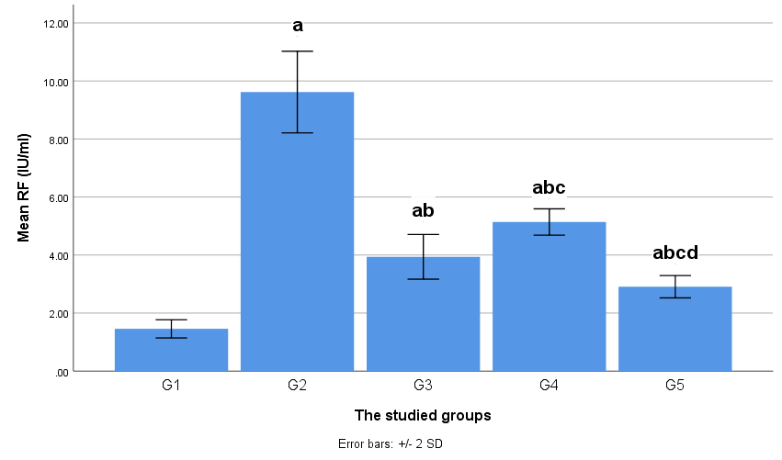

**Figure (6): Histogram showing serum RF in different study groups:**

**a: significant in comparison with G1**

**b: significant in comparison with G2**

**c: significant in comparison with G3**

**d: significant in comparison with G4**

**Tumour necrosis factor-α (TNF-α)**

The obtained results revealed a high significant (P≤0.001) increase in the serum concentration of tumour necrosis factor-α (TNF-α) in diseased group (G2) as compared to the normal control group (G1) (Table 2, Table 6and Fig. 7). This elevated level was significantly decreased following administration of methotrexate (G3), fluoxetine (G4) and moringa oleifera (G5), with lowest expression in (G5) moringa oleifera group.However, tumour necrosis factor-α (TNF-α) levels of the three treated groups (G3, G4 and G5) remained significantly higher than the control group (G1).

**Table 2. Effect of methotrexate, fluoxetine and moringa oleifera on the serum concentration of TNF-α.**

|  |  |  |
| --- | --- | --- |
| **Group** | **Serum levels** | |
| **Mean** | **±SD** |
| Normal control (G1) | 16.67 | 0.50 |
| Diseased group (G2) | 87.53**a** | 0.54 |
| Methotrexate treated group (G3) | 45.84**ab** | 0.78 |
| Fluoxetine treated group (G4) | 38.64**abc** | 0.98 |
| Moringa oleifera treated group(G5) | 29.16**abcd** | 0.64 |

**a: significant in comparison with G1**

**b: significant in comparison with G2**

**c: significant in comparison with G3**

**d: significant in comparison with G4**

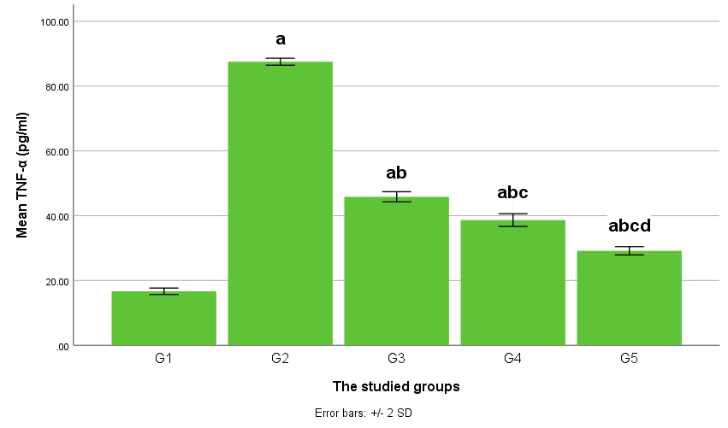

**Figure (7): Histogram showing serum TNF-α in different study groups:**

**a: significant in comparison with G1**

**b: significant in comparison with G2**

**c: significant in comparison with G3**

**d: significant in comparison with G4**

**C-reactive protein (CRP):**

The obtained results revealed a high significant (P≤0.001) increase in the serum concentration of C-reactive protein (CRP) in diseased group (G2) as compared to the normal control group (G1) (Table3,Table 6 and Fig. 8). This elevated level was significantly decreased following administration of methotrexate (G3), fluoxetine (G4) and moringa oleifera (G5), with lowest expression in (G5) moringa oleifera group.However, C-reactive protein (CRP) levels of the three treated groups (G3, G4 and G5) remained significantly higher than the control group (G1).

**Table 3. Effect of methotrexate, fluoxetine and moringa oleifera on the serum concentration of CRP.**

|  |  |  |
| --- | --- | --- |
| **Group** | **Serum levels** | |
| **Mean** | **±SD** |
| Normal control (G1) | 1.64 | 0.11 |
| Diseased group (G2) | 8.63**a** | 0.54 |
| Methotrexate treated group (G3) | 4.74**ab** | 0.76 |
| Fluoxetine treated group (G4) | 5.9**abc** | 0.32 |
| Moringa oleifera treated group(G5) | 3.67**abcd** | 0.38 |

**a: significant in comparison with G1**

**b: significant in comparison with G2**

**c: significant in comparison with G3**

**d: significant in comparison with G4**

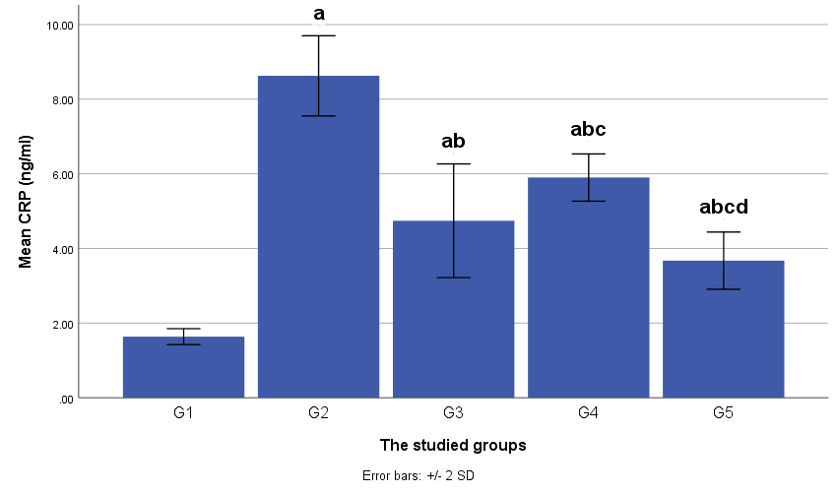

**Figure (8): Histogram showing serum CRP in different study groups:**

**a: significant in comparison with G1**

**b: significant in comparison with G2**

**c: significant in comparison with G3**

**d: significant in comparison with G4**

**Reduced glutathione (GSH):**

The obtained results revealed a high significant (P≤0.001) decrease in the serum concentration of reduced glutathione (GSH)in diseased group (G2) as compared to the normal control group (G1) (Table 4 ,table 6 and Fig. 9). This decreased level was significantly increased following administration of methotrexate (G3), fluoxetine (G4) and moringa oleifera (G5), with highest expression in (G5) moringa oleifera group.However, reduced glutathione (GSH)levels of (G3and G4) remained significantly lower than the control group (G1), while in MO group (G5) reduced glutathione (GSH) levels show significant increase more than normal control group (G1).

**Table 4. Effect of methotrexate, fluoxetine and moringa oleifera on the serum concentration of GSH.**

|  |  |  |
| --- | --- | --- |
| **Group** | **Serum levels** | |
| **Mean** | **±SD** |
| Normal control (G1) | 21.47 | 0.87 |
| Diseased group (G2) | 6.97a | 0.34 |
| Methotrexate treated group (G3) | 11.63ab | 0.66 |
| Fluoxetine treated group (G4) | 14.8abc | 0.76 |
| Moringa oleifera treated group(G5) | 24.15abcd | 1.04 |

**a: significant in comparison with G1**

**b: significant in comparison with G2**

**c: significant in comparison with G3**

**d: significant in comparison with G4**

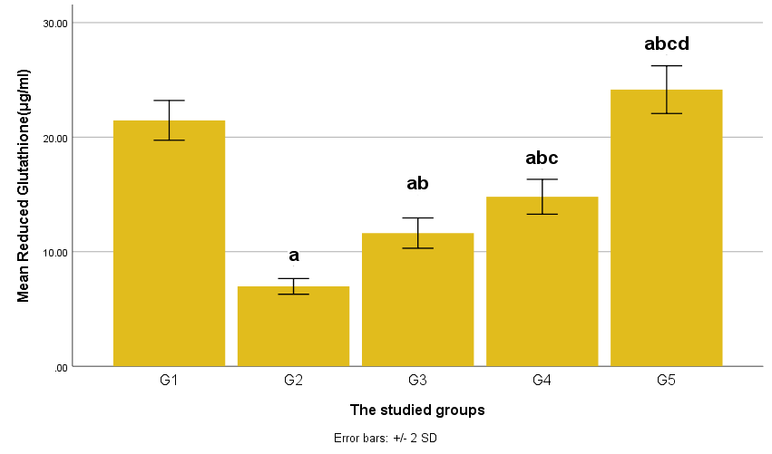

**Figure (9): Histogram showing serum GSH in different study groups:**

**a: significant in comparison with G1**

**b: significant in comparison with G2**

**c: significant in comparison with G3**

**d: significant in comparison with G4**

**Anti-CCP antibodies:**

The obtained results revealed a high significant (P≤0.001) increase in the serum concentration of Anti-CCP antibodies in diseased group (G2) as compared to the normal control group (G1) (Table5,Table 6 and Fig. 10). This elevated level was significantly decreased following administration of methotrexate (G3), fluoxetine (G4) and moringa oleifera (G5), with lowest expression in (G5) moringa oleifera group.However, Anti-CCP antibodies levels of the three treated groups (G3, G4 and G5) remained significantly higher than the control group (G1).

**Table 5. Effect of methotrexate, fluoxetine and moringa oleifera on the serum concentration of anti-CCP:**

|  |  |  |
| --- | --- | --- |
| **Group** | **Serum levels** | |
| **Mean** | **±SD** |
| Normal control (G1) | 3.71 | 1.19 |
| Diseased group (G2) | 29.05a | 0.35 |
| Methotrexate treated group (G3) | 14.3ab | 1.57 |
| Fluoxetine treated group (G4) | 18.85abc | 0.54 |
| Moringa oleifera treated group(G5) | 10.12abcd | 1.04 |

**a: significant in comparison with G1**

**b: significant in comparison with G2**

**c: significant in comparison with G3**

**d: significant in comparison with G4**

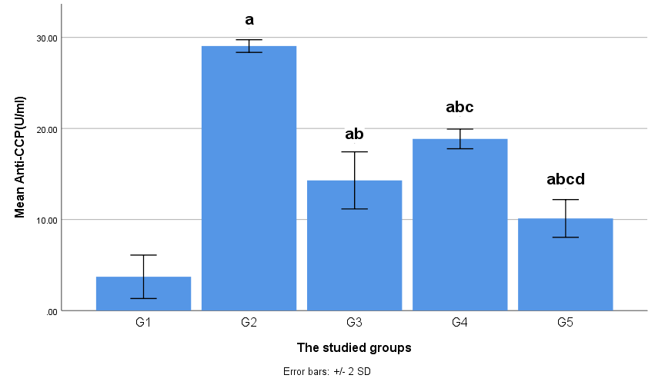

**Figure (10): Histogram showing serum anti-CCP in different study groups:**

**a: significant in comparison with G1**

**b: significant in comparison with G2**

**c: significant in comparison with G3**

**d: significant in comparison with G4**

**Table (6): The effect of methotrexate, Fluoxetine and Moringa Oleifera on serum RF, TNF-α, CRP , GSH and Anti CCP in experimentally induced rheumatoid arthritis in rats:**

|  |  |  |  |  |  |  |  |  |  |  |  |
| --- | --- | --- | --- | --- | --- | --- | --- | --- | --- | --- | --- |
|  | G1 | | G2 | | G3 | | G4 | | G5 | | P value |
| Mean | ±SD | Mean | ±SD | Mean | ±SD | Mean | ±SD | Mean | ±SD |
| **RF**  **(IU/ml)** | 1.46 | 0.16 | 9.62**a** | 0.70 | 3.94  **ab** | 0.38 | 5.14  **abc** | 0.23 | 2.91  **abcd** | 0.19 | <0.001** |
| **CRP**  **(ng/ml)** | 1.64 | 0.11 | 8.63**a** | 0.54 | 4.74  **ab** | 0.76 | 5.9  **abc** | 0.32 | 3.67  **abcd** | 0.38 | <0.001** |
| **TNF-α**  **(pg/ml)** | 16.67 | 0.50 | 87.53**a** | 0.54 | 45.84  **ab** | 0.78 | 38.64  **abc** | 0.98 | 29.16  **abcd** | 0.64 | <0.001** |
| **Reduced Glutathione**  **(μg/ml)** | 21.47 | 0.87 | 6.97**a** | 0.34 | 11.63  **ab** | 0.66 | 14.8  **abc** | 0.76 | 24.15  **abcd** | 1.04 | <0.001** |
| **Anti-CCP**  **(U/ml)** | 3.71 | 1.19 | 29.05**a** | 0.35 | 14.3  **ab** | 1.57 | 18.85  **abc** | 0.54 | 10.12  **abcd** | 1.04 | <0.001** |

**a: significant versus G1 b: significant versus G2**

**c: significant versus G3 d: significant versus G4**

Data expressed as mean ± SD (n=6)

**SD:** standard deviation  **Test used**: ANOVA One Way test

**Normal control group (G1) Diseased group (G2)**

**MTX group (G3) Fluoxetine group (G4)**

**MO group (G5)**

**RF**: Rheumatoid factor  **TNF-α**: Tumor necrosis factor-α

**CRP**: C-reactive protein  **GSH**: Glutathione (reduced)

**Anti CCP:** anti -Cyclic Citrullinated Peptide antibody

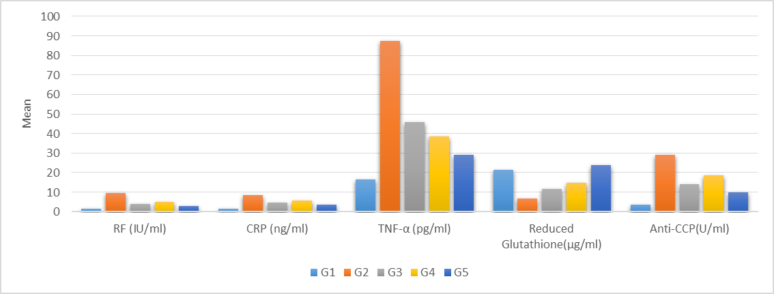

**Figure (11): Histogram showing the effect of methotrexate, Fluoxetine and Moringa Oleifera, on serum RF, TNF-α, CRP , GSH and anti-CCP in different groups:**

Data expressed as mean ± SD (n=6)

**SD:** standard deviation  **Test used**: ANOVA test

Normal control group (G1) Diseased group (G2)

MTX group (G3) Fluoxetine group (G4)

MO group (G5)

The obtained results as presented in (table6, figure11) showed the best results of all parameters in moringa oleifera treated group (G5) it showed significant decrease in serum concentration of serum RF, TNF-α, CRP and anti-CCP than the diseased group (G2) and also than the other treated groups methotrexate (G3) and fluoxetine (G4), However, it remained significantly higher than the control group (G1).also it showed significant increases in GSH level more than diseased group(G2), other treated groups G3&G4 and even more than normal control group.

MTX group (G3) and fluoxetine group(G4) showed significant decrease in serum concentration of serum RF, TNF-α, CRP and anti-CCP than the diseased group (G2) but they are significantly higher than Moringa oleifera group (G5) and normal control group(G1). Also they showed significant increase in GSH level more than diseased group (G2) but significantly less than normal group (G1) and moringa treated group (G5).

**Table (7): Arthritis score in the study groups at different times:**

|  |  |  |  |  |  |  |  |  |  |  |  |
| --- | --- | --- | --- | --- | --- | --- | --- | --- | --- | --- | --- |
|  | G1 | | G2 | | G3 | | G4 | | G5 | | P value |
| Mean | ±SD | Mean | ±SD | Mean | ±SD | Mean | ±SD | Mean | ±SD |
| Arteritis score 0 | 0.0 | 0.0 | 3.0 | 0.0 | 3.0 | 0.0 | 3.0 | 0.0 | 3.0 | 0.0 | - |
| Arteritis score  1st w | 0.0 | 0.0 | 4.0 **a** | 0.0 | 3.33 **ab** | 0.52 | 3.5  **ab** | 0.55 | 3.0  **Ab** | 0.0 | <0.001** |
| Arteritis score 2nd w | 0.0 | 0.0 | 4.0 **a** | 0.0 | 3.0  **ab** | 0.63 | 3.33  **ab** | 0.52 | 2.5  **Abd** | 0.55 | <0.001** |
| Arteritis score 3rd w | 0.0 | 0.0 | 4.0 **a** | 0.0 | 2.83  **ab** | 0.75 | 3.0  **abc** | 0.63 | 2.33  **Abcd** | 0.52 | <0.001** |
| Arteritis score 4th w | 0.0 | 0.0 | 4.0 **a** | 0.0 | 2.10 **ab** | 0.63 | 2.67  **abc** | 0.52 | 1.5  **Abcd** | 0.55 | <0.001** |

**a: significant versus G1 b: significant versus G2**

**c: significant versus G3 d: significant versus G4**

Data expressed as mean ± SD (n=6)

**SD:** standard deviation  **Test used**: ANOVA One Way test

Normal control group (G1) Diseased group (G2)

MTX group (G3) Fluoxetine group (G4)

MO group (G5)

Artheritis score 0: after inuction before the start of treatment .

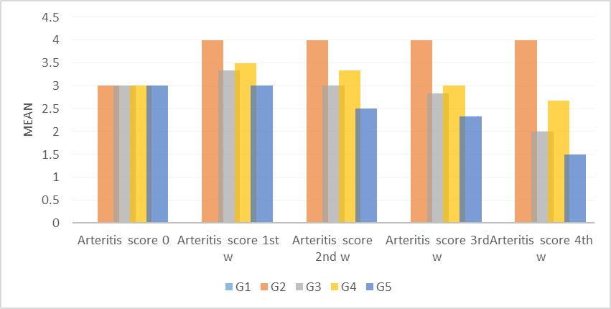

**Figure (12): Histogram showing Arthritis score in different study groups, at different times:**

Data expressed as mean ± SD (n=6)

**SD:** standard deviation  **Test used**: ANOVA One Way test

Normal control group (G1) Diseased group (G2)

MTX group (G3) Fluoxetine group (G4)

MO group (G5)

Artheritis score 0: after inuction before the start of treatment .

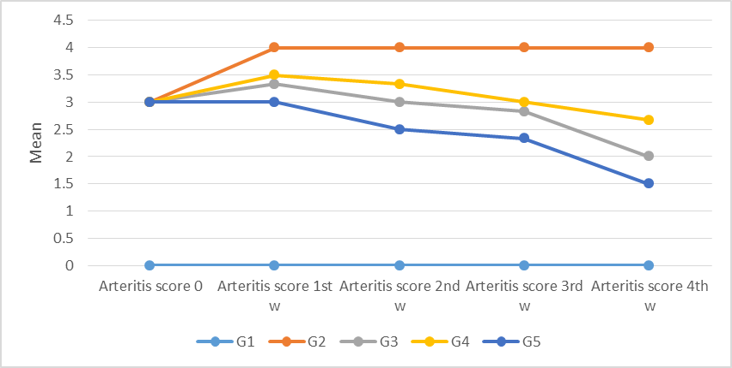

**Figure (13): Line graph showing arthritis score in different study groups, at different times:**

Data expressed as mean ± SD (n=6)

**SD:** standard deviation  **Test used**: ANOVA One Way test

Normal control group (G1) Diseased group (G2)

MTX group (G3) Fluoxetine group (G4)

MO group (G5)

Artheritis score 0: after inuction before the start of treatment .

For arthritis score at the end of 3 doses of adjuvant arthritis (after 12 days from the start of the experiment), there was no significant difference between diseased group (G2), methotrexate group (G3), fluoxetine group (G4) and moringa oleifera group (G5). (Table 7, figure 12, 13).

According to methotrexate group (G3) at the end of the 1st week of the treatment there was significant decrease in methotrexate score more than diseased group (G2), but score still significantly higher than normal control group (G1), also there are no significant change between MTX group and groups of fluoxetine (G4) and moringa (G5). (Table 7, figure 12, 13).

According to fluoxetine group (G4) at the end of the 1st week of the treatment there was significant decrease in fluoxetine score more than diseased group (G2), but score still significantly higher than normal control group (G1), also there are no significant change between fluoxetine group and groups of methotrexate (G3) and moringa (G5). (Table 7, figure 12, 13).

According to moringa oleifera group (G5) at the end of the 1st week of the treatment there was significant decrease in moringa score more than diseased group (G2), but score still significantly higher than normal control group (G1), also there are no significant change between fluoxetine group and groups of methotrexate (G3) and fluoxetine (G4). (Table 7, figure 12, 13).

At the end of the second week of the treatment there was significant decrease in all treated groups score more than diseased group (G2), but score still significantly higher than normal control group (G1), also there are no significant change between MTX group and fluoxetine (G4) .but there was significant decrease in moringa score (G5) more than fluoxetine while no significance between moringa group and MTX group. (Table 7, figure 12, 13).

At the end of the third week of treatment there was significant decrease in all treated groups score more than diseased group (G2), but score still significantly higher than normal control group (G1), also there was significant change between MTX group and fluoxetine (G4) showing that improvement in MTX group score more than fluoxetine group .Also there was significant decrease in moringa score (G5) more than MTX and fluoxetine group. (Table 7, figure 12, 13).

At the end of the fourth week of treatment there was significant decrease in all treated groups score more than diseased group (G2), but score still significantly higher than normal control group (G1), also there was significant change between MTX group and fluoxetine (G4) showing that more improvement in MTX group score .Also there was significant decrease in moringa score (G5) than MTX and fluoxetine group.that showing best improvement in MO group followed by MTX group followed by fluoxetine group (Table 7, figure 12, 13).

From arthritis score (Table 7, figure 12, 13) moringa oleifera group showed best improvement in the arthritis score followed by MTX group then fluoxetine group.

**Histopathological changes:**

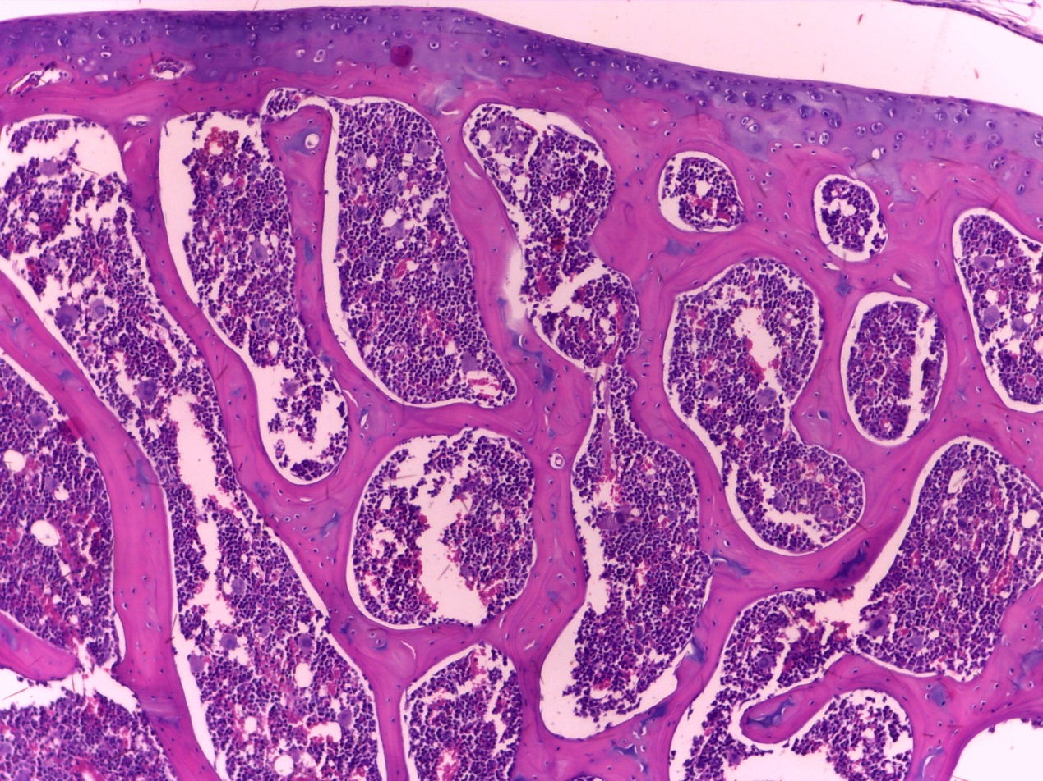

**b**

**a**

**Figure (14):** Photomicrograph of a cut section in normal rat joint shows (black arrow) flattened synovial membrane (a) cartilage associated with (b) bone marrow with no inflammatory cellular infiltrate (H&E x 100).

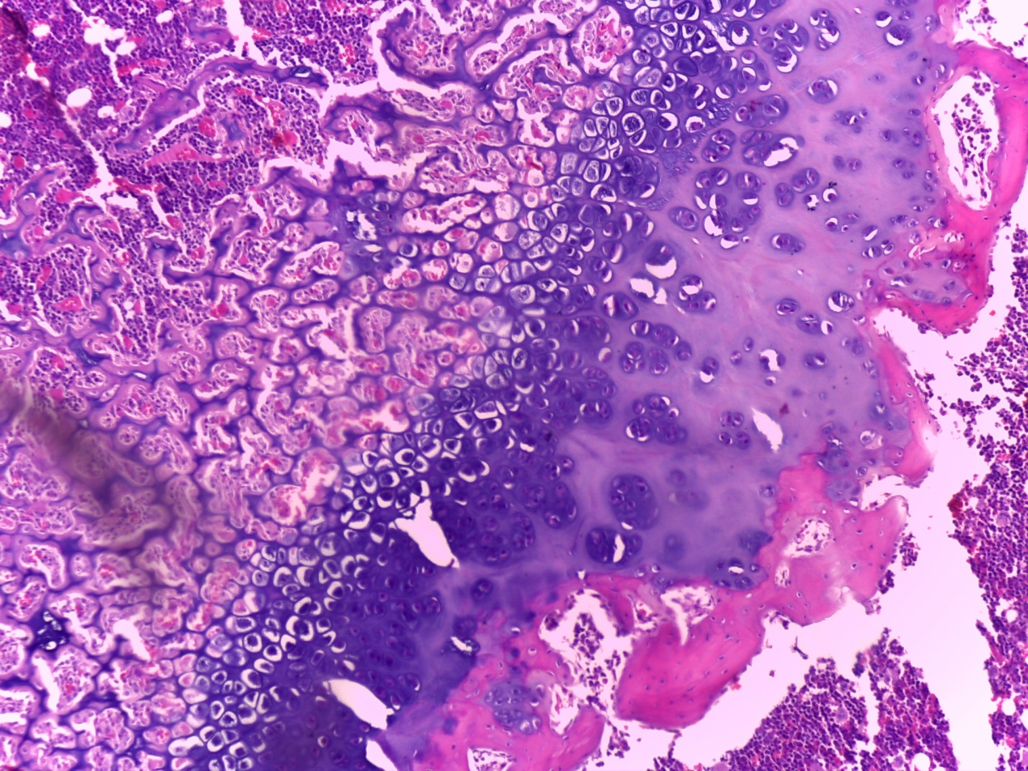

**b**

**a**

**Figure (15):** Photomicrograph of a cut section in rat joint of diseased group shows inflammatory infiltrate and proliferated blood vesseles (black arrow),synovial hyperplasia(a),pannus formation(b) (H&E x 100).

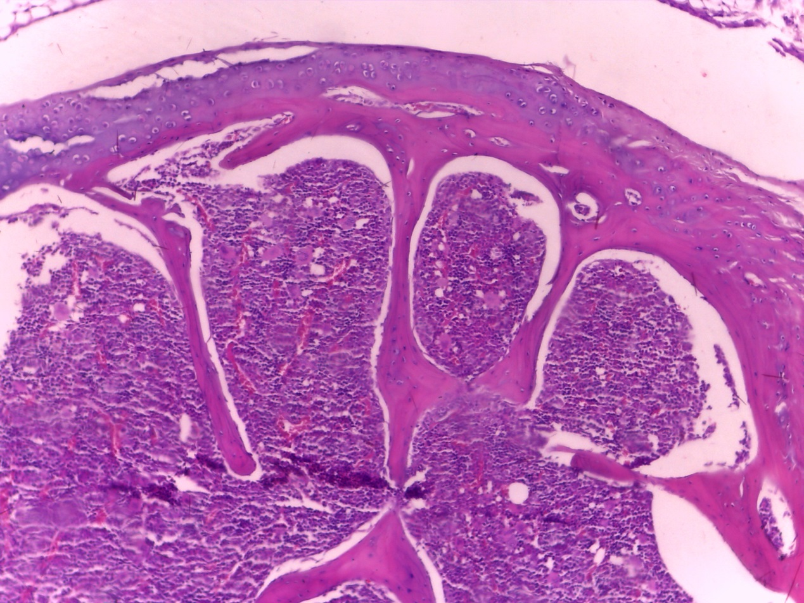

**a**

**Figure (16):** Photomicrograph of a cut section in rat joint of MTX treated group shows improvement of the inflammatory response (a) and flattening of synovial membrane(black arrow). (H&E x100).

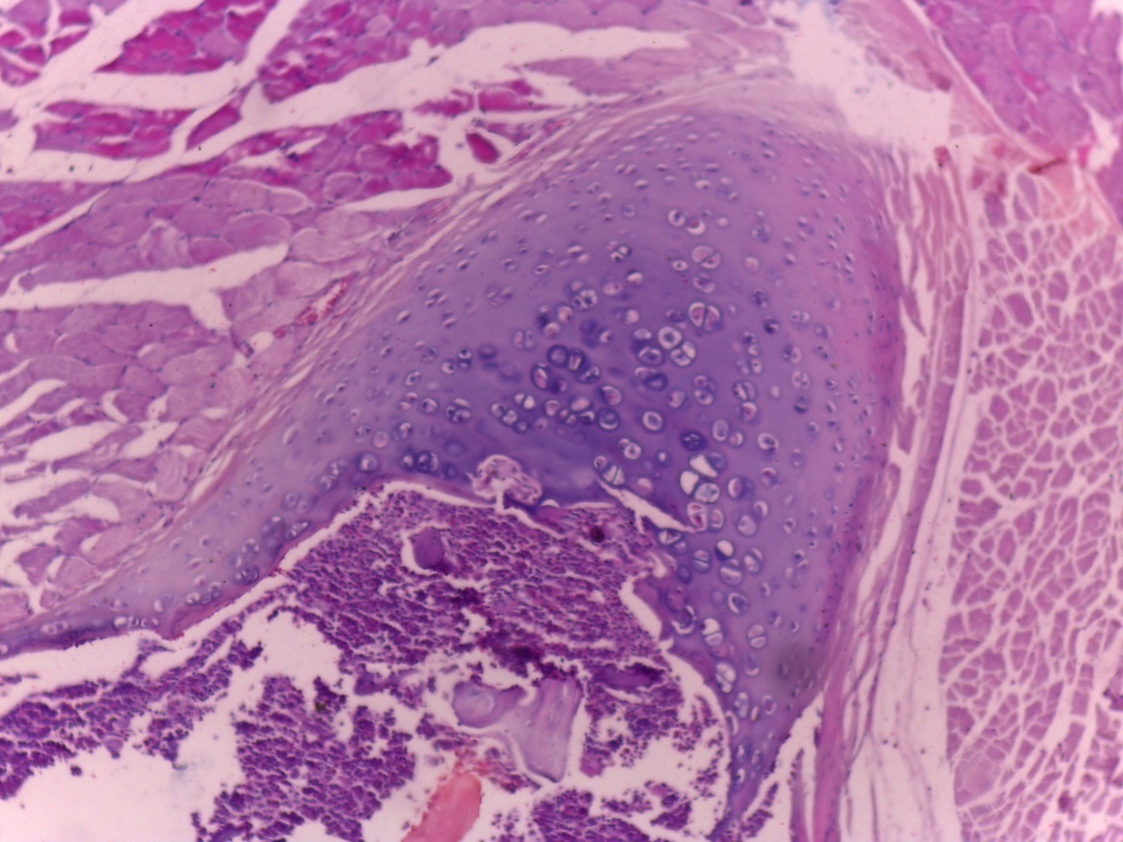

**a**

**Figure (17):** Photomicrograph of a cut section in rat joint of fluoxetine treated group showed (black arrow) multilayered synovial membrane, (a) mild improvement of inflammatory infiltrate (H&E x100).

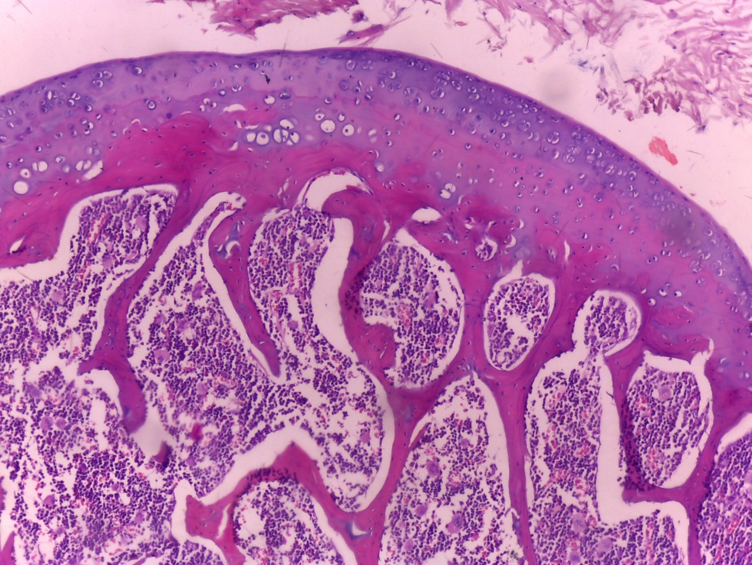

**a**

**Figure (18):** Photomicrograph of a cut section in rat joint of Moringa oleifera treated group shows (black arrow) marked flattening of superficial synovial layer (a) and marked improvement of inflammatory infiltrate (H&E x 100).

**Discussion**

RA is a common autoimmune systemic inflammatory disease. The interaction of genetic and environmental factors results in a cascade of immune reactions, which lead to development of synovitis, joint damage, and structural bone damage. These lead to pain, disability, emotional, social, and economic challenges. Also extra articular manifestations are present in patients with RA, which result in increased mortality. **(Gibofsky, 2012).**

RA occurs in about 5 per 1000 people that leads to severe joint damage and disability. Significant progress has been made in the last 2 decades regarding understanding of disease pathophysiology, optimal outcome measures, and effective treatment strategies, including the recognition of the importance of early RA diagnosis and treatment. **(Aletaha&Smolen, 2018).**

Identification of RA at the early presentation and starting treatment at an earlier stage can affect the disease course, prevent the development of joint erosions, or retard the progression of erosive disease. **(Murata et al., 2019).**

MTX is recommended as a first-line treatment in patients with active RA, and because of its efficacy and its reduction immunogenicity is typically used in combination with biologics. **(Curtis et al., 2016).**

Although MTX is the most frequently used for the treatment of RA. However, 30–50% of patients do not respond and up to 35% develop severe side effects, including cytopenia, hepatotoxicity and interstitial pneumonitis, leading to withdrawal of the treatment. **(Moya et al., 2016).**

Fluoxetine is SSRI, which has been widely used as an anti-depressant agent, Furthermore, fluoxetine has also shown anti-inflammatory and direct immunosuppressive effects such as suppression of T cell activation, cytokine secretion and proliferation and induction of apoptosis in vitro and in vivo. **( Li et al.,2016).**

Medicinal plants have been proven to be potent and effective in the management of RA. The use of medicinal plants provides another approach for the management of RA and currently a number of medicinal plants are under exploration for development of novel drugs. **(Aloke et al.,2019).**

The herbal formulations can be used as safe treatment for the management of RA. It is recommended that herbal formulations are integrated into our healthcare system in the management of RA. **(Elechi-Amadi et al.,2019).**

Historically, MO has been known for its many medicinal properties for hundreds of years. MO has been utilized in folk medicine in order to treat different diseases. All parts of the plant are used and contain constituents that give MO ability to treat multiple diseases. Also it has potant anti-inflammatory effect. **(Tate&Mowa, 2020).**

The present work was designed to evaluate the effect of (MTX, Fluoxetine and MO) for 4 weeks, on RF, TNF-α, CRP, GSH , anti-CCP , arthritis score and histopathological changes of joint, on RA induced experimentally in rats by s. c injection of complete freund's adjuvant in right hind limb.

In RA there are specific autoantibodies. These antibodies include the RF, which is directed against the Fc of the IgG to form immune complex that contribute the disease. **(Regueiro et al.,2020).**

The cytokines are involved in the pathogenesis of RA. In particular, TNFα has been suggested as one of the most potent cytokines associated with RA. **(Kojima et al., 2016).**

TNFα induces activation of leukocyte and endothelial cells. Also, synoviocyte activation and survival, cytokine and chemokine amplification, angiogenesis and nociceptor activation. the blockade of TNFα significantly decreases the production of other pro-inflammatory cytokines and chemokines, as IL-1, IL-6, IL-8, or GMCSF. **( Noack & Miossec, 2017)**

CRP is an acute-phase protein developed by liver hepatocytes. CRP is an important marker in RA.CRP can be used as a pathological tool for the measurement of inflammation in RA. **(Das et al., 2020).**

GSHis the most abundant intracellular small-molecule thiol and is essential for maintaining the thiol status of various molecules. GSH has many biological roles, including protection against reactive oxygen and nitrogen species (ROS/NOS), which are reduced by two GSH molecules forming oxidized glutathione (GSSG) in the process.**(Damgaard et al.,2016).**

Anti‐CCP also called anti-citrullinated protein antibodies (ACPA) is sensitive and specific diagnostic and prognostic markers for RA. In particular, anti‐CCP appears to be more specific than RF in the diagnosis of RA and may also be better predictors of erosive disease. **(Chang et al., 2016).**

Anti-CCP may appear in blood prior to the clinical onset of RA. The Anti-CCP levels increase, markedly 2–4 years prior to a diagnosis of RA, alongside a rise in inflammatory cytokine levels. **(Hafström et al., 2019).**

Freund’s adjuvants are water-in-mineral oil emulsions (W/O emulsions) without heat-killed mycobacteria added (Freund’s incomplete adjuvant) or with heat-killed mycobacteria added (Freund’s complete adjuvant). The adjuvants have been used extensively in experimental immunology owing to their high efficacy. **(Lindblad, 2000).**

Complete Freund's adjuvant (CFA)-induced arthritis is considered a scientifically standard experimental procedure for the induction of chronic immune-pathological RA in laboratory animals with similar cellular immunity response and pathological mechanism as in the human. **(Mahdi et al., 2018).**

The data of the present work revealed that s. c injection of CFA resulted in increase in level of RF, TNF-α, CRP and anti-CCP compared to normal control group. Also, there was significant increase in arthritic score in diseased group at the end of 3 doses of CFA injection compared to the score at 1st day before adjuvant injection. This increase was continuous every week, as the diseased group showed progression of arthritis till the end of the experiment. While there was decrease in GSH level compared to normal control group. Regarding histopathological changes, joints obtained from adjuvant induced arthritis (AIA) group showed proliferated blood vessels, prominent inflammatory infiltrate and villous formation.

According to **(Saleemet al.,2020)** who test Moringarivae leaf extracts attenuate Complete Freund’s adjuvant-induced arthritis in Wistar rats showed administration of CFA increased inflammation in the injected paw resulting in swelling and erythema The results of ankle joint histopathology at the end of 28 day study revealed infiltration with mononuclear cells, bone erosion, pannus formation and synovial hyperplasia in arthritic rats in contrast to normal control. And this is in line with our study in the diseasd group.

Regarding to **(Zhao et al., 2016)** who test anti-arthritic Effects of total Flavonoids from Juniperus sabina on Complete Freund's Adjuvant induced Arthritis in Rats. The levels of inflammatory cytokines as TNF-α in RA group rats which induced by CFA were significantly elevated respectively the control group and also occur in the diseased group in our study.

Also**,(Mehta et al.,2012)** who test Anti-arthritis activity of roots of Hemidesmusindicus R.Br in rats, showed serum RF and serum CRP level were significantly increased in CFA rats compared with normal control group which is in consistence with our study.

Our study is in line with **(Ahmed et al.,2015)**who test Protective Effects of Simvastatin and Hesperidin against Complete Freund’s Adjuvant-Induced rheumatoid arthritis in rats, showed serum reduced glutathione GSH level were significantly decreased in CFA rats compared with normal control group.

The results in in these study also are parallel with **(Gowayed et al., 2015)** who tested effect of galantamine on adjuvant-induced arthritis in rats. The Adjuvant arthritis model showed the anti-CCP level increasing by 12.7 folds in the untreated adjuvant arthritic rats relative to the healthy control group.

In our study, treatment with MTX showed significant improvement of RF, TNF-α, CRP, GSH and anti-CCP compared to diseased group. For arthritic score, this group showed improvement of the score at the end of 3rd and 4th weeks, compared to diseased group, also showed improved histopathology of the joint compared to diseased.

The result of this study is supported by a study of **(Makar et al., 2020)** who investigate the Beneficial Effect of Metformin Alone or in Combination with MTX in RA Induced Rat Model. Their study reported that administration of MTX as a treatment after induction of RA by CFA, show a highly significant decrease in serum RF, serum TNF-α, serum CRP and a highly significant increase in blood GSH level compared with arthritic rats. Also, MTX significantly improve arthritic score and histopathology of the joints.

Also, **(Ali et al., 2017)** study is in line with these results. The purpose of their study was showing Anti-hepatotoxic and synergistic effects of sesame oil with MTX in adjuvant induced arthritis. This study reported that the paw edema, RF and anti-CCP antibody were significantly reduced with MTX treated group.

In addition, our results are in consistence with the study of **(Roy et al.,2017)** which aimed to evaluate Effects of co-treatment with pioglitazone and MTX on experimentally induced RA in rats. It showed that a significant reduction in paw diameters in MTX-treated rats with that observed in arthritic group and histopathology of joints of MTX-treated group showed reduction in vascular proliferation, destruction of cartilage, synovial membrane, and sub periosteal region.

For the arthritic score, **Wang et al., (2018)** who aimed to compare the safety and effectiveness of MTX administrated traditionally and via chronotherapy in collagen induced arthritis. This study is in agreement with our results as MTX administration decreased the arthritis score significantly.

MTX treatment caused significant improvement of the arthritis index as well as modulation of the different parameters produced in arthritic rats. This can be attributed to its established anti-inflammatory, anti-proliferative action of MTX. Another mechanism of MTX action is mediated by blocking the migration of leukocytes into the joint synovia by decreasing cytokine production which attract more and more inflammatory cells. **(Feketeováet al.,2012).**

The anti-inflammatory actions of MTX are also due to the participation of adenosine. Adenosine is an endogenous anti-inflammatory factor in arthritis. MTX acts as a 5-aminoimidazole-4-carboxamide ribonucleotide suppressor and increases adenosine levels. Adenosine suppresses neutrophil migration to areas of inflammation, promotes the differentiation of macrophages and also inhibits the production of interleukin-1 or leukotriene B4.**(Koyama et al., 2017).**

Some researchers have postulated that MTX treatment decrease of the severity of arthritis by down-regulation of pro-inflammatory TNF-α, IL-6 and IL-17A cytokine expression.**(Zhao et al., 2014).**This also can explain the significant improve in CRP as one of the effects of IL-6 is to stimulate expression of CRP from hepatocytes and kupffer cells thus increasing level of CRP.**(Frleta-Gilchrist&McInnes, 2020).**

But, ***Ismail et al., (2018)*** study was in contrast to previous results. The aim of their study was to investigate the potential therapeutic effects of Dronabinol against the standard drug MTX in experimental model of RA. Their study showed that, treatment with MTX did not improve GSH as the levels of GSH were markedly suppressed in the group treated by MTX, compared to the corresponding value of normal group.

In Contrast to the previous results, ***Hendawy et al., (2015)*** study which was designed to investigate the effect of atorvastatin and vit D as a combination therapy with MTX. Their study showed that treatment of arthritic rats with atorvastatin lowered the level of TNF-α more than the decrease recorded with methotrexate; this was in contrast with our results. This contrast may be due to small dose of MTX used in their study.

Regarding treatment with fluoxetine, it showed significant improvement of RF, TNF-α, CRP, GSH and anti-CCP antibodies, compared to diseased. For arthritic score, this group showed improvement of the score at the end of 3rd and 4th weeks, compared to diseased group.

The effect of fluoxetine on serum level of TNF-α and arthritis score was studied by **(Sacre et al.,2010)** who studied Fluoxetine anti-inflammatory activity in murine model of RA**,** it showed significant improve in arthritis score and significant decrease in TNF-α level compared to non-treated group as approved in our study.

Fluoxetine is counteracting depressive symptoms by inhibiting the reuptake of serotonin and thus, augments serotonin concentration. The relatively high extracellular serotonin levels can inhibit the secretion of cytokines. **(Lu et al., 2017).**

Also fluoxetine can inhibit endosomal TLR such as TLR 8 which plays an important role in the production of TNF-α.**( Sacre et al., 2010).**

Fluoxetine effect on serum CRP was significantly decreased as studied by **(Coccaro et al., 2015)** who studied the effect of fluoxetine on inflammatory markers; it showed significant reduction in serum CRP level, and this run in consistence with the current work.

IL-6 is also the main pro-inflammatory cytokine that induce synthesis of type 1 acute phase proteins such as CRP, elevated levels of stress leads to activation that triggers an NF-KB–dependent cascade of pro-inflammatory events that contribute to increases in CRP. **(Chavda& ND Kantharia, 2011).**

It also proved by **(Liu** **et al.,2011)** thatfluoxetine decrease expression of nuclear factor NF-κB , this explain the reduction of the release of a number of pro-inflammatory and cytotoxic factors such as TNF-α, IL-1ß, nitric oxide, and reactive oxygen radicals. It also suggested that fluoxetine inhibits the mRNA for these cytokines as well as for IL-6.

Our study is in line with **(Perić et al.,2017)** who studied fluoxetine effect on behavior of socially isolated rats and hippocampal GSH-dependent defense system and proinflammatory cytokines.it showed that fluoxetine has increased level of GSH significantly as proved in our study.

And this explained by restoring the affected GSH pathways with Fluoxetine treatment may relate to neuroprotection, as the antioxidative effects of Fluoxetine, are thought to be mediated by increases in serotonin levels. **(Zafir et al., 2009).**

It has been reported by **(Diamond et al., 2006)** who studied effect of fluoxetine on Th1 and interferon-γ production, it showed that fluoxetine suppress T cell proliferation and inhibit interferon- (IFN) production in whole blood cultures. These also explain the decreased cytokines level in our present study.

In addition to the reported ability of fluoxetine to supress T cell proliferation, fluoxetine may also be inhibiting the response of antigen presenting cells. **(O'neill, 2008).** These can explain the decreased levels of auto-antibodies as RF and Anti-CCP.

According to paw edema and arthritis score fluoxetine showed significant reduction in edema and improvement of arthritis score especially at 3rd and 4th weeks and this is in line with **(Kostadinov et al.,2015)** who studied the anti-inflammatory and immunomodulatory effects of fluoxetine in rat models.

Also, histopathological examination to fluoxetine group showed decreased inflammatory infiltration, bone and cartilage destruction which is in line with **(Branco-de-Almeida et al., 2012)** who studied the inhibitory effect of fluoxetine on inflammation and bone loss in rats. And this is due to the anti-inflammatory effect of fluoxetine as approved by **(Abdel-Salam et al., 2004).**

On the other hand **(Sacre et al., 2010)** who studied different doses of fluoxetine in arthritis model showed that 10 mg/kg of fluoxetine the same dose in our study showed a small reduction in the clinical score and a slower decrease in paw swelling but at the higher dose (25 mg/kg), fluoxetine profoundly decrease the disease progression, with no further elevation in the clinical score or paw swelling.

Regarding treatment with Moringa oleifera, it showed highly significant improvement of RF, TNF-α, CRP, GSH and anti-CCP, compared to diseased and other treated groups. For arthritic score, this group showed significant improvement of the score at the end of 3rd and 4th weeks, compared to diseased group and other treated groups.

The result of this study showed that MO group has highly significant decrease in TNF- α and this is supported by a study for **(Araújo et al., 2013)** who studied anti-inflammatory effect of MO extract, it showed MO reduce TNF-α significantly and this may explained by β-sitosterol present in MO which is a compound with potent activity against inflammation, whose mechanism of action includes reducing the production of TNF-α.

MO also used in treatment of asthma and associated allergic diseases; these studies showed significant decrease in TNF-α, IL-6, these findings also indicate that the possible mechanism of action may be associated with a reduction in cytokine production and release as explained by **(Mahajan et al., 2009).**

Lipopolysaccharide (LPS) can bind to TLRand activate the NF-κB signaling pathway. The activation of these cascades and transcription factors subsequently results in the releasing of pro-inflammatory cytokines by macrophages and circulating monocytes, resulting in a transient immune activation, which is characterized by elevated levels of TNF-α, IL-1β, and IL-6,MoringaOleifera extract strongly inhibit the LPS-induced expression of IL-6 and TNF-α during inflammation.**(Luetragoon et al.,2020).**

In addition, our results are in consistence with the study of **(Randriamboavonjy et al., 2017)** who studied the effect of MO on vascular oxidative stress in hypertensive rats, it showed that significant decrease in CRP in MO treated group.

IL-6 is an important mediator of the inflammatory response as it participates in the development and differentiation of B- and T-cells, as well as the activation of acute phase proteins as CRP, Moringa oleifera inhibit mRNA expression of IL-6and thus consciously leads to decreased CRP level. **(Abdel-Daim et al., 2020).**

Also **(Saleem et al., 2020)** who studied the antioxidant ,anti-inflammatory and anti-arthritic effect of M. oleiferashowed in histopathology minimal inflammation, no pannus formation and erosion of epithelial cells. Also decrease in paw edema of moringa treated rats as approved in our study.

M.oleifera shows significant protection against lymphocytic infiltration, bone destruction and cartilage erosion and this is in line with our study. Also significant reduction in RF and TNF-α, and this is supported by **(Mahajan et al.,2007)** who studied the Protective effect of ethanolic extract of seeds of MO in arthritic rats .

B cells isolated from RA synovium can secrete RF and anti-CCP antibodies, indicating that the autoantibody is produced locally in the joint.**(Tehlirian&Bathon., 2010**).

As reported by **(Leone et al., 2016)** the ability of Moringa seed extract to attenuate the chronic immune-mediated inflammatory responses typical of certain diseases such as asthma and RA and this explain the decrease in parameters of rheumatoid arthritis such as RF and anti-CCP antibodies.

MO showed significant increase in GSH and this is supported by **(Abdalrhman et al., 2018)** who studied the protective effect of MO seeds against diabetic nephropathy in Rats.

The significant increase in GSH is also supported by **(Abarikwu et al.,2017).** Who studied the effect of Moringa oleifera seed extract on induced testicular toxicity in rats .

These significant increase in GSH may explained by Glutathione Reductase (GR) is essential in maintaining adequate GSH level by facilitating the regeneration of GSH from oxidized glutathione (GSSG).The protective effect of MO was also reflected in the induction of GR activity by MO extract.**( Uma et al.,2010).**

It could be due to the interaction between cysteine and methionine rich proteins that are present in high amounts in MO seeds .Beside this, MO, which is also rich with other potent antioxidant s like vitamin C, vitamin E and B-carotene.**( Gupta et al.,2007).**

**Summary & Conclusion**

Rheumatoid arthritis is a chronic, relapsing inflammatory and autoimmune multisystem illness that affects the joints. The early recognition and treatment of RA is important to minimize disability and maximize quality of life.

Methotrexate is a potent antimetabolite inhibiting purine synthesis enzyme dihydro folate reductase, which subsequently inhibits de-novo purine and pyrimidine synthesis. It is known that it is the cornerstone of disease-modifying treatment in patients with RA.

Fluoxetine is a selective serotonin reuptake inhibitor that has been widely used for the treatment of depression due to is safer profile, fewer side effects, and greater tolerability compared to other many antidepressants. Studies have found the following important functions of fluoxetine related to the central nervous system: neuroprotection; anti-inflammatory properties similar to standard drugs for the treatment of inflammatory conditions; antioxidant properties, contributing to its therapeutic action.

Moringaoleiferais known for its nutritional and numerous medicinal uses that have been appreciated for centuries in many parts of habitat and introduced ranges. It belongs to Moringaceae family*.* In addition to its high nutritional value, this plant is very important for its medicinal value. Moringa oleiferahas been reported to provide analgesic, antioxidant, anti-cancer, antimicrobial and anti-inflammatory effect.

The present work was designed to evaluate the effect of methotrexate (0. 6 mg/kg/week/by oral gavage), fluoxetine (20 mg/kg/day /by oral gavage) and Moringa oleifera seed extract (200 mg/kg/day /by oral gavage) on experimentally-induced rheumatoid arthritis in rats.

To study the effect of these drugs on induced adjuvant arthritis in rats, 30 male albino rats were classified into 5 equal groups (6 rats in each group). First group is normal control group. Second group is the diseased group, third group treated with methotrexate, fourth group treated with fluoxetine and fifth group treated with Moringa oleifera seed extract.

Adjuvant Arthritis was induced by S. C injection of 0. 4 ml of complete Freund's adjuvant in the right hind limb for 12 day in three doses (one dose every four days). The following parameters were measured RF, TNF-α, CRP, GSH, anti-CCP antibodies arthritis score and histopathological changes.

Subcutaneous injection of CFA produced increase in level of RF, TNF-α , CRP and anti-CCP antibodies compared to normal control group. Also, there was significant increase in arthritic score in diseased group at the end of 3 doses of CFA injection compared to before adjuvant injection. The diseased group showed progression of arthritis till the end of the experiment. While there was decrease in GSH level compared to normal control group. Regarding histopathological changes, there were proliferated blood vessels, prominent inflammatory infiltrate and villous formation.

Regarding, the treated groups leaded to significant improvement in serum RF, TNF-α, CRP, GSH, anti-CCP with improvement of arthritic score and the histopathology of the joint compared to normal control and diseased groups. Treatment with Moringa Oleifera seed extract showed the best results.

In addition, other treated groups rather than Moringa oleifera showed significant improvement in serum RF, TNF-α, CRP, GSH and anti-CCP compared to control and diseased groups.

Regarding arthritis score, a significant reduction in the score was seen in all treated group at the end of 3rd and 4th weeks. Moringa Oleifera group was the most effective group in improvement of the arthritic score at the end of 4th week of treatment (the end of the experiment).

Histopathology indicates improvement of the joint as regard synovial hyperplasia, villous formation, inflammatory cell infiltration and blood vessels proliferation. This improvement was observed in all treated groups with best result in Moringa Oleifera treated group.

**From previous data one may assume that (conclusions):**

* Moringa Oleifera can be used as new treatment in cases of rheumatoid arthritis thus can decrease MTX dose to avoid its side effects.
* Fluoxetine is a good antidepressant drug that has anti-inflammatory action. It is the best choice in depression that is common association with rheumatoid arthritis.

**Recommendation**

* Further experimental and clinical studies are needed for confirming effectiveness and safety of Moringa Oleifera and Fluoxetine.
* More studies are needed to elucidate other mechanisms of action of methotrexate in treatment of rheumatoid arthritis.
* Also, further investigations are needed to confirm the mechanism of action of Moringa Oleifera and Fluoxetine in rheumatoid arthritis to confirm results of this study.
* In our study fluoxetine showed significant reduction in anti CCP, a new point to be confirmed by researches.
* In our study Moringa oleifera showed significant reduction in anti CCP, a new point to be confirmed by researches.

**References**

|  |
| --- |
| **Aaltonen, K. (2015)**. Efficacy, Safety and Clinical Outcomes of Biologic Drugs in the Treatment of Rheumatoid Arthritis.  **Abarikwu, S. O., Benjamin, S., Ebah, S. G., Obilor, G., &Agbam, G. (2017).** Oral administration of Moringaoleifera oil but not coconut oil prevents mercury‐induced testicular toxicity in rats. Andrologia, 49(1), e12597.  **Abbas, H., & El-Badawi, A. (2014)**. Use of hematological and biochemical parameters and histological changes to assess the toxicity of drumstick tree (Moringa oleifera) seeds extract on Tilapia (Oreochromis niloticus) fish. Egyptian Journal of Aquatic Biology and Fisheries, 18(3), 21-40.  **Abd Rani, N. Z., Husain, K., & Kumolosasi, E. (2018).** Moringa genus: a review of phytochemistry and pharmacology. Frontiers in Pharmacology, 9, 108**.**  **Abdalrhman, I, K., Naziha, N. &Ali, M. (2018)**Evaluation the Protective Effect of MoringaOleifera Seeds Oil Against Diabetic Nephropathy in Male Rats.Scientific Journal of Specific Education and Applied Sciences,(1)1,267-282.  **Abdel-Daim, M. M., Khalil, S. R., Awad, A., Abu Zeid, E. H., El-Aziz, R. A., & El-Serehy, H. A. (2020).**Ethanolic Extract of Moringaoleifera Leaves Influences NF-κB Signaling Pathway to Restore Kidney Tissue from Cobalt-Mediated Oxidative Injury and Inflammation in Rats. Nutrients, 12(4), 1031.‏  **Abdel-Salam, O. M., Baiuomy, A. R., & Arbid, M. S. (2004).** Studies on the anti-inflammatory effect of fluoxetine in the rat. Pharmacologicalresearch, *49*(2), 119-131.‏  **Abolmaali, S. S., Tamaddon, A. M., & Dinarvand, R. (2013)**. A review of therapeutic challenges and achievements of methotrexate delivery systems for treatment of cancer and rheumatoid arthritis. Cancer chemotherapy and pharmacology, 71(5), 1115-1130.  **Acuram, L. K., & Hernandez, C. L. C. (2019).** Anti-hypertensive effect of Moringa oleifera Lam. Cogent Biology, 5(1), 1596526.  **Adedapo, A. A., Falayi, O. O., & Oyagbemi, A. A. (2015).** Evaluation of the analgesic, anti-inflammatory, anti-oxidant, phytochemical and toxicological properties of the methanolic leaf extract of commercially processed Moringa oleifera in some laboratory animals. Journal of basic and clinical physiology and pharmacology, 26(5), 491-499.‏  **Aekthammarat, D., Pannangpetch, P., & Tangsucharit, P. (2019).** Moringa oleifera leaf extract lowers high blood pressure by alleviating vascular dysfunction and decreasing oxidative stress in L-NAME hypertensive rats. Phytomedicine, 54, 9-16.  **Agbogidi, O. M., & Ilondu, E. M. (2012).** Moringa oleifera Lam: Its potentials as a food security and rural medicinal item. J. Bio. Innov, 1(6), 156-167.  **Agboke, A. A. (2015).** Antimicrobial activity of ethanol extract and fractions of Moringa oleifera lam. root bark on clinical isolates of methicillin resistant Staphylococcus aureus. METHODS, 8, 6.  **Aggarwal, A., Jethani, S. L., Rohatgi, R. K., & Kalra, J. (2012).** Effects of fluoxetine on testis of albino rats–a histological assessment. Int. J. Sci. Eng. Res., 3, 1-5.  **Ahmed, H., M Metwally, F., Rashad, H., M Zaazaa, A., M Ezzat, S., & M Salama, M. (2014).** Moringa oleifera offers a multi-mechanistic approach for management of obesity in rats.‏  **Ahmed, N. F., Sadek, K. M., Soliman, M. K., Khalil, R. H., Khafaga, A. F., Ajarem, J. S., ... & Allam, A. A. (2020**). Moringa Oleifera Leaf Extract Repairs the Oxidative Misbalance following Sub-Chronic Exposure to Sodium Fluoride in Nile Tilapia Oreochromis niloticus. Animals, 10(4), 626.‏  **Ahmed, Y. M., Messiha, B. A., & Abo-Saif, A. A. (2015).**Protective effects of simvastatin and hesperidin against complete freund's adjuvant-induced rheumatoid arthritis in rats. Pharmacology, 96(5-6), 217-225.  **Ajuogu, P. K., Mgbere, O. O., Bila, D. S., & McFarlane, J. R. (2019).** Hormonal changes, semen quality and variance in reproductive activity outcomes of post pubertal rabbits fed Moringa oleifera Lam. leaf powder. Journal of ethnopharmacology, 233, 80-86.  **Al-Abri, M., Ashique, M., Ramkumar, A., Nemmar, A., & Ali, B. H. (2018).** Motor and Behavioral Effects of Moringa oleifera Leaf Extract. Natural Product Communications, 13(1), 1934578X1801300126.‏  **Aletaha D, Neogi T, Silman A. (2010) .**rheumatoid arthritis classification criteria: an American College of Rheumatology/ European League Against Rheumatism collaborative initiative. Ann Rheum Dis 2010; 69: 1580–88.  **Aletaha D, Neogi T, Silman AJ, Funovits J, Felson DT, Bingham 3rd CO. (2010)** Rheumatoid arthritis classification criteria: an American college of rheumatology/European league against rheumatism collaborative initiative. Arthritis Rheum 2010;62(9):2569–81.  **Aletaha, D., &Smolen, J. S. (2018).** Diagnosis and management of rheumatoid arthritis: a review. Jama, 320(13), 1360-1372.‏  **Ali, Z., Atia, H., El Allawy, R., &AbdAlla, S. (2017).** Anti-hepatotoxic and synergistic effects of sesame oil with methotrexate in adjuvant induced arthritis. *The Egyptian Journal of Biochemistry and Molecular Biology*, *35*(1-2), 77-92.‏  **Alinejad, A., Akbari, H., Ghaderpoori, M., Jeihooni, A. K., & Adibzadeh, A. (2019**). Catalytic ozonation process using a MgO nano-catalyst to degrade methotrexate from aqueous solutions and cytotoxicity studies in human lung epithelial cells (A549) after treatment. RSC advances, 9(15), 8204-8214.  **Aliyu, A., Chukwuna, U. D., Omoregie, E. H., & Folashade, K. O. (2016).** Qualitative phytochemical analysis of the leaf of Moringa oleifera lam. from three climatic zones of Nigeria. J. Chem. Pharm. Res, 8(8), 93-101.  **Al-Malki, A. L., & El Rabey, H. A. (2015).** The antidiabetic effect of low doses of Moringa oleifera Lam. seeds on streptozotocin induced diabetes and diabetic nephropathy in male rats. BioMed research international, 2015.  **Aloke, C., Ibiam, U. A., Orji, O. U., Ugwuja, E. I., Ezeani, N. N., Aja, P. M., &Obasi, N. A. (2019).** Anti-arthritic potentials of ethanol and aqueous extracts of stem bark of Cleistopholispatens on complete Freund's adjuvant-induced rheumatoid arthritis in rats. Journal of Ayurveda and Integrative Medicine.  **Amaglo, N. K., Bennett, R. N., Curto, R. B. L., Rosa, E. A., Turco, V. L., Giuffrida, A., ... & Timpo, G. M. (2010).** Profiling selected phytochemicals and nutrients in different tissues of the multipurpose tree Moringa oleifera L., grown in Ghana. Food Chemistry, 122(4), 1047-1054.  **Amaya J, Botello-Corzo D, Calixto J,(2012):** Usefulness of patients-reported outcomes in rheumatoid arthritis focus group. Arthritis.  2012:935187.  **Anders, H. J., & Vielhauer, V. (2011).** Renal co-morbidity in patients with rheumatic diseases. *Arthritis research & therapy*, *13*(2), 222.‏  **Andrés-Costa, M. J., Proctor, K., Sabatini, M. T., Gee, A. P., Lewis, S. E., Pico, Y., & Kasprzyk-Hordern, B. (2017**). Enantioselective transformation of fluoxetine in water and its ecotoxicological relevance. Scientific reports, 7(1), 1-13.  **Araújo, L. C. C., Aguiar, J. S., Napoleão, T. H., Mota, F. V. B., Barros, A. L. S., Moura, M. C., ... &Paiva, P. M. G. (2013).**Evaluation of cytotoxic and anti-inflammatory activities of extracts and lectins from Moringaoleifera seeds.*PloS one*, *8*(12), e81973.‏  **Asci, H., Ozmen, O., Ellidag, H. Y., Aydin, B., Bas, E., & Yilmaz, N. (2017).** The impact of gallic acid on the methotrexate-induced kidney damage in rats. journal of food and drug analysis, 25(4), 890-897.  **Avčin, T., Cimaz, R., Falcini, F., Zulian, F., Martini, G., Simonini, G., ... & Meroni, P. L. (2002).** Prevalence and clinical significance of anti-cyclic citrullinated peptide antibodies in juvenile idiopathic arthritis. Annals of the rheumatic diseases, 61(7), 608-611.  **Bakare, M. A., & Onifade, A. K. (2019).** Evaluation of Antimicrobial Activities of Carica papaya, Azadirachta indica and Moringa oleifera on Helicobacter Pylori Isolated from Ulcer Patients in Ondo State, Nigeria. International Journal of Biomedical Materials Research, 7(1), 61.**‏**  **Bakre, A. G., Aderibigbe, A. O., & Ademowo, O. G. (2013).** Studies on neuropharmacological profile of ethanol extract of Moringa oleifera leaves in mice. Journal of Ethnopharmacology, 149(3), 783-789.  **Barakat, A., Hamdy, M. M., & Elbadr, M. M. (2018).** Uses of fluoxetine in nociceptive pain management: A literature overview. European journal of pharmacology, 829, 12-25.‏  **Benham, H., Nel, H. J., Law, S. C., Mehdi, A. M., Street, S., Ramnoruth, N., ... & Hyde, C. (2015**). Citrullinated peptide dendritic cell immunotherapy in HLA risk genotype–positive rheumatoid arthritis patients. Science translational medicine, 7(290), 290ra87-290ra87.  **Bentebibel, S. E., Schmitt, N., Banchereau, J., & Ueno, H. (2011).** Human tonsil B-cell lymphoma 6 (BCL6)-expressing CD4+ T-cell subset specialized for B-cell help outside germinal centers. Proceedings of the National Academy of Sciences, 108(33), E488-E497.  **Beutler, E.; Duron, O. and Kelly, M. B. (1963):** Glutathione reduced. J Lab Clin Med.; 61:882.  **Bezabeh, S., Mackey, A. C., Kluetz, P., Jappar, D., & Korvick, J. (2012**). Accumulating evidence for a drug–drug interaction between methotrexate and proton pump inhibitors. The oncologist, 17(4), 550.  **Bidel, F., Di Poi, C., Imarazene, B., Koueta, N., Budzinski, H., Van Delft, P., ... & Jozet-Alves, C. (2016).** Pre-hatching fluoxetine-induced neurochemical, neurodevelopmental, and immunological changes in newly hatched cuttlefish. Environmental Science and Pollution Research, 23(6), 5030-5045.  **Birch J, Bhattacharya S, .2010:** Emerging trends in diagnosis and treatment of rheumatoid arthritis. Prim Care. 2010;37:779–92.  **Biswas, D., Nandy, S., Mukherjee, A., Pandey, D. K., & Dey, A. (2019).** Moringa oleifera Lam. and derived phytochemicals as promising antiviral agents: A review. South African Journal of Botany.  [**Branco de Almeida**](https://aap.onlinelibrary.wiley.com/action/doSearch?ContribAuthorStored=Branco-de-Almeida%2C+Luciana+S) **L.,**  [**Franco**](https://aap.onlinelibrary.wiley.com/action/doSearch?ContribAuthorStored=Franco%2C+Gilson+C) **G.,**  [**Castro**](https://aap.onlinelibrary.wiley.com/action/doSearch?ContribAuthorStored=Castro%2C+Myrella+L)**M.,**  [**dos Santos**](https://aap.onlinelibrary.wiley.com/action/doSearch?ContribAuthorStored=Dos+Santos%2C+Juliana+G) **J.,**  [**Anbinder**](https://aap.onlinelibrary.wiley.com/action/doSearch?ContribAuthorStored=Anbinder%2C+Ana+Lia) **A.,**  [**Cortelli**](https://aap.onlinelibrary.wiley.com/action/doSearch?ContribAuthorStored=Cortelli%2C+Sheila+C) **S.,**  [**Kajiya**](https://aap.onlinelibrary.wiley.com/action/doSearch?ContribAuthorStored=Kajiya%2C+Mikihito) **M.,**  [**Kawai**](https://aap.onlinelibrary.wiley.com/action/doSearch?ContribAuthorStored=Kawai%2C+Toshihisa) **T.,** [**Rosalen**](https://aap.onlinelibrary.wiley.com/action/doSearch?ContribAuthorStored=Rosalen%2C+Pedro+L) **P. *(*2012*):*** Fluoxetine Inhibits Inflammatory Response and Bone Loss in a Rat Model of Ligature‐Induced Periodontitis***.***Journal of periodontology Pages 664-671.  **Brown, P. M., Pratt, A. G., & Isaacs, J. D. (2016)**. Mechanism of action of methotrexate in rheumatoid arthritis, and the search for biomarkers. Nature Reviews Rheumatology, 12(12), 731-742.  **Cai, L., He, Q., Lu, Y., Hu, Y., Chen, W., Wei, L., & Hu, Y. (2019).** Comorbidity of pain and depression in a lumbar disc herniation model: biochemical alterations and the effects of fluoxetine. Frontiers in Neurology, 10, 1022.‏  **Caiaffo V. Oliveira B., de Sa´ F. & Neto J. (2016):**Anti-inflammatory, antiapoptotic, and antioxidant activity of fluoxetine. Pharmacology Research& Perspective, 4(3)  **Carotti, M., Galeazzi, V., Catucci, F., Zappia, M., Arrigoni, F., Barile, A., & Giovagnoni, A. (2018).** Clinical utility of eco-color-power Doppler ultrasonography and contrast enhanced magnetic resonance imaging for interpretation and quantification of joint synovitis: a review. Acta bio-medica: Atenei Parmensis, 89(Suppl 1), 48.‏  **Chan, E. S., & Cronstein, B. N. (2013).** Mechanisms of action of methotrexate. Bulletin of the NYU Hospital for Joint Diseases, 71(suppl 1), S5.  **Chang, P. Y., Yang, C. T., Cheng, C. H., & Yu, K. H. (2016).**Diagnostic performance of anti‐cyclic citrullinated peptide and rheumatoid factor in patients with rheumatoid arthritis. International Journal of Rheumatic Diseases, 19(9), 880-886.  **Chantiluke, K., Barrett, N., Giampietro, V., Brammer, M., Simmons, A., & Rubia, K. (2015).** Disorder-dissociated effects of fluoxetine on brain function of working memory in attention deficit hyperactivity disorder and autism spectrum disorder. Psychological Medicine, 45(6), 1195-1205.  **Chauhan, V., & Pandey, V. N. (2014).** Characterization of an Ethanomedicinal Plant: Moringa oleifera Lam. Biosciences, 890.  **Chavda, N., & ND Kantharia, J. (2011).** Effects of fluoxetine and escitalopram on C-reactive protein in patients of depression. Journalofpharmacology *&* pharmacotherapeutics, *2*(1), 11.‏  **Chhikara, N., Kaur, A., Mann, S., Garg, M. K., Sofi, S. A., & Panghal, A. (2020**). Bioactive compounds, associated health benefits and safety considerations of Moringa oleifera L.: an updated review. Nutrition & Food Science**.**  **Choy, E. (2012)**. Understanding the dynamics: pathways involved in the pathogenesis of rheumatoid arthritis. Rheumatology, 51(suppl_5), v3-v11.  **Chung, Y. C., Kim, S. R., Park, J. Y., Chung, E. S., Park, K. W., Won, S. Y., ... & Ko, H. W. (2011).** Fluoxetine prevents MPTP-induced loss of dopaminergic neurons by inhibiting microglial activation. Neuropharmacology, 60(6), 963-974.‏  **Coccaro, E. F., Lee, R., Breen, E. C., & Irwin, M. R. (2015).**Inflammatory markers and chronic exposure to fluoxetine, divalproex, and placebo in intermittent explosive disorder.Psychiatryresearch, *229*(3), 844-849.‏  **Cojocaru M, Cojocaru IM, Silosi I, Vrabie CD, Tanasescu R (.2010).** Extra-articular manifestations in rheumatoid arthritis. Maedica (Buchar) ;5:286–91  **Cooper, G. S., & Stroehla, B. C. (2003**). The epidemiology of autoimmune diseases. Autoimmunity reviews, 2(3), 119-125**.‏**  **Coriolano, M. C., Brito, J. S., Ferreira, G. R. S., Moura, M. C., Melo, C. M. L., Soares, A. K. A., ... & Coelho, L. C. B. B. (2020).** Antibacterial lectin from Moringa oleifera seeds (WSMoL) has differential action on growth, membrane permeability and protease secretory ability of Gram-positive and Gram-negative pathogens. South African Journal of Botany, 129, 198-205.‏  **Curtis, J. R., Bykerk, V. P., Aassi, M., & Schiff, M. (2016).** Adherence and persistence with methotrexate in rheumatoid arthritis: a systematic review. The Journal of rheumatology, 43(11), 1997-2009.  **Damgaard, D., Bjørn, M. E., Steffensen, M. A., Pruijn, G. J., & Nielsen, C. H. (2016**).Reduced glutathione as a physiological co-activator in the activation of peptidylargininedeiminase.Arthritis research & therapy, 18(1), 102.  **Das, D. C., Jahan, I., Uddin, M. G., Hossain, M. M., Chowdhury, M. A. Z., Fardous, Z., ...& Das, A. (2020**). Serum CRP, MDA, Vitamin C, and Trace Elements in Bangladeshi Patients with Rheumatoid Arthritis. Biological Trace Element Research, 1-9**.‏**  **Dasgupta, S., Gunda, N. S. K., & Mitra, S. K. (2016).** Evaluation of the antimicrobial activity of Moringa oleifera seed extract as a sustainable solution for potable water. Rsc Advances, 6(31), 25918-25926.  **Davies, N. M., & Skjodt, N. M. (2000)**. Choosing the right nonsteroidal anti-inflammatory drug for the right patient. Clinical pharmacokinetics, 38(5), 377-392.  **Davignon, J. L., Hayder, M., Baron, M., Boyer, J. F., Constantin, A., Apparailly, F., ... & Cantagrel, A. (2013).** Targeting monocytes/macrophages in the treatment of rheumatoid arthritis. Rheumatology, 52(4), 590-598.  **Derksen V, HuizingaT& van der Woude, D. (2017).** The role of autoantibodies in the pathophysiology of rheumatoid arthritis. In *Seminars in immunopathology* (Vol. 39, No. 4, pp. 437-446). Springer Berlin Heidelberg.‏  **Deshmukh, M. T., & Mohite, S. K. (2018).** Formulation and Pharmacodynamic Evaluation of Fluoxetine HCl Mucoadhesive Microsphere. *Current Pharma Research*, *8*(3), 2458-2471.‏  **Desmoulin, S. K., Hou, Z., Gangjee, A., & Matherly, L. H. (2012).** The human proton-coupled folate transporter: Biology and therapeutic applications to cancer. Cancer biology & therapy, 13(14), 1355-1373.  **Dewangan, G., Koley, K. M., Vadlamudi, V. P., Mishra, A., Poddar, A., & Hirpurkar, S. D. (2010).** Antibacterial activity of Moringa oleifera (drumstick) root bark. Journal of Chemical and Pharmaceutical Research, 2(6), 424-428.  **Dhakar, R. C., Maurya, S. D., Pooniya, B. K., Bairwa, N., & Gupta, M. (2011). Moringa:** The herbal gold to combat malnutrition. Chronicles of Young Scientists, 2(3).  **Dhami, K. S., Churchward, M. A., Baker, G. B., & Todd, K. G. (2019**). Fluoxetine and its metabolite norfluoxetine induce microglial apoptosis. Journal of neurochemistry, 148(6), 761-778.  **Di Rosso, M. E., Palumbo, M. L., & Genaro, A. M. (2016).** Immunomodulatory effects of fluoxetine: a new potential pharmacological action for a classic antidepressant drug. Pharmacological research, 109, 101-107.  **Diamond, M., Kelly, J. P., & Connor, T. J. (2006).** Antidepressants suppress production of the Th1 cytokine interferon-γ, independent of monoamine transporter blockade. European Neuropsychopharmacology, 16(7), 481-490.  **Dixit, N. K., Hossain, S. A., Bharti, B. K., Singh, S. S., & Mishra, S. (2018).** Development of Lassi Using Whey and Moringa Powder. Int. J. Curr. Microbiol. App. Sci, 7(11), 602-612.  **Dogra, S., & Mahajan, R. (2013).** Systemic methotrexate therapy for psoriasis: past, present and future. Clinical and experimental dermatology, 38(6), 573-588.  **Dong, X., Zheng, Z., Zhai, Y., Zheng, Y., Ding, J., Jiang, J., & Zhu, P. (2018).** ACPA mediates the interplay between innate and adaptive immunity in rheumatoid arthritis. Autoimmunity reviews, 17(9), 845-853.  **Dubey, D. K., Dora, J., Kumar, A., & Gulsan, R. K. (2013).** A multipurpose tree-Moringa oleifera. International Journal of Pharmaceutical and Chemical Sciences, 2(1), 415-423.  **Düsman, E., Almeida, I. V., Mariucci, R. G., Mantovani, M. S., & Vicentini, V. E. P. (2014).** Cytotoxicity and mutagenicity of fluoxetine hydrochloride (Prozac), with or without vitamins A and C, in plant and animal model systems. *Genetics and Molecular Research*, *13*(1), 578-589.‏  **Elbakry, M. A., El Rabey, H. A., Elremaly, W., Sakran, M. I., & Almutairi, F. M. (2019).** The methanolic extract of Moringa oleifera attenuates CCl4 induced hepatonephro toxicity in the male rat.  **Elechi-Amadi, K. N., Nwachuku, E. O., Tamuno-Emine, D. G., Nduka, N., Briggs, O. N., &Teme, R. (2019).** Anti-arthritic activity of a herbal formulation (Jointeez) in albino wistar rats. Journal of Complementary and Alternative Medical Research, 1-8**.**  **Elsayed, E. A., Sharaf-Eldin, M. A., & Wadaan, M. (2015).** In vitro evaluation of cytotoxic activities of essential oil from Moringa oleifera seeds on HeLa, HepG2, MCF-7, CACO-2 and L929 cell lines. Asian Pac. J. Cancer Prev, 16(11), 4671-4675.‏  **Engin, B., Sevim, A., Cesur, S. K., & Tüzün, Y. (2019).** Eruptions in life-threatening rheumatologic diseases. *Clinics in Dermatology*.‏  ***Engvall, E. and Perlman, p. (1971):*** Enzyme-Linked Immunosorbent Assay, (ELISA) Quantitative Assay of Immunoglobulin G. Immunochemistry. 8: 871-874.  **Faisal, R.; Ahmad, N.; Fahad, Y. S. et al., (2018):** Anti-arthritic effect of thymoquinonein comparison with methotrexate on pristine induced arthritis in female Sprague dawely rats. J Ayub Med Coll Abbottabad., 30(1).  **Falgarone, G., Jaen, O., & Boissier, M. C. (2005):** Role for innate immunity in rheumatoid arthritis. *Joint Bone Spine*, *72*(1), 17-25.‏ |

**Feketeová, L., Jančová, P., Moravcová, P., Janegová, A., Bauerová, K., Poništ, S., ...&Babál, P. (2012).** Effect of methotrexate on inflammatory cells redistribution in experimental adjuvant arthritis.Rheumatology international, 32(11), 3517-3523.

**Firestein, G. S. (2003).** Evolving concepts of rheumatoid arthritis. Nature, 423(6937), 356-361.

**Foyet, H. S.; Tsala, D. E.; Zogo Essono Bodo, J. C. et al., (2015):** Anti-inflammatory and antiarthritic activity of a methanol extract from Vitellaria paradoxa stem bark. Phcog Res., 27:367–77.

**Friedman, B., & Cronstein, B. (2019).** Methotrexate mechanism in treatment of rheumatoid arthritis. Joint Bone Spine, 86(3), 301-307.

**Frleta-Gilchrist, M., &McInnes, I. B. (2020).**Cytokines and other mediators.Oxford Textbook of Rheumatoid Arthritis, 95.

**Furst, D. E., & Emery, P. (2014).** Rheumatoid arthritis pathophysiology: update on emerging cytokine and cytokine-associated cell targets. Rheumatology, 53(9), 1560-1569.

**Gao, S. Y., Wu, Q. J., Zhang, T. N., Shen, Z. Q., Liu, C. X., Xu, X., ... & Zhao, Y. H. (2017).** Fluoxetine and congenital malformations: a systematic review and meta‐analysis of cohort studies. British journal of clinical pharmacology, 83(10), 2134-2147.

**Germic, N., Frangez, Z., Yousefi, S., & Simon, H. U. (2019).** Regulation of the innate immune system by autophagy: Monocytes, macrophages, dendritic cells and antigen presentation. Cell Death & Differentiation, 26(4), 715-727.

**Gibofsky, A. (2012).**Overview of epidemiology, pathophysiology, and diagnosis of rheumatoid arthritis.The American journal of managed care, 18(13 Suppl), S295.

**Gohil, N., Chaudhary, A., Kale, K., Gajera, V., & Lambole, V. (2017)**. A review on rheumatoid arthritis: Disease. Pharma Science Monitor, 8(2), 219-254.

**Goma, S. H., Mahran, D. G., El-Hakeim, E. H., Ghandour, A. M., Abdelaziz, M. M., Galal, M. A., & Gamal, R. M. (2016).** Spectrum of Rheumatic Diseases in Egypt is Similar/Different from that in Non-Arabic Countries: An Inpatient Comparison.‏

**Gopalakrishnan, L., Doriya, K., & Kumar, D. S. (2016)**. Moringa oleifera: A review on nutritive importance and its medicinal application. Food science and human wellness, 5(2), 49-56.

**Gothai, S., Arulselvan, P., Tan, W. S., & Fakurazi, S. (2016).** Wound healing properties of ethyl acetate fraction of Moringa oleifera in normal human dermal fibroblasts. Journal of intercultural ethnopharmacology, *5*(1), 1.‏

**Gowayed, M. A., Refaat, R., Ahmed, W. M., & El-Abhar, H. S. (2015).**Effect of galantamine on adjuvant-induced arthritis in rats. European journal of pharmacology, 764, 547-553.‏

**Grim, J., Chládek, J., & Martínková, J. (2003).** Pharmacokinetics and pharmacodynamics of methotrexate in non-neoplastic diseases. Clinical pharmacokinetics, 42(2), 139-15.

**Guo, Q., Wang, Y., Xu, D., Nossent, J., Pavlos, N. J., & Xu, J. (2018)**. Rheumatoid arthritis: pathological mechanisms and modern pharmacologic therapies. Bone research, 6(1), 1-14.

**Gupta, R., Dubey, D. K., Kannan, G. M., & Flora, S. J. S. (2007).**Concomitant administration of Moringaoleifera seed powder in the remediation of arsenic‐induced oxidative stress in mouse. Cell Biology International, 31(1), 44-56.

**Gupta, R., Mathur, M., Bajaj, V. K., Katariya, P., Yadav, S., Kamal, R., & Gupta, R. S. (2012).** Evaluation of antidiabetic and antioxidant activity of Moringa oleifera in experimental diabetes. Journal of diabetes, 4(2), 164-171.

**Hafström, I., Ajeganova, S., Forslind, K., & Svensson, B. (2019).** Anti-citrullinated protein antibodies are associated with osteopenia but not with pain at diagnosis of rheumatoid arthritis: data from the BARFOT cohort. Arthritis research & therapy, 21(1), 45.‏

**Hamdy, M. M., Elbadr, M. M., & Barakat, A. (2018).** Fluoxetine uses in nociceptive pain management: a promising adjuvant to opioid analgesics. Fundamental & clinical pharmacology, 32(5), 532-546.

**Hamza, A. A. (2010).** Ameliorative effects of Moringa oleifera Lam seed extract on liver fibrosis in rats. Food and Chemical Toxicology, 48(1), 345-355.

# Hendawy, O. M.; Ahmed, W. M. S.; Abosaif, A. A. et al., (2015): Effect of atorvastatin and vitamin D on freund adjuvant-induced rheumatoid arthritis in rat. J Bioequiv Availab., 7:090-094. doi: 10. 4172/jbb. 100221.

**Hoovestol, R.A.; Mikuls, T.R 2011:** Environmental exposures and rheumatoid arthritis risk. *Curr. Rheumatol. Rep*, *13*, 431–439.

**Hu, H. M., Li, B., Wang, X. D., Guo, Y. S., Hui, H., Zhang, H. P., ... & Hao, D. J. (2018**). Fluoxetine is neuroprotective in early brain injury via its anti-inflammatory and anti-apoptotic effects in a rat experimental subarachnoid hemorrhage model. Neuroscience bulletin, 34(6), 951-962.

**Ibrahim, H. A., Telep, N. A., & Hemed, M. M. (2019).** Moringa (Moringa oleifera) Leaves' Extract and Linseed (Linum usitatissimum) Oil Ameliorate Piroxicam Induced Gastric Ulcers in Male Rats. Zagazig Veterinary Journal, 47(4), 419-431.

**Ismail, M.; Hasan, H.; El-Orfali, Y. et al., (2018*):*** Anti-Inflammatory, Antioxidative, and Hepatoprotective Effects of Trans 9-Tetrahydrocannabinol/Sesame Oil on Adjuvant-Induced Arthritis in Rats Evidence-Based Complementary and Alternative Medicine Volume 2018, Article ID 9365464, 13 pages.

**Joaquim, A. F., & Appenzeller, S. (2015).** Neuropsychiatric manifestations in rheumatoid arthritis. *Autoimmunity reviews*, *14*(12), 1116-1122.‏

**Joosten, L. A., Abdollahi-Roodsaz, S., Dinarello, C. A., O'neill, L., & Netea, M. G. (2016).** Toll-like receptors and chronic inflammation in rheumatic diseases: new developments. Nature Reviews Rheumatology, 12(6), 344

**Kandasamy, M., Tripathy, K., Ravi, S., Kamath, N., Pai, B., Srinivas, N. R., ... & Thangam, S. (2010).** Unsuspected poor metabolizer phenotypes of fluoxetine in bioavailability/bioequivalence studies from an Indian population perspective. Arzneimittelforschung, 60(01), 12-21.**‏**

**Karlsson, M. V., Marshall, S., Gouin, T., & Boxall, A. B. (2016).** Routes of uptake of diclofenac, fluoxetine, and triclosan into sediment‐dwelling worms. *Environmental toxicology and chemistry*, *35*(4), 836-842.

***Kasumagic-Halilovic, E.; Prohic, A. and Cavaljuga, S. (2011):*** Tumor necrosis factor-alpha in patients with alopecia areata. Indian Journal of Dermatology, 56(5):494-6.

**Kaur, G., Invally, M., Sanzagiri, R., & Buttar, H. S. (2015).** Evaluation of the antidepressant activity of Moringa oleifera alone and in combination with fluoxetine. Journal of Ayurveda and integrative medicine, 6(4), 273**.**

**Kavanaugh, A., & Wells, A. F. (2014)**. Benefits and risks of low-dose glucocorticoid treatment in the patient with rheumatoid arthritis. Rheumatology, 53(10), 1742-1751.‏

**Khanna, S., Raj, N., & Aparna, K. C. (2015).** Moringaoleifera and obesity: A review. International Journal of Advanced Research in Engineering and Applied Sciences, 4(11), 1-23.

**Khor, K. Z., Lim, V., Moses, E. J., & Abdul Samad, N. (2018).** The in vitro and in vivo anticancer properties of Moringa oleifera. Evidence-Based Complementary and Alternative Medicine, 2018.‏

**Kianifard, T., & Chopra, A. (2018).** A therapeutic role for potassium (K) to reduce pain and complications related to the cardiovascular system and bone in rheumatoid arthritis (RA): A clinical research perspective. Rheumatology Research, 3(1), 1-12.‏

**Kojima, A., Kobayashi, T., Ito, S., Murasawa, A., Nakazono, K., &Yoshie, H. (2016).** Tumor necrosis factor‐alpha gene promoter methylation in Japanese adults with chronic periodontitis and rheumatoid arthritis.Journal of periodontal research, 51(3), 350-358.

**Konmy, B. B., Olounladé, P. A., Doko-allou, S., Azando, E. B. V., & Hounzangbé-Adoté, S. E. G. (2016).** A review on phytochemistry and pharmacology of Moringa oleifera leaves (Moringaceae). Journal of Pharmacognosy and Phytochemistry, 5(5), 325-330.

**Kostadinov, I., Delev, D., Petrova, A., Stanimirova, I., Draganova, K., Kruzliak, P. & Murdjeva, M. (2015).** Study on anti-inflammatory and immunomodulatory effects of fluoxetine in rat models of inflammation. *European Journal of Inflammation*, *13*(3), 173-182.

**Koyama, A., Tanaka, A., & To, H. (2017).** Daily oral administration of low‐dose methotrexate has greater antirheumatic effects in collagen‐induced arthritis rats. Journal of Pharmacy and Pharmacology, 69(9), 1145-1154.

**Krishnamurthy, A., Joshua, V., Hensvold, A. H., Jin, T., Sun, M., Vivar, N., & Magnusson, M. (2016).** Identification of a novel chemokine-dependent molecular mechanism underlying rheumatoid arthritis-associated autoantibody-mediated bone loss. Annals of the rheumatic diseases, 75(4), 721-729.‏

**Kumar P and Bain k (2013):** Pharmacotherapy Options in Rheumatoid Arthritis **,** [Clinical Medicine Insights Arthritis Musculoskelet Disord](https://www.ncbi.nlm.nih.gov/pmc/journals/1400/)ers 35–43.

**Kumar, P. S., Mishra, D., Ghosh, G., & Panda, C. S. (2010).** Medicinal uses and pharmacological properties of Moringa oleifera. International Journal of Phytomedicine, 2(3).

**Kumar, P., & Banik, S. (2013)**. Pharmacotherapy options in rheumatoid arthritis. Clinical Medicine Insights: Arthritis and Musculoskeletal Disorders, 6, CMAMD-S5558.‏

**Kumar, S. (2017**). Medicinal importance of Moringa oleifera: drumstick plant. Indian J. Sci. Res, 16(1), 129-132.

**Lahlou, M. (2013).** The success of natural products in drug discovery.

**Lakhne, R., Gupta, R., & Gupta, R. S. (2015).** Active Phytoconstituents for Controlling Hypercholesterolemia: A Review. Int J Clin Endocrinol Metab 1 (1): 022, 30, 022.

**Lam, Y. F. (2019).** Metoprolol and paroxetine or fluoxetine. The Brown University Psychopharmacology Update, 30(10), 2-3.**‏**

**Lee, M., George, D., Khor, S., Elvey, M., & Rashid, A. (2018).** Surgical intervention for Rheumatoid Arthritis and complication risks. Handbook of Systemic Autoimmune Diseases, 15, 127-160.‏

**Leone, A., Spada, A., Battezzati, A., Schiraldi, A., Aristil, J., & Bertoli, S. (2016).** Moringa oleifera seeds and oil: characteristics and uses for human health. International Journal of Molecular Sciences, 17(12), 2141.

**Leone, A., Spada, A., Battezzati, A., Schiraldi, A., Aristil, J., & Bertoli, S. (2015).** Cultivation, genetic, ethnopharmacology, phytochemistry and pharmacology of Moringa oleifera leaves: An overview. International journal of molecular sciences, 16(6), 12791-12835.

**Leone, A., Spada, A., Battezzati, A., Schiraldi, A., Aristil, J., &Bertoli, S. (2016).** Moringaoleifera seeds and oil: characteristics and uses for human health. International Journal of Molecular Sciences, 17(12), 2141.

**Li, Y., Chen, L., Du, Y., Huang, D., Han, H., & Dong, Z. (2016).**Fluoxetine ameliorates atopic dermatitis-like skin lesions in BALB/c mice through reducing psychological stress and inflammatory response. Frontiers in pharmacology, 7, 318.

**Lin, X., Racette, S. B., Lefevre, M., Spearie, C. A., Most, M., Ma, L., and Ostlund, R. E. Jr. (2010).** The effects of phytosterols present in natural food matrices on cholesterol metabolism and LDL-cholesterol: a controlled feeding trial. Eur. J. Clin. Nutr. 64, 1481–1487.‏

**Lindblad, E. B. (2000).** Freund's adjuvants.In Vaccine Adjuvants (pp. 49-63).Springer, Totowa, NJ.

**Ling, S. F., & Bluett, J. (2020)**. Pharmacogenetics of methotrexate response in rheumatoid arthritis: an update 3-6.

**Link, W. (2019).** Cancer Therapy. In Principles of Cancer Treatment and Anticancer Drug Development (pp. 7-76). Springer, Cham.

**Lioté H(2008).** Pulmonary manifestation of rheumatoid arthritis. Rev Mal Respir.;25:973–88.

**Liu, D., Wang, Z., Liu, S., Wang, F., Zhao, S., & Hao, A. (2011).** Anti-inflammatory effects of fluoxetine in lipopolysaccharide (LPS)-stimulated microglial cells. Neuropharmacology, 61(4), 592-599.

**Lu, M. C., Lai, N. S., Yu, H. C., Huang, H. B., Hsieh, S. C., & Yu, C. L. (2010).** Anti–citrullinated protein antibodies bind surface‐expressed citrullinated Grp78 on monocyte/macrophages and stimulate tumor necrosis factor α production. Arthritis & Rheumatism, 62(5), 1213-1223.

**Lu, Y., Ho, C. S., Liu, X., Chua, A. N., Wang, W., McIntyre, R. S., & Ho, R. C. (2017).** Chronic administration of fluoxetine and pro-inflammatory cytokine change in a rat model of depression. *PloS one*, *12*(10), e0186700.‏

**Luetragoon, T., PanklaSranujit, R., Noysang, C., Thongsri, Y., Potup, P., Suphrom, N., ...&Usuwanthim, K. (2020**). Bioactive compounds in Moringaoleifera Lam. leaves inhibit the pro-inflammatory mediators in lipopolysaccharide-induced human monocyte-derived macrophages. Molecules, 25(1), 191**.**

**Lürling, M., & Beekman, W. (2010).** Anti-cyanobacterial activity of Moringa oleifera seeds. Journal of applied phycology, 22(4), 503-510.

**M&M**

# [*Mahajan*](https://www.tandfonline.com/author/Mahajan%2C+Shailaja+G) *S.,* [*Mali*](https://www.tandfonline.com/author/Mali%2C+Ravindra+G) *R. &* [*Mehta*](https://www.tandfonline.com/author/Mehta%2C+Anita+A) *A.(2008):*Protective Effect of Ethanolic Extract of Seeds of *Moringa oleifera* Lam. Against Inflammation Associated with Development of Arthritis in Rats*.* [Journal of Immunotoxicology](https://www.tandfonline.com/toc/iimt20/current). Pages 39-47.

**Mahajan, S. G., & Mehta, A. A. (2010).** Immunosuppressive activity of ethanolic extract of seeds of Moringa oleifera Lam. in experimental immune inflammation. Journal of ethnopharmacology, 130(1), 183-186.

**Mahajan, S. G., Banerjee, A., Chauhan, B. F., Padh, H., Nivsarkar, M., & Mehta, A. A. (2009).** Inhibitory effect of n-butanol fraction of Moringaoleifera Lam. seeds on ovalbumin-induced airway inflammation in a guinea pig model of asthma. International journal of toxicology, 28(6), 519-527,

**Mahajan, S. G., Mali, R. G., & Mehta, A. A. (2007**). Effect of Moringa oleifera Lam. seed extract on toluene diisocyanate-induced immune-mediated inflammatory responses in rats. Journal of immunotoxicology, 4(2), 85-96.

**Mahajan, S. G., Mali, R. G., & Mehta, A. A. (2007).** Protective effect of ethanolic extract of seeds of Moringaoleifera Lam. against inflammation associated with development of arthritis in rats. *Journal of Immunotoxicology*, *4*(1), 39-47.

**Mahdi, H. J., Khan, N. A. K., Asmawi, M. Z. B., Mahmud, R., Vikneswaran, A., &Murugaiyah, L. (2018).**In vivo anti-arthritic and anti-nociceptive effects of ethanol extract of Moringaoleifera leaves on complete Freund's adjuvant (CFA)-induced arthritis in rats. Integrative Medicine Research, 7(1), 85-94.

**Majumder, P. D., Ramana, A., & Biswas, J. (2018)**. Ocular Involvement in Systemic Rheumatic Diseases. *Gems of Ophthalmology: Diseases of Uvea*, 241.

**Makar, N., Elhawary, A. H., Emam, H., Abo Ria, N., &Shaaban, E. E. S. (2020).** Possible Beneficial Effect of Metformin Alone or in Combination with Methotrexate in Rheumatoid Arthritis Induced Rat Model. *Benha Medical Journal*, *37*(1), 143-154.‏

**Maksimovic, V., Pavlovic-Popovic, Z., Vukmirovic, S., Cvejic, J., Mooranian, A., Al-Salami, H., & Golocorbin-Kon, S. (2020).** Molecular mechanism of action and pharmacokinetic properties of methotrexate. Molecular Biology Reports.

**Maldini, M., Maksoud, S. A., Natella, F., Montoro, P., Petretto, G. L., Foddai, M., ... & Pintore, G. (2014).** Moringa oleifera: study of phenolics and glucosinolates by mass spectrometry. Journal of Mass Spectrometry, 49(9), 900-910**.**

**Manoj, R. K. (2012).** Phytochemical and Pharmacological investigation of some Indian Medicinal Plants in standard models (Doctoral dissertation, Nandha College of Pharmacy, Erode).‏

**Marrufo, T., Nazzaro, F., Mancini, E., Fratianni, F., Coppola, R., De Martino, L., ... & De Feo, V. (2013).** Chemical composition and biological activity of the essential oil from leaves of Moringa oleifera Lam. cultivated in Mozambique. Molecules, 18(9), 10989-11000.

**Matucci, A., Cammelli, D., Cantini, F., Goletti, D., Marino, V., Milano, G. M. & Vultaggio, A. (2016).** Influence of anti-TNF immunogenicity on safety in rheumatic disease: a narrative review. Expert opinion on drug safety, 15(sup1), 3-10.‏

**Mazhar, F., Akram, S., Haider, N., & Ahmed, R. (2016).** Overlapping of serotonin syndrome with neuroleptic malignant syndrome due to linezolid-fluoxetine and olanzapine-metoclopramide interactions: a case report of two serious adverse drug effects caused by medication reconciliation failure on hospital admission. Case reports in medicine, 2016.

**McGarry, T., Veale, D. J., Gao, W., Orr, C., Fearon, U., & Connolly, M. (2015)**. Toll-like receptor 2 (TLR2) induces migration and invasive mechanisms in rheumatoid arthritis. Arthritis research & therapy, 17(1), 153.

**McInnes, I. B., & Liew, F. Y. (2005).** Cytokine networks—towards new therapies for rheumatoid arthritis. Nature clinical practice Rheumatology, 1(1), 31-39.

**McInnes, I. B., & Schett, G. (2007).** Cytokines in the pathogenesis of rheumatoid arthritis. Nature Reviews Immunology, 7(6), 429-442**.**

**McInnes, I. B., & Schett, G. (2011).** The pathogenesis of rheumatoid arthritis. New England Journal of Medicine, 365(23), 2205-2219.

**Med, J. A. H. (2017).** Herbal approach to management of thyroid disease-a review. Journal of Ayurvedic and Herbal Medicine, 3(1), 48-52.

**Mehta, A., Sethiya, N. K., Mehta, C., & Shah, G. B. (2012).**Anti–arthritis activity of roots of Hemidesmusindicus R. Br.(Anantmul) in rats. Asian Pacific Journal of Tropical Medicine, 5(2), 130-135.

**Metwally, F. M., Rashad, H. M., Ahmed, H. H., Mahmoud, A. A., Raouf, E. R. A., & Abdalla, A. M. (2017).** Molecular mechanisms of the anti-obesity potential effect of Moringa oleifera in the experimental model. Asian Pacific Journal of tropical biomedicine, 7(3), 214-221.

**Minaiyan, M., Asghari, G., Taheri, D., Saeidi, M., & Nasr-Esfahani, S. (2014).** Anti-inflammatory effect of Moringa oleifera Lam. seeds on acetic acid-induced acute colitis in rats. Avicenna journal of phytomedicine, 4(2), 127.

**Misra, A., Srivastava, S., & Srivastava, M. (2014).** Evaluation of anti-diarrheal potential of Moringa oleifera (Lam.) leaves. Journal of Pharmacognosy and Phytochemistry, 2(5), 43-46**.‏**

**Modabbernia, A., Sohrabi, H., Nasehi, A. A., Raisi, F., Saroukhani, S., Jamshidi, A., ... & Akhondzadeh, S. (2012).** Effect of saffron on fluoxetine-induced sexual impairment in men: randomized double-blind placebo-controlled trial. Psychopharmacology, 223(4), 381-388.

**Mohammed, S., & Manan, F. A. (2015).** Analysis of total phenolics, tannins and flavonoids from Moringa oleifera seed extract. J Chem Pharm Res, 7(1), 135-7.

**Monera, T. G., & Maponga, C. C. (2012).** Prevalence and patterns of Moringa oleifera use among HIV positive patients in Zimbabwe: a cross-sectional survey. Journal of public Health in Africa, 3(1).

**Moya, P., Salazar, J., Arranz, M. J., Díaz-Torné, C., del Río, E., Casademont, J., ...&Baiget, M. (2016).** Methotrexate pharmacokinetic genetic variants are associated with outcome in rheumatoid arthritis patients. Pharmacogenomics, 17(11), 25-9.

**Murata, K., Ito, H., Hashimoto, M., Nishitani, K., Murakami, K., Tanaka, M. & Matsuda, S. (2019).** Elderly onset of early rheumatoid arthritis is a risk factor for bone erosions, refractory to treatment: KURAMA cohort. International journal of rheumatic diseases, 22(6), 1084-1093.

**Musumeci, G. (2015).** Effects of exercise on physical limitations and fatigue in rheumatic diseases. World journal of orthopedics, 6(10), 762.‏

**Myasoedova, E.; Crowson, C. S.; Turesson, C. et al., (2011):** Incidence of extraarticular rheumatoid arthritis in Olmsted County, Minnesota, in 1995-2007 versus 1985-1994: a population-based study. J Rheumatol., 38(6):983-989.

**Nakayamada, S., Kubo, S., Yoshikawa, M., Miyazaki, Y., Yunoue, N., Iwata, S. & Tanaka, Y. (2018)**. Differential effects of biological DMARDs on peripheral immune cell phenotypes in patients with rheumatoid arthritis. Rheumatology, 57(1), 164-174.

***Nathan, B. R. and Scheld, W. M. (2002):*** The potential roles of C-reactive protein and procalcitonin concentrations in the serum and cerebrospinal fluid in the diagnosis of bacterial meningitis. Curr Clin Top Infect Dis., 22:155-165.

**Nedelcu, R. I., Balaban, M., Turcu, G., Brinzea, A., Ion, D. A., Antohe, M., ... & Cioplea, M. (2019).** Efficacy of methotrexate as anti‑inflammatory and anti‑proliferative drug in dermatology: Three case reports. Experimental and therapeutic medicine, 18(2), 905-910.

**Nishimoto, N., & Kishimoto, T. (2006)**. Interleukin 6: from bench to bedside. Nature clinical practice Rheumatology, 2(11), 619-626.

**Niu, Q., Cai, B., Huang, Z. C., Shi, Y. Y., & Wang, L. L. (2012).** Disturbed Th17/Treg balance in patients with rheumatoid arthritis. Rheumatology international, 32(9), 2731-2736.‏

**Njan, A. A., Amali, M. O., Olatunji, L. O., & Olorundare, O. E. (2014).** An overview of the ethno-pharmacological potential of Moringa oleifera Lam," The Miracle Tree. Arch Basic Appl Med, 2, 135-45.

**Noack, M., &Miossec, P. (2017, June).**Selected cytokine pathways in rheumatoid arthritis.In Seminars in immunopathology (Vol. 39, No. 4, pp. 365-383).Springer Berlin Heidelberg.

**Omotesho, K. F., Sola-Ojo, F. E., Fayeye, T. R., Babatunde, R. O., Otunola, G. A., & Aliyu, T. H. (2013**). The potential of Moringa tree for poverty alleviation and rural development: Review of evidences on usage and efficacy. International Journal of Development and Sustainability, 2(2), 799-813.

**O'neill, L. A. (2008).** Primer: Toll-like receptor signaling pathways—what do rheumatologists need to know?. Nature clinical practice Rheumatology, 4(6), 319-327.‏

**Ortega-Hernandez OD, Pineda-Tamayo R, Pardo AL, Rojas-Villarraga A, Anaya JM,(2009).** Cardiovascular disease is associated with extra-articular manifestations in patients with rheumatoid arthritis. Clin Rheumatol.2009;28:767–75.

**Oyeyinka, A. T., & Oyeyinka, S. A. (2018)**. Moringa oleifera as a food fortificant: Recent trends and prospects. Journal of the Saudi Society of Agricultural Sciences, 17(2), 127-136.

**Page, T. H., Turner, J. J., Brown, A. C., Timms, E. M., Inglis, J. J., Brennan, F. M., ... & Feldmann, M. (2010)**. Nonsteroidal anti-inflammatory drugs increase TNF production in rheumatoid synovial membrane cultures and whole blood. The Journal of Immunology, 185(6), 3694-3701.‏

**Paikra, B. K. (2017).** Phytochemistry and pharmacology of Moringa oleifera Lam. Journal of pharmacopuncture, 20(3), 194.

**Panayi, G. S. (2006)**. Even though T-cell-directed trials have been of limited success, is there reason for optimism. Nature clinical practice Rheumatology, 2(2), 58-59. ‏

**Panda, S., Kar, A., Sharma, P., & Sharma, A. (2013).** Cardioprotective potential of N, α-l-rhamnopyranosyl vincosamide, an indole alkaloid, isolated from the leaves of Moringa oleifera in isoproterenol induced cardiotoxic rats: In vivo and in vitro studies. Bioorganic & medicinal chemistry letters, 23(4), 959-962.

**Perić, I., Stanisavljević, A., Gass, P., &Filipović, D. (2017).** Fluoxetine reverses behavior changes in socially isolated rats: role of the hippocampal GSH-dependent defense system and proinflammatory cytokines. European Archives of Psychiatry and Clinical Neuroscience, 267(8), 737-749.

**Pinto, B. V., Ferreira, A. P. G., & Cavalheiro, E. T. G. (2017**). A mechanism proposal for fluoxetine thermal decomposition. Journal of Thermal Analysis and Calorimetry, 130(3), 1553-1559.

**Prete M, Racanelli V, Digiglio L, Vacca A, Dammacco F, Perosa F,(2011)**. Extra-articular manifestations of rheumatoid arthritis: An update. Autoimmun Rev;11:123–31.

**Priadarshini, A., Pankaj, P. P., Varma, M. C., & Kumar, K. (2013).** Evaluation of the antibacterial potential of Moringa oleifera and Azadirachta indica against some pathogenic microbes: A comparative study. Int. J. Drug Dev. & Res, 5(1), 214-218.

**Rachmawati, I., & Rifa’i, M. (2014).** In vitro immunomodulatory activity of aqueous extract of Moringa oleifera Lam. leaf to the CD4+, CD8+ and B220+ cells in Mus musculus. The Journal of Experimental Life Science, 4(1), 15-20.

**Rajanandh, M. G., & Kavitha, J. (2010).** Quantitative estimation of β-sitosterol, total phenolic and flavonoid compounds in the leaves of Moringa oleifera. International Journal of PharmTech Research, 2(2), 1409-1414.

**Randriamboavonjy, J. I., Loirand, G., Vaillant, N., Lauzier, B., Derbré, S., Michalet, S., ... & Tesse, A. (2016).** Cardiac protective effects of Moringa oleifera seeds in spontaneous hypertensive rats. American journal of hypertension, 29(7), 873-881.

**Randriamboavonjy, J. I., Rio, M., Pacaud, P., Loirand, G., &Tesse, A. (2017).**Moringaoleifera seeds attenuate vascular oxidative and nitrosative stresses in spontaneously hypertensive rats. *Oxidative Medicine and Cellular Longevity*, *2017*.‏

**Rao, D. A. (2018).** T cells that help B cells in chronically inflamed tissues. Frontiers in immunology, 9, 1924.

**Ravera, S., Ramaekers, J. G., & de Gier, J. J. (2012).** Are selective serotonin reuptake inhibitors safe for drivers? What is the evidence?. Clinical therapeutics, 34(5), 1070-1083.‏

**Ravindra A., Priya S. and Siddheshwar S.(2019):**A pharmacological Review On Moringa Oleifera , World Journal of Pharmaceutical Research ,8,910-920.

**Regueiro, C., Rodriguez-Rodriguez, L., Lopez-Mejias, R., Nuño, L., Triguero-Martinez, A., Perez-Pampin, E., ...&Remuzgo-Martínez, S. (2020).** A predominant involvement of the triple seropositive patients and others with rheumatoid factor in the association of smoking with rheumatoid arthritis. Scientific reports, 10(1), 1-11.

**Ridgley, L. A. (2018)**. Cytokine mediated CD4+ T-cell dysregulation in early rheumatoid arthritis (Doctoral dissertation, Newcastle University).

**Roberts, C. A., Dickinson, A. K., & Taams, L. S. (2015).** The interplay between monocytes/macrophages and CD4+ T cell subsets in rheumatoid arthritis. Frontiers in immunology, 6, 571.

**Rovenský, J.; Švík, K.; Stancíková, M. et al., (2006):** The effects of selenium enriched enterococus faecium M-74 on methotrexate treatment of rats with adjuvant arthritis. International Journal of Probiotics and Prebiotics, 1(2):137-144.

**Rowaida Refaat, Mona Salama, Elham Abdel Meguid, Ashgan El Sarha, MennatallahGowayed,2013:** “Evaluation of the effect of losartan and methotrexate combined therapy in adjuvant-induced arthritis in rats”, European Journal of Pharmacology 698 421.

**Roy, T., Banerjee, I., Ghosh, S., Dhali, R. S., De Pati, A., &Tripathi, S. K. (2017).** Effects of co-treatment with pioglitazone and methotrexate on experimentally induced rheumatoid arthritis in Wistar albino rats. *Indian journal of pharmacology*, *49*(2), 168.‏

**Sachan, D., Jain, S. K., & Singh, N. (2011).** In Vitro and In Vivo Efficacy of Moringa oleifera Plant Constituents in Urolithiasis as Antilithiatic Drugs. International Journal of Pharma Sciences and Research, 2(7), 1638-1644.

**Sachin, V.; Subhash, B. L.; Vishwaraman, M. et al., (2013):** Anti-inflammatory and antiarthritic activity of type –A procyanidine polyphenols from bark of Cinnamomumzeylanicum in rats. Food Sci Hum Wellness, 2:5967.

**Sacre, S., Medghalchi, M., Gregory, B., Brennan, F., & Williams, R. (2010).** Fluoxetine and citalopram exhibit potent antiinflammatory activity in human and murine models of rheumatoid arthritis and inhibit toll‐like receptors. Arthritis & Rheumatism, 62(3), 683-693**.**

**Saini, R. K., Shetty, N. P., Prakash, M., & Giridhar, P. (2014).** Effect of dehydration methods on retention of carotenoids, tocopherols, ascorbic acid and antioxidant activity in Moringa oleifera leaves and preparation of a RTE product. Journal of food science and technology, 51(9), 2176-2182.

**Saka, S., & Aouacheri, O. (2017).** The investigation of the oxidative stress-related parameters in high doses methotrexate-induced albino Wistar rats. J Bioequiv Availab, 9, 372-376.

**Saleem, A., Saleem, M., & Akhtar, M. F. (2020).** Antioxidant, anti-inflammatory and antiarthritic potential of Moringa oleifera Lam: An ethnomedicinal plant of Moringaceae family. South African Journal of Botany, 128, 246-256.

**Saleem, A., Saleem, M., Akhtar, M. F., Shahzad, M., &Jahan, S. (2020).**Moringarivae leaf extracts attenuate complete Freund’s adjuvant-induced arthritis in Wistar rats via modulation of inflammatory and oxidative stress biomarkers. Inflammopharmacology, 28(1), 139-151.

**Salman, M. O., Al-Saadi, R. R., Al-Ani, B. T., Al-Ani, I. M., & Al-Jashamy, K. (2016).** Effect of Methotrexate on Stillbirth, Weight of Mice Embryos and Histopathological changes of Embryonic Liver. Annals of Microscopy, 15, 49-56**.**

**Sangkitikomol, W., Rocejanasaroj, A., & Tencomnao, T. (2014).** Effect of Moringa oleifera on advanced glycation end-product formation and lipid metabolism gene expression in HepG2 cells. Genetics and Molecular Research, 13(1), 723-735.**‏**

**Satish, A., Sairam, S., Ahmed, F., & Urooj, A. (2012).** Moringa oleifera Lam.: Protease activity against blood coagulation cascade. Pharmacognosy Research, 4(1), 44.‏

**Sattar, N., McCarey, D. W., Capell, H., & McInnes, I. B. (2003).** Explaining how “high-grade” systemic inflammation accelerates vascular risk in rheumatoid arthritis. Circulation, 108(24), 2957-2963.

***Schemer, S. (1967):*** The blood morphology of laboratory animals.3rd ed. Philadelphia,USA: Davis company;42.

**Schmitt, N., & Ueno, H. (2015).** Regulation of human helper T cell subset differentiation by cytokines. Current opinion in immunology, 34, 130-136.**‏**

**Scott, D.L.; Wolfe, F.; Huizinga, T.W.(2010**): Rheumatoid arthritis. *Lancet* , *376*, 1094–1108

**Sghendo, L., & Mifsud, J. (2012).** Understanding the molecular pharmacology of the serotonergic system: using fluoxetine as a model. Journal of Pharmacy and Pharmacology, 64(3), 317-325.‏

**Shah and Ankur (2012).** Harrisons Principles of Internal Medicine (18th ed),United States:McGraw Hill.p.2738.

**Sharma, V., & Paliwal, R. (2013).** Isolation and characterization of saponins from Moringa oleifera (moringaceae) pods. Int J Pharm Pharm Sci, 5(1), 179-183.

**Shea, B., Swinden, M. V., Ghogomu, E. T., Ortiz, Z., Katchamart, W., Rader, T., ... & Tugwell, P. (2013**). Folic acid and folinic acid for reducing side effects in patients receiving methotrexate for rheumatoid arthritis. Cochrane Database of Systematic Reviews, (5).

**Shelke, T., Wayal, S., Gunjegaokar, S., Gaikwad, S., Shirsath, A., & Hadke, S. (2014).** An overview on Indian medicinal plants with antiurolithiatic activity. J. Pharm. Res. Clin. Pract, 4, 33-40.

**Shen, S., O’Brien, T., Yap, L. M., Prince, H. M., & McCormack, C. J. (2012).** The use of methotrexate in dermatology: a review. Australasian Journal of Dermatology, 53(1), 1-18.

**Siddiqui, N., Alam, M. S., Alam, O., & Azad, B. (2011).** Fluoxetine: Pharmacological And Computational Study.‏

**Sikder, K., Sinha, M. A. H. U. Y. A., Das, N. I. L. A. N. J. A. N., Das, D. K., Datta, S. A. N. J. U. K. T. A., & Dey, S. A. N. J. I. T. (2013).** Moringa oleifera Leaf extract prevents in vitro oxidative DNA damage. Asian J Pharm Clin Res, 6(2), 157-161.

**Singh, J. A. (2013).** Folic acid supplementation for rheumatoid arthritis patients on methotrexate: the good gets better. Cochrane Database of Systematic Reviews, (7).

**Singh, R. G., Negi, P. S., & Radha, C. (2013).** Phenolic composition, antioxidant and antimicrobial activities of free and bound phenolic extracts of Moringa oleifera seed flour. Journal of functional foods, 5(4), 1883-1891**.‏**

**Smolen, J. S., & Steiner, G. (2003).** Therapeutic strategies for rheumatoid arthritis. *Nature reviews Drug discovery*, *2*(6), 473-488.‏

**Spolski, R., & Leonard, W. J. (2014).** Interleukin-21a double-edged sword with therapeutic potential. Nature reviews Drug discovery, 13(5), 379-395.

**Spurlock, C. F. (2014).** Methotrexate and Rheumatoid Arthritis: At the Crossroads Between Inflammation and Defects in Cell Cycle Checkpoints Doctoral dissertation, Vanderbilt University.

**Sramek, M., Neradil, J., & Veselska, R. (2017**). Much more than you expected: the non-DHFR-mediated effects of methotrexate. Biochimica et Biophysica Acta (BBA)-General Subjects, 1861(3), 499-503.

**Sreelatha, S., Jeyachitra, A., & Padma, P. R. (2011).** Antiproliferation and induction of apoptosis by Moringa oleifera leaf extract on human cancer cells. Food and Chemical Toxicology, 49(6), 1270-1275.

**Stahl, E. A., Raychaudhuri, S., Remmers, E. F., Xie, G., Eyre, S., Thomson, B. P., & Guiducci, C. (2010).** Genome-wide association study meta-analysis identifies seven new rheumatoid arthritis risk loci. *Nature genetics*, *42*(6), 508.‏

**Stamp, L. K., & Roberts, R. L. (2011).** Effect of genetic polymorphisms in the folate pathway on methotrexate therapy in rheumatic diseases. Pharmacogenomics, 12(10), 1449-1463.

**Stamp, L. K., Easson, A., Pettersson, L., Highton, J., & Hessian, P. A. (2009)**. Monocyte derived interleukin (IL)-23 is an important determinant of synovial IL-17A expression in rheumatoid arthritis. The Journal of rheumatology, 36(11), 2403-2408.

**Sulaiman, M., Zhigila, D. A., Mohammed, K., Umar, D. M., Aliyu, B., & Abd Manan, F. (2017**). Moringa oleifera seed as alternative natural coagulant for potential application in water treatment: a review. J Adv Rev Sci Res, 30(1), 1-11.‏

**Sultana, S., Akram, M., Shah, S. M. A., Ayaz, S., Rehman, M. R. U., Ahmad, H., & Chishti, A. W. (2018).** Moringa oleifera Lam. A miraculous medicinal plant. Pak J Med Biol Sci, 2(1**).**

**Sumpter, J. P., Donnachie, R. L., & Johnson, A. C. (2014).** The apparently very variable potency of the anti-depressant fluoxitine. Aquatic toxicology, 151, 57-60.

**Sunilkumar, K. (2011).** Evaluation of Moringa oleifera flowers for antidiabetic activity in type-1 and type-2 diabetic rat models (Doctoral dissertation, RGUHS).

**Suresh, S., Chhipa, A. S., Gupta, M., Lalotra, S., Sisodia, S. S., Baksi, R., & Nivsarkar, M. (2020**). Phytochemical analysis and pharmacological evaluation of methanolic leaf extract of Moringa oleifera Lam. in ovalbumin induced allergic asthma. South African Journal of Botany, 130, 484-493.

**Suryadevara, N., Gopinath, L. R., Velaga, V. S. A. R., Shanmugam, G., & Ponmurugan, P. (2020).** Chapter-2 The Potent Cytotoxic and Antitumor Properties of Methanol Extract of Moringa Oleifera Leaves. Chief Editor, 25.

**Tamaddonfard, E.; Erfanparast, A.; Hamzeh-Gooshchi, N. and Yousofizadeh, S. (2012):** Effect of curcumin, the active constituent of turmeric, on penicillin-induced epileptiform activity in rats. Avicenna J P**.**

**Tate, B. N., &Mowa, C. N. (2020).**Proteomic analysis of Moringaoleifera's anti-arthritic effects on human fibroblasts-like synoviocytes. South African Journal of Botany, 129, 324-335.‏

**Tehlirian, C. V., &Bathon, J. M. (2010**).Rheumatoid arthritis.In Primer on the rheumatic diseases (pp. 114-141). Springer, New York, NY.‏

**Thorat, V. H., & Rangari, D. T.(2018).** Pharmacognostic account and phytochemical studies of moringa olifera linn ,International Journal of Medicine, Vol. 5(5): 278-283.

**Tian, H., & Cronstein, B. N. (2007).** Understanding the mechanisms of action of methotrexate. Bull NYU Hosp Jt Dis, 65(3), 168-173.

**Tian, X., Tang, H., Lin, H., Cheng, G., Wang, S., & Zhang, X. (2013).** Saponins: the potential chemotherapeutic agents in pursuing new anti-glioblastoma drugs. Mini reviews in medicinal chemistry, 13(12), 1709-1724.

**Tiloke, C., Anand, K., Gengan, R. M., & Chuturgoon, A. A. (2018).** Moringa oleifera and their phytonanoparticles: Potential antiproliferative agents against cancer. Biomedicine & Pharmacotherapy, 108, 457-466**.**

**Toppo, R., Roy, B. K., Gora, R. H., Baxla, S. L., & Kumar, P. (2015).** Hepatoprotective activity of Moringa oleifera against cadmium toxicity in rats. Veterinary world, 8(4), 537**.**

**Tug, N., Sargin, M. A., & Yassa, M. (2019).** Multidose Methotrexate Treatment of Ectopic Pregnancies with High initial β-Human Chorionic Gonadotropin: Can Success Be Predicted?. Gynecologic and obstetric investigation, 84(1), 56-63.‏

**Uma, N., Jr, Fakurazi, S., &Hairuszah, I. (2010).** Moringaoleifera Enhances Liver Antioxidant Status via Elevation of Antioxidant Enzymes Activity and Counteracts Paracetamol-induced Hepatotoxicity.Malaysian journal of nutrition, 16(2), 293–307**.**

**Ungvari, Z. I., Tarantini, S., Yabluchanskiy, A., & Csiszar, A. (2019).** Potential adverse cardiovascular effects of treatment with fluoxetine and other selective serotonin reuptake inhibitors (SSRIs) in patients with geriatric depression: implications for atherogenesis and cerebromicrovascular dysregulation. Frontiers in Genetics, 10, 898.

**van der Woude, D., Rantapää-Dahlqvist, S., Ioan-Facsinay, A., Onnekink, C., Schwarte, C. M., Verpoort, K. N., ... & Pruijn, G. J. (2010).** Epitope spreading of the anti-citrullinated protein antibody response occurs before disease onset and is associated with the disease course of early arthritis. Annals of the rheumatic diseases, 69(8), 1554-1561.

**Van Roon, E. N., & Van de Laar, M. A. F. J. (2010).** Methotrexate bioavailability. Clinical and Experimental Rheumatology-Incl Supplements, 28(5), S27.

**Varan, Ö., Babaoğlu, H., & Göker, B. (2018**). Associations between depressive disorders and inflammatory rheumatic diseases. Current topics in medicinal chemistry, 18(16), 1395-1401.

**Venables, P., & Maini, R. N. (2014).** Diagnosis and differential diagnosis of rheumatoid arthritis. *UpToDate2012*.

**Verberne, E. A., de Haan, E., van Tintelen, J. P., Lindhout, D., & van Haelst, M. M. (2019).** Fetal methotrexate syndrome: A systematic review of case reports. Reproductive Toxicology

**Wang, X., Yan, X., Wang, F., Ge, F., & Li, Z. (2018).**Role of methotrexate chronotherapy in collagen-induced rheumatoid arthritis in rats.ZeitschriftfürRheumatologie, 77(3), 249-255.

**Wang, Y., Gao, Y., Ding, H., Liu, S., Han, X., Gui, J., & Liu, D. (2017).** Subcritical ethanol extraction of flavonoids from Moringa oleifera leaf and evaluation of antioxidant activity. Food chemistry, 218, 152-158**.**

**Wasserman M. (2011):** Diagnosis and management of rheumatoid arthritis. AmFam Physician, 84: 1245-1252.

**Wenthur, C. J., Bennett, M. R., & Lindsley, C. W. (2014).** Classics in chemical neuroscience: fluoxetine (Prozac). *ACS chemical neuroscience*, *5*(1), 14-23.

**Wessels, J. A. M., Huizinga, T. W. J., & Guchelaar, H. J. (2008).** Recent insights in the pharmacological actions of methotrexate in the treatment of rheumatoid arthritis. Rheumatology, 47(3), 249-255.

**West, S. (2018).** Clinical Overview of Rheumatoid Arthritis. In *Lung Disease in Rheumatoid Arthritis* (pp. 1-18). Humana Press, Cham.

**Widemann, B. C., & Adamson, P. C. (2006).** Understanding and managing methotrexate nephrotoxicity. The oncologist, 11(6), 694-703.

**Yamagishi, Y.; Igarashi, M.; Suzuki, A. et al., (2012):** Evaluation of the effect of methionine and glucosamine on adjuvant arthritis in rats. Experimental and Therapeutic Medicine, 668:640-644.

**Yassa, H. D., & Tohamy, A. F. (2014).** Extract of Moringa oleifera leaves ameliorates streptozotocin-induced Diabetes mellitus in adult rats. Acta Histochemica, 116(5), 844-854.

**Zade, V. S., Dabhadkar, D. K., Thakare, V. G., & Pare, S. R. (2013).** Effect of aqueous extract of Moringa oleifera seed on sexual activity of male albino rats. In Int J Bio Forum (Vol. 5, pp. 129-40).

**Zafir, A., Ara, A., &Banu, N. (2009).**In vivo antioxidant status: a putative target of antidepressant action. Progress in Neuro-Psychopharmacology and Biological Psychiatry, 33(2), 220-228.

**Zappia, M., Castagna, A., Barile, A., Chianca, V., Brunese, L., & Pouliart, N. (2017).** Imaging of the coracoglenoid ligament: a third ligament in the rotator interval of the shoulder. Skeletal radiology, 46(8), 1101-1111.

**Zhao, J., Liu, T., Xu, F., You, S., Xu, F., Li, C., &Gu, Z. (2016).** Anti-arthritic effects of total flavonoids from Juniperussabina on complete freund's adjuvant induced arthritis in rats. Pharmacognosy Magazine, 12(47), 178

**Zhao, P. W., Jiang, W. G., Wang, L., Jiang, Z. Y., Shan, Y. X., & Jiang, Y. F. (2014).** Plasma levels of IL-37 and correlation with TNF-α, IL-17A, and disease activity during DMARD treatment of rheumatoid arthritis. PloS one, 9(5), e95346.‏

**Zhu, S., & Qian, Y. (2012).** IL-17/IL-17 receptor system in autoimmune disease: mechanisms and therapeutic potential. Clinical science, 122(11), 487-511.